Oracle Database 12c

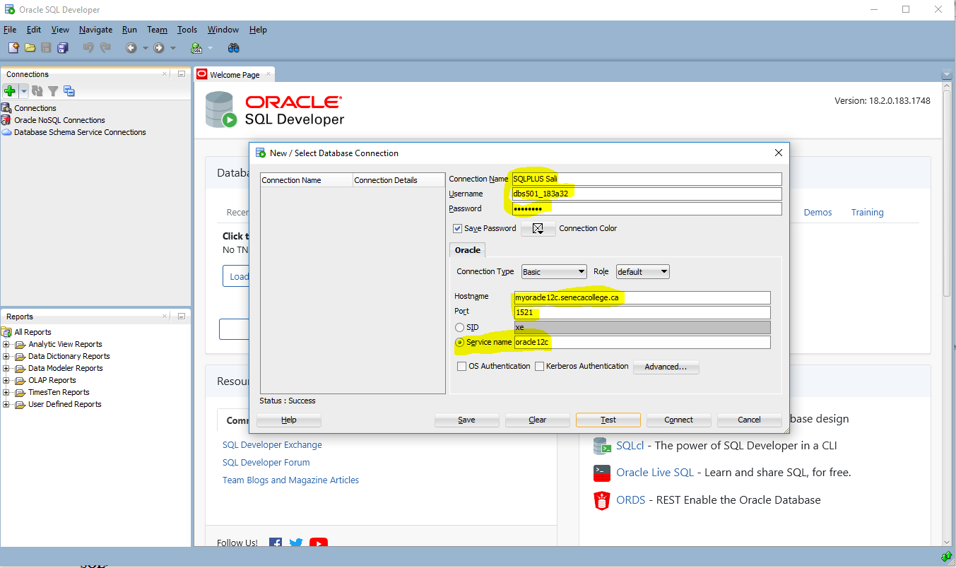

SET SERVEROUTPUT ON SIZE 1000000;

SET LINESIZE 50000;

set pagesize 50000;

set long 50000;

Output improvements:

SET LINESIZE 32000;

SET PAGESIZE 40000;

SET LONG 50000;

SPOOL output.txt

SQL Training

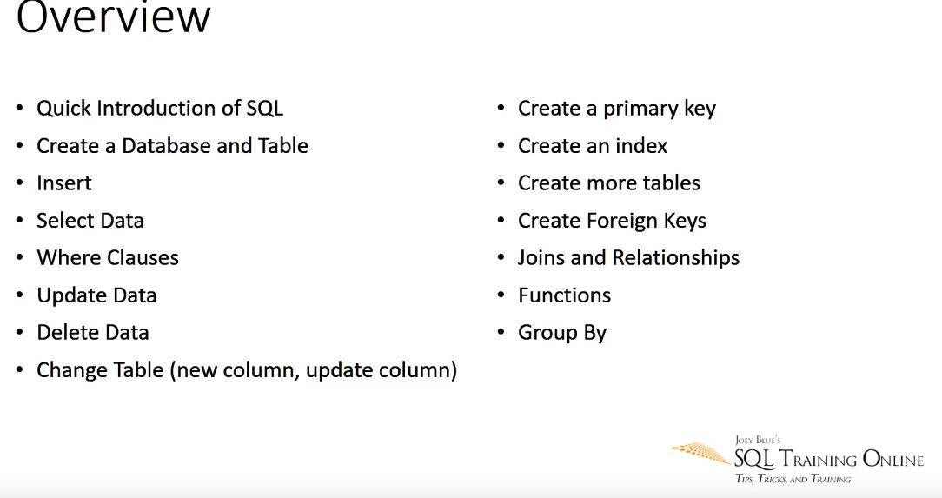

SQL stands for Structure Query Language which is like php, C# and other programming languages; however, it is a language to talk to database

Databases that uses SQL

* SQL Server DB2
* Oracle Big Data
* SQLite (Android) Postgre SQL

Tools to write SQL

* SQL Developer
* SQL Workbench
* Management Studio(SSMS)

1. Oracle Database 12c provides support for the _____ and _____ database models.

Relational, object relational

1. Oracle SQL is a procedural query language.

False – Structural Query Language

1. The acronym DDL stands for which type of Oracle SQL command?

DDL stands for Data Definition Language used for creating, modify and delete database objects, such as tables, indexes, users, constrains, …

DML stands for Data Manipulation Language that are INSERT, UPDATE and DELETE

1. The alternative to quoting strings with single quotes is double quotes.

False – In Oracle double quote is only used for alias a column name and so

1. What single-row function would be most appropriate to use to convert a DATE column to the format "YYYY/MM/DD HH:MI:SS" for a report?

To_Char not To_DateTime

1. You want to roll up totals by department, but only see the totals for two of the departments. To do this, you'll have to use the _____ and the _____ clauses.

Group by and Having not Group by and Where clauses

1. Your query using set operators(UPDATE - SET) has multiple subqueries and you want to change the order of evaluation. What is the best method for changing the evaluation order?

Put parentheses around pairs of queries that you want to run before any other set operators.

1. You're using SQL Developer and running some INSERT and UPDATE statements. What is the easiest way to perform a COMMIT on your work so far?

Click on Commit button on the top of the SQL window

1. A datafile in a _____ tablespace is limited to about 64 GB if you have a 16K block size.

SMALLFILE not BIGFILE

1. The _____ logical database structure is the most granular in an Oracle Database.

Data block

1. What is the difference between a view starting with V$ and a view starting with GV$?

The GV$ view contains an INST_ID column that identifies which database instance in the cluster this row is referencing.

1. Blocks storing a(n) _____ column does not have nor need a setting for PCTFREE.

CLOB not XML not LONG and not IOT

1. Both _____ and _____ need data in the UNDO tablespace.

Queries - DML

**Is SQL developer free to use?**

SQL developer is a free database management and development tool developed by Oracle which is free to use.

How to install Oracle 12 c:

1. First install **jdk** file from Oracle website

<https://www.oracle.com/technetwork/java/javase/downloads/jdk10-downloads-4416644.html>

1. Install **SQL Developer** from <https://goo.gl/nftWBA> -> Redirects to

<https://www.oracle.com/technetwork/developer-tools/sql-developer/downloads/index.html>

1. **Create an Oracle account**

In order to download the SQL Developer, you need to create a free Oracle account.

Then sign in to the account and continue the download and unzip the files

1. Put the unzip file with the JDK and Oracle files
2. Then open up the folder and Run ‘ sqldeveloper.exe ‘ file
3. On execution the Oracle SQL needs a path to the jdk file. This is a one time process.
4. After giving your jdk path press OK and installation will starts

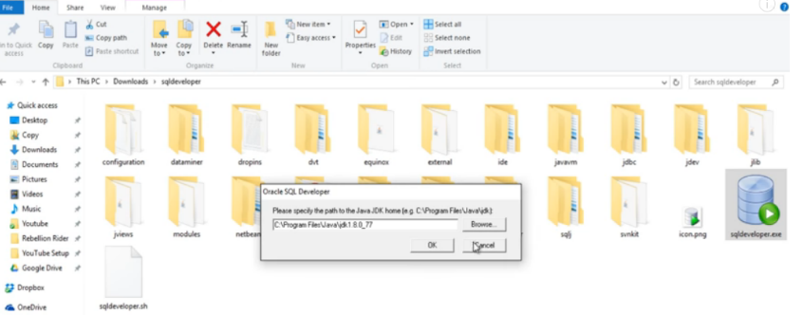

How to create connection to SQL

Connection name: HR@Local

Username: hr

Password: hr

Hostname: localhost

Port: 1521

SID: ORCL

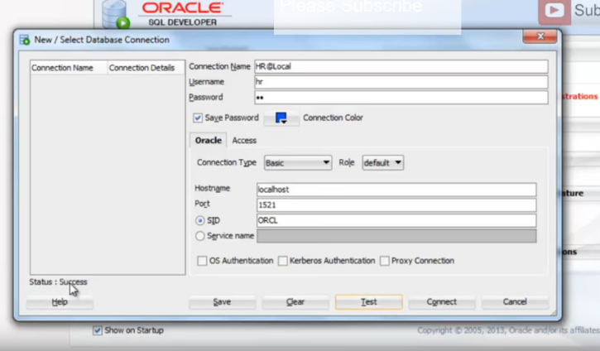

Use the **‘ Test ‘** button to test the connection

**To create the connection using command line:**

**>>> SET ORACLE_SID = orcl**

Check it:

**>>>> Echo %ORACLE_SID%**

Output: **orcl**

**>>> sqlplus hr/hr**

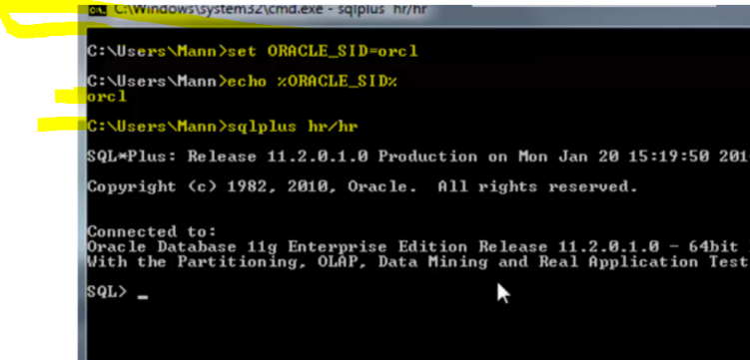

**To create connection to database SQL without using any specific user account though:**

**>>> sqlplus /nolog**

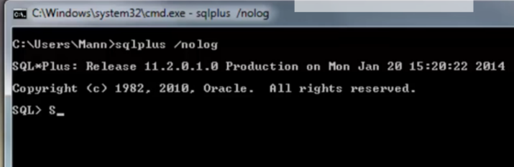

**Connect back to ‘ hr ‘ account**

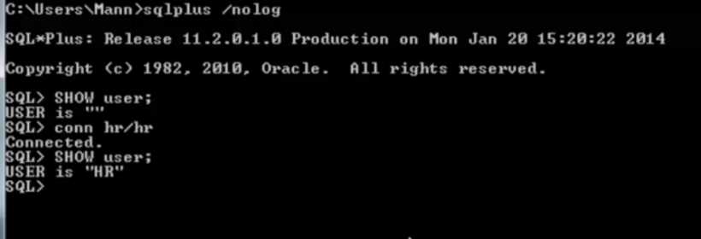

**Create another connection to database**

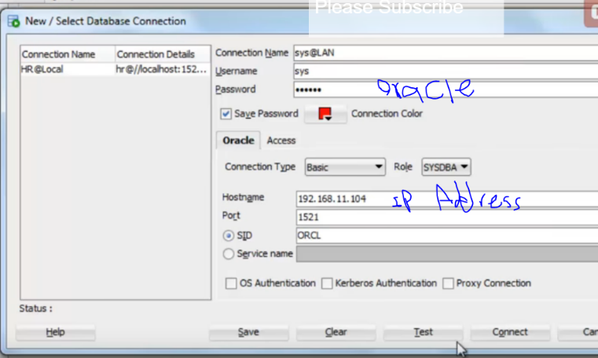

**Important:**

SET SERVEROUTPUT ON SIZE 1000000;

SET LINESIZE 50000;

set pagesize 50000;

set long 50000;

select * from user_tables

what you should know:

* Access to an Oracle 12 c database
* Install SQL Developer (free) -link above
* Basic understanding of relational databases
* Some experience with a dialect of SQL
* Understanding of client-server architecture and networks
* Database application development experience helpful

Whether you're using a relational database, hierarchical, network, or an object-relational database, you need to use a data modeling tool to document the objects, attributes and relationships between the objects in the database. In the '60s and '70s, both hierarchical and network data models were more prevalent, mostly because of limitations with the hardware and software available at the time. As computing power and capabilities increased, other models emerged such as the relational database model. The primary data modeling technique used with Oracle Database is the relational model.

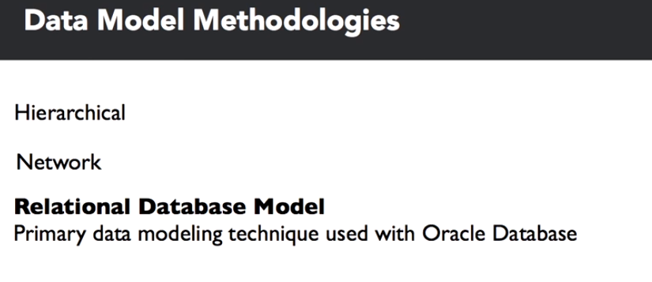

The most popular hierarchical database, IMS, was first released in 1966 by IBM in conjunction with Rockwell and Caterpillar as a database to support bill of materials, application management for the Apollo space program. IMS has evolved enough to be a viable platform well into the 21st century with support for Java, XML and web applications. IDMS, Integrated Database Management System, is an example of the network database model, first developed at BF Goodrich in 1973 and later marketed commercially by Cullinet.

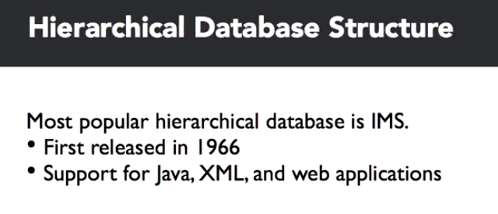

Relational database modeling was born in the early 1970's with a paper by Dr. E. F. Codd in June of 1970, entitled, "A Relational Model of Data for Large Shared Data Banks." So, what is a relational model? It's really three things: a collection of objects, relations, operators that act on the relations, and data integrity operations.

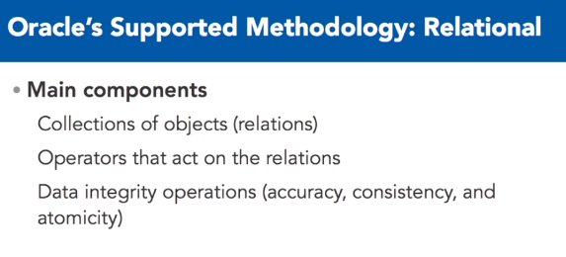

The collection of objects represents real world things such as a list of auto parts, a balance sheet, or in this case, customer orders, much like a spreadsheet.

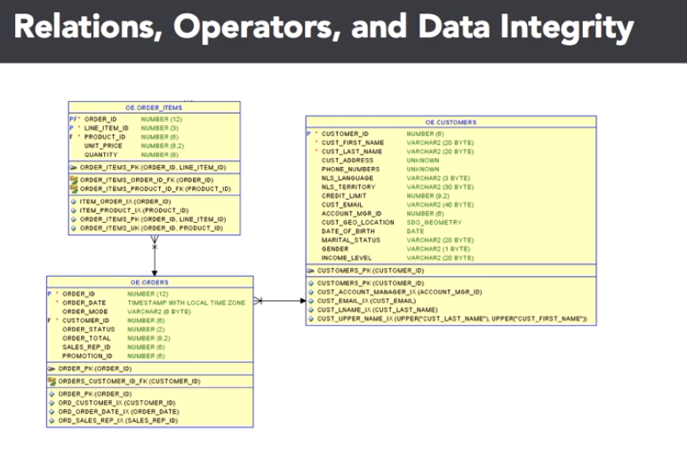

These are what are called relations. Second, a relational model has a set of operators that act on one or more relations. These operators include filtering the components of a relation to get the desired results. In a spreadsheet, the original version of a database table, you might use a filter operation to only view certain columns, or you might only want to see certain rows of the spreadsheet. Finally, you must have one of the most important components of the relational model: data integrity operations.

For subcomponents of any given relation, you want to make sure that the information in the relation is accurate and logically consistent with the information in the other relations of your data model. We'll point out these components in the following slides. You've probably noticed some interesting nomenclature and symbols in the previous slide. That is the logical implementation of those business entities in Oracle Sequel Data Modeler, of an entity relationship diagram. These diagrams make it easy to identify relations among the entities along with the business rules that apply to the attributes in each entity.

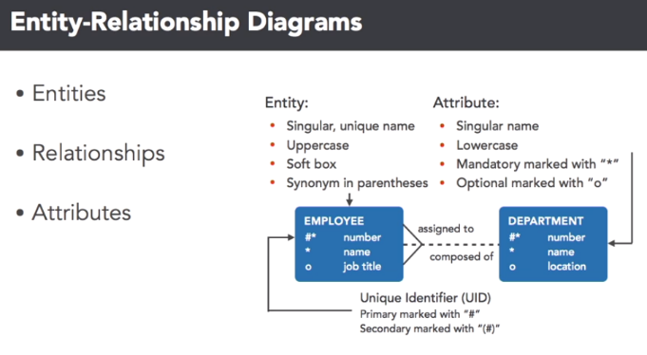

We'll use this notation throughout this course when referencing logical data model components. Here, we see a small subset of tables in the database.

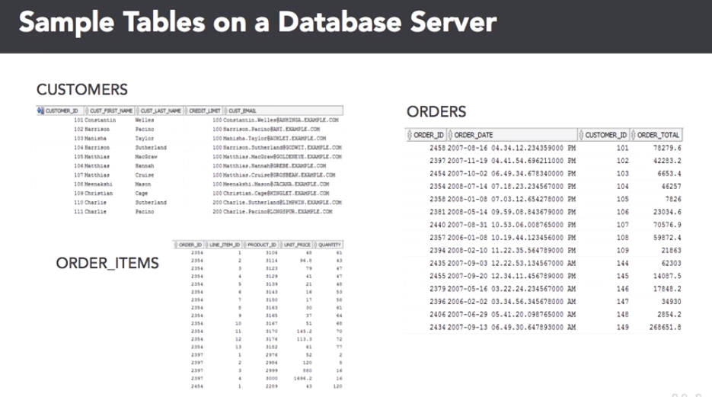

We'll get back to the data modeling development part in a bit. The three relations stored as tables in the database are the customers, orders and order item tables. Notice that there are many operators you can use on these tables. For example, you may use a projection on the customer's table to only see a customer's first name and e-mail address or you may want to see all information about a single customer's orders using a selection on the order items table.

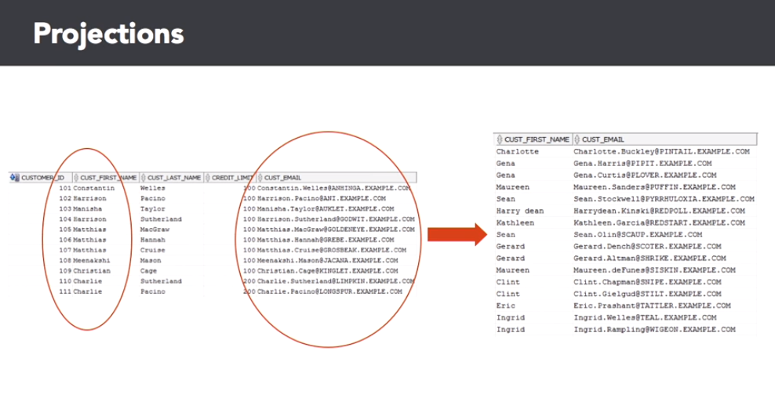

Finally, you may want to use a join operator on the orders and order items table to generate a new relation that shows a given order number and its associated line items.

Let's talk about data integrity next. When defining a relation, you may also want to define the data integrity operations that ensure data quality and consistency. For example, you don't want to have any missing data for custfirst name or custlast name in the customers table, as you can see in the slide.

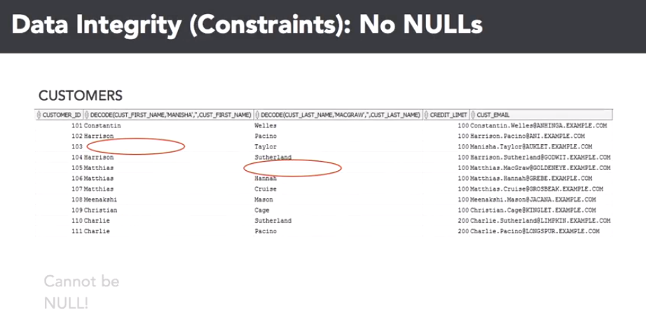

Also, you want to make sure that the order ID column in the order items table has an entry in the orders table. This is called a foreign key constraint.

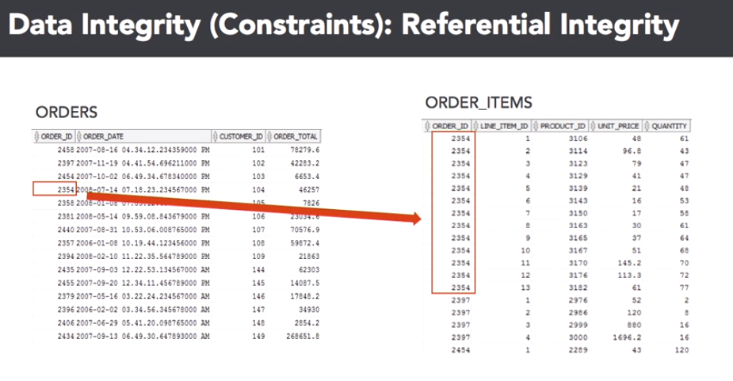

How do you get from an idea in a CEO's head to the actual data model? Well, when you want to create an Oracle Database for an application to fulfill a business need, you usually don't want to start creating tables on a new database as your first step. It's important to start with the application stakeholders to gather business requirements for the data model. Frequently, the application owners have an idea in their head of the types of data they want to store, but that doesn't translate directly to Oracle Database tables.

After the business requirements are gathered, you'll facilitate the creation of an entity relationship, ER diagram, to capture the entities, relations and their attributes, which are usually columns, that are important to the application along with the relationships between the entities and the data integrity constraints. This would be considered the logical ER diagram. From the logical ER diagram, the modeler will generate the database table model for the diagram, in other words, the Oracle Database statements that will be executed to create the physical representations of the entities, attributes and relationships, not to be confused with relations, defined in the ER diagram.

Finally, the Oracle DBA, which may also be you, will run the commands to create the first version of the database tables for the application.

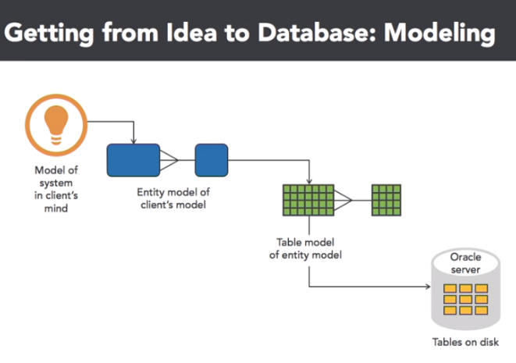

So, what do we know now? Several things. Oracle Database is primarily a relational database platform with some object-oriented capabilities thrown in, and is firmly based on the relational database model, first proposed by E. F. Codd in 1970. An entity relationship ER diagram shows the logical objects and relationships in a relational database.

These objects will map almost one to one with the physical objects in the database itself.

Logical database modeling

Let's start out this lesson by analyzing the components in a logical data model diagram.

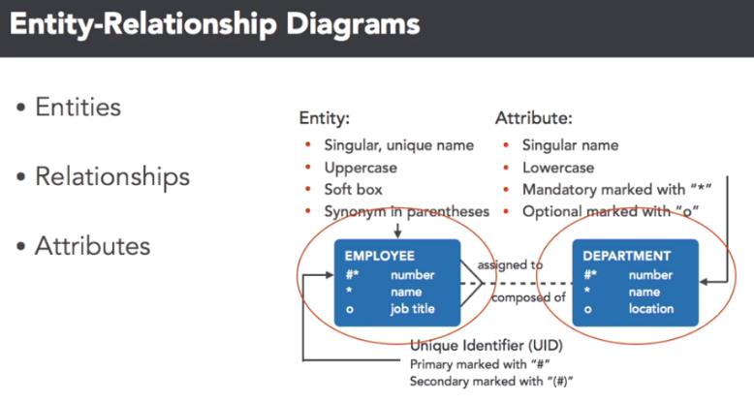

At this level, you're not as concerned about data types, but instead, what elements of your organization are important from a business perspective. Each blue box is one of the entities, remember, this is also called a relation and data modeling terminology, in this case, employees and departments. You'll use certain conventions in your data modeling tool, to assign characteristics to the attributes of each entity.

The entity name is in upper case, the attributes are in lower case, and both are almost always singular. You'll also want to mark certain attributes as being unique, or not knowable, to enforce data integrity. Here, the employee number, and department number, are unique identifiers, and the name attribute in both of those entities, can't be empty. No worries, a lot of these requirements are easy to implement, in most data modeling tools, as you'll see later in this video. In your favorite data modeling tool, you'll also define the relationships between the entities.

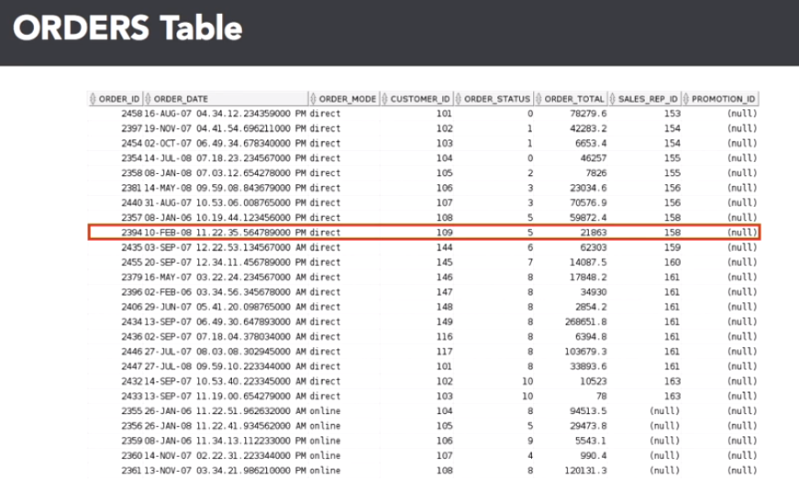

This is a critical step to ensure that data integrity will be enforced using database features such as foreign keys, as well as defining the cardinality of the entities in your database. After you've created the table in the Oracle database, it will look something like this in SQL Developer. Let's review the connection between the elements in your data model diagram, with the database table itself. Here are the first 25 rows of the order table. A row in the database, is a tuple in a classic relational database model.

And you select rows using relational database languages, such as a SQL SELECT statement structured query language. In this diagram, the row with an order ID of 2394 is highlighted. A column, also known as a projection, is the attribute of an entity. A column can have several attributes beyond what kind of data type it is. It can be, one, a unique identifier, two, an identifier that links to a unique column in another table.

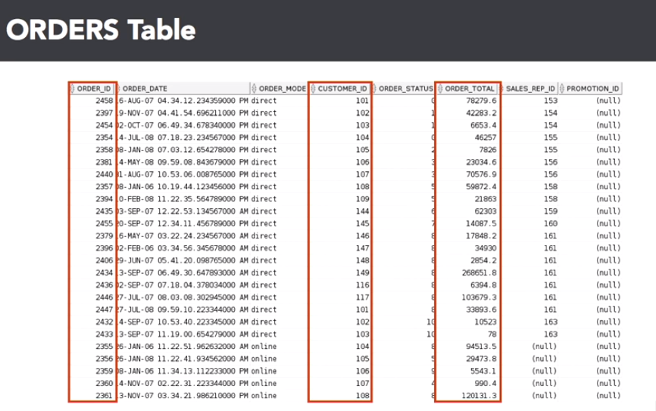

Or three, just to another column, usually dependent on the unique identifier in that row. An intersection of a row and column is a field, a single atomic value of a column, in a single database row.

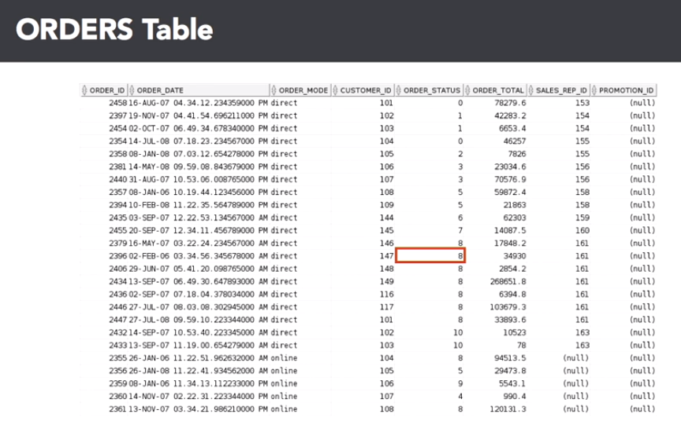

The highlighted field answers the question, "What is the order status for order number 2396?" For a customer service representative that is inquiring on the order status, seeing a value of eight might not be very useful or obvious, therefore the result of this query will probably be joined to the order status table, to get the text description.

Finally, any non-primary key columns can have a value of null, meaning that the field has no value, or it's unknown. It does not mean that it is blank, or has spaces, or has a value of zero, it does not exist. This has many implications when selecting rows, or joining tables, based on the value, or lack thereof, in this column.

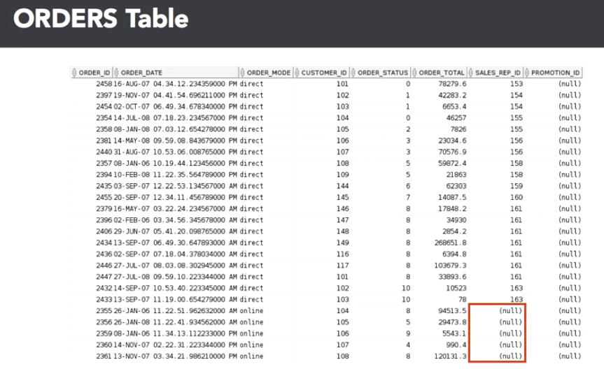

Now that you know what you want to do, which is to create the data model, you can use one of many good tools from vendors such as Embarcadero, and Computer Associates, to perform your data modeling tasks.

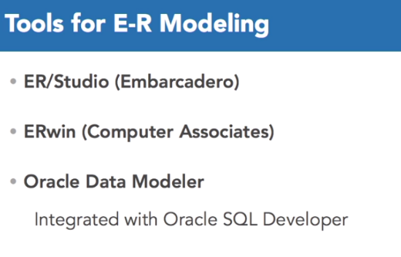

A big advantage to using Oracle Data Modeler, is that it's integrated into Oracle SQL Developer, allowing you to manage the entire database development and deployment life cycle within one gooey, and on top of it all, it's free.

Here's how well-integrated Oracle SQL Developer is with Oracle Data Modeler. Going to the file tab, select data modeler, then select import. As you can see, there are a wide variety of other data sources, in this case we're going to import from data dictionary.

Next, pick a connection to the database you want to use for the import, I'm going to click on the OE connection. Click on next, and you'll see a list of the schemas in the database. I'm going to pick the OE schema, since it contains the order entry tables. Go ahead and click that check box, and then click next. Right here, you'll see all the tables that OE owns, and there are the two we want, orders, and order items. So I'm going to select both of those, and then click on next.

Before performing the import, you'll see a summary screen, click on finish. As the gears grind, it's generating the design for the data model design for you. There's a summary of what it did, how many statements it imported and so forth. You can save the summary of the import operation, or you can close it. In this case, I'm going to close it. What you see is the imported data model, including the foreign key relationship between the orders and order items table. You will also be able to use SQL Developer long after the data model has been deployed, for report writing, ad hoc queries, and DBA specific duties, such as managing users, table spaces, and database server resources.

Here's a built-in report to list the columns for all views in the database. An Oracle DBA is only as good, and as efficient, as the tool sets they use. Using Oracle’s free data modeling, deployment, and development tools will help any DBA power user be successful in their job. The tools that Oracle provides can truly be one-stop shopping for all of your database design, development, and maintenance needs.

**How to access Oracle developer remotely**

|  |
| --- |
| **Oracle Instance: The instance for Oracle Database Server  is called  ORACLE12C**    **You will need to perform TWO initial steps in order to connect from home:**    **1)    Download Oracle 12c  Client Software for your Home OS  from**[**www.oracle.com/technology**](http://www.oracle.com/technology) **by Login** (you will  need to create a free account first) and then  choose Your OS and then Install option  Follow the DEFAULT options and you will be fine.    **2)   Create or Edit file called tnsnames.ora by putting the content  (about ORACLE12C database and its alias NEPTUNE) like shown below**    **NEPTUNE =   (DESCRIPTION =     (ADDRESS = (PROTOCOL = TCP)(HOST = myoracle12c.senecacollege.ca)(PORT = 1521))     (CONNECT_DATA =       (SERVER = DEDICATED)       (SERVICE_NAME = oracle12c)     )   )**    **tnsnames.ora** is located in your network files directory i.e for Windows may be  **C:\app\UserName\product\12.1.0\client_1\network\admin\** ,  For Linux is $ORACLE_HOME\network\admin.    You may copy the existing file **sqlnet**to the same folder, then rename it to **tnsnames**, then erase the whole file content and just ADD the content shown below.  Then SAVE it, but  you may need to EDIT permissions on this **admin** Folder for yourself by ADDING Modify and Write permissions.    **3)   Then whenever you login, you MUST use command line SQL*PLUS application either from DOS prompt or Linux (Unix) prompt.** |
| Now launch **sqlplus** application and enter your login information from the OS prompt.    Windows:    **C:\Temp>   sqlplus  Login/Password@neptune**    **SQL>**    Unix:    **$>  sqlplus  Login/Password@neptune** |
|  |
|  |

***NOTE :  You may also Login to « matrix.senecac.on.ca » server with your Student Id and Password first and then follow Only Step 3 to connect to SQL,***

***but your Database Alias is @oracle12c here.***

***Then you will need to choose your EDITOR like shown here:***

***SQL> define  _editor=vi               --  you will change your command and then  do ESC  :wq to get back the SQL> prompt   and then  /  ENTER            OR***

***SQL> define  _editor=nled          --  you will change your command and then  do ESC  q  followed by Y to get back the SQL> prompt and then  / ENTER***

**PL/SQL**

PL/SQL is a language that has programming features that serve as an extension to SQL. SQL, which is a nonprocedural language, is made procedural with PL/SQL programming constructs.

PL/SQL applications can run on any platform or operating system on which an Oracle server runs. In this lesson, you learned how to build basic PL/SQL blocks.

Human Resources (HR) Schema for This Course

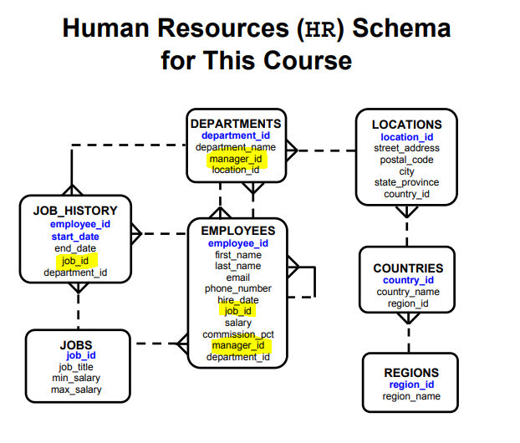

**Human Resources (HR) Schema Description**

The Human Resources (HR) schema is part of the Oracle Sample Schemas that can be installed in an Oracle database. The practice sessions in this course use data from the HR schema.

**Table Descriptions**

• REGIONS contain rows that represent a region such as Americas, Asia, and so on.

• COUNTRIES contain rows for countries, each of which is associated with a region.

• LOCATIONS contain the specific address of a specific office, warehouse, or production site of a company in a country.

• DEPARTMENTS show details about the departments in which employees work. Each department may have a relationship representing the department manager in the

EMPLOYEES table.

• EMPLOYEES contain details about each employee working for a department. Some employees may not be assigned to any department.

• JOBS contain the job types that can be held by each employee.

• JOB_HISTORY contains the job history of the employees. If an employee change department within a job or changes jobs within a department, then a new row is inserted into this table with the old job information of the employee.

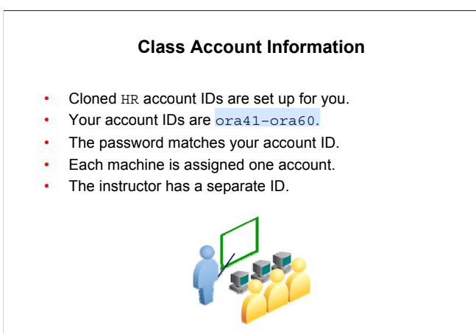

**PL/SQL Development Environments**

Oracle provides several tools that can be used to write PL/SQL code.

Some of the development tools that are available for use in this course:

* Oracle SQL Developer: A graphical tool
* Oracle SQL*Plus: A window or command-line application
* Oracle JDeveloper: A window-based integrated development environment (IDE)

Note: The code and screen examples presented in the course notes were generated from output in the SQL Developer environment.

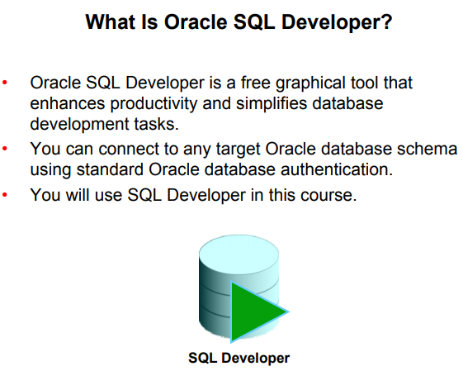

SQL Developer, the visual tool for database development, simplifies the following tasks:

* Browsing and managing database objects
* Executing SQL statements and scripts
* Editing and debugging PL/SQL statements
* Creating reports

You can connect to any target Oracle database schema using standard Oracle database authentication. When connected, you can perform operations on objects in the database.

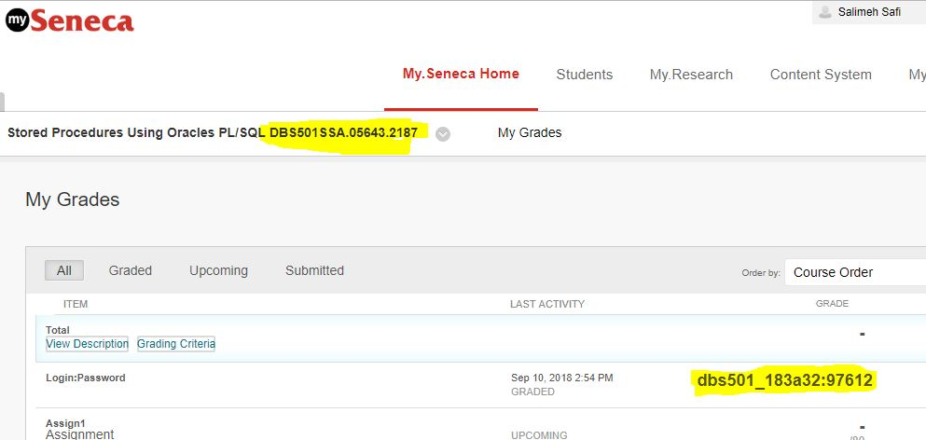

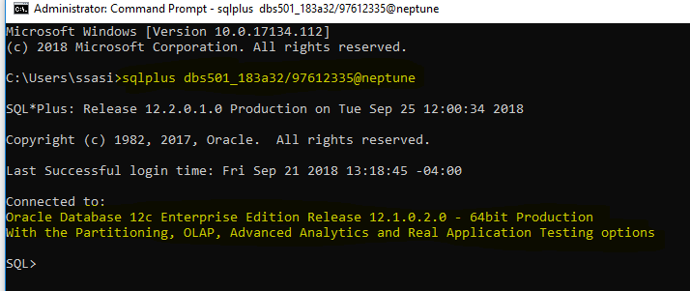

**Coding PL/SQL in SQL*Plus**

Oracle SQL*Plus is a graphical user interface (GUI) or command-line application that enables you to submit SQL statements and PL/SQL blocks for execution and receive the results in an application or a command window.

SQL*Plus is:

* Shipped with the database
* Installed on a client and on the database server system
* Accessed from an icon or the command line

When coding PL/SQL subprograms using SQL*Plus, remember the following:

* You create subprograms by using the CREATE SQL statement.
* You execute subprograms by using either an anonymous PL/SQL block or the EXECUTE command.

• If you use the DBMS_OUTPUT package procedures to print text to the screen, you must first execute the SET SERVEROUTPUT ON command in your session.

**Coding PL/SQL in Oracle JDeveloper**

Oracle JDeveloper allows developers to create, edit, test, and debug PL/SQL code by using a sophisticated GUI. Oracle JDeveloper is a part of Oracle Developer Suite and is also available as a separate product.

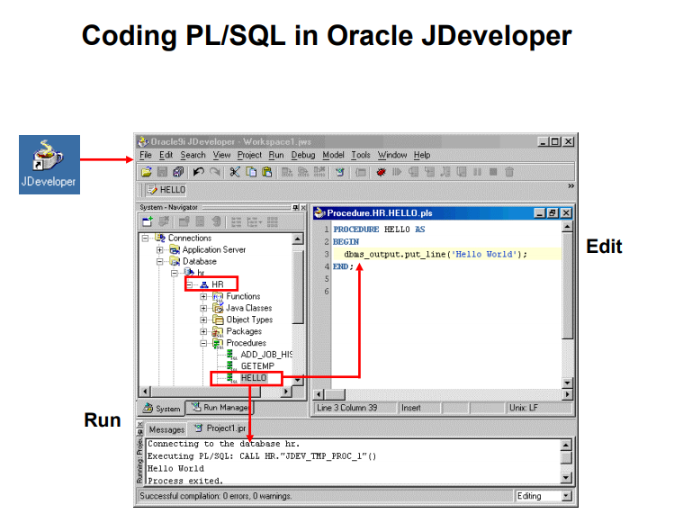

When coding PL/SQL in JDeveloper, consider the following:

* You first create a database connection to enable JDeveloper to access a database schema owner for the subprograms.
* You can then use the JDeveloper context menus on the Database connection to create a new subprogram construct using the built-in JDeveloper Code Editor. The JDeveloper

Code Editor provides an excellent environment for PL/SQL development, with features such as the following:

* Different colors for syntactical components of the PL/SQL language
* Code insight to rapidly locate procedures and functions in supplied packages

• You invoke a subprogram by using a Run command on the context menu for the named subprogram. The output appears in the JDeveloper Log Message window, as shown in the lower portion of the screenshot.

Note: JDeveloper provides color-coding syntax in the JDeveloper Code Editor and is sensitive to PL/SQL language constructs and statements

**Creating a Database Connection**

To create a database connection, perform the following steps:

1. Double-click <your_path>\sqldeveloper\sqldeveloper.exe.
2. On the Connections tabbed page, right-click Connections and select New Connection.
3. Enter the connection name, username, password, host name, and SID for the database you want to connect to.
4. Click Test to make sure that the connection has been set correctly.
5. Click Connect.

On the basic tabbed page, at the bottom, enter the following options:

* **Hostname**: Host system for the Oracle database
* **Port**: Listener port
* **SID**: Database name
* **Service name**: Network service name for a remote database connection

If you select the Save Password check box, the password is saved to an XML file. So, after you close the SQL Developer connection and open it again, you will not be prompted for the password.

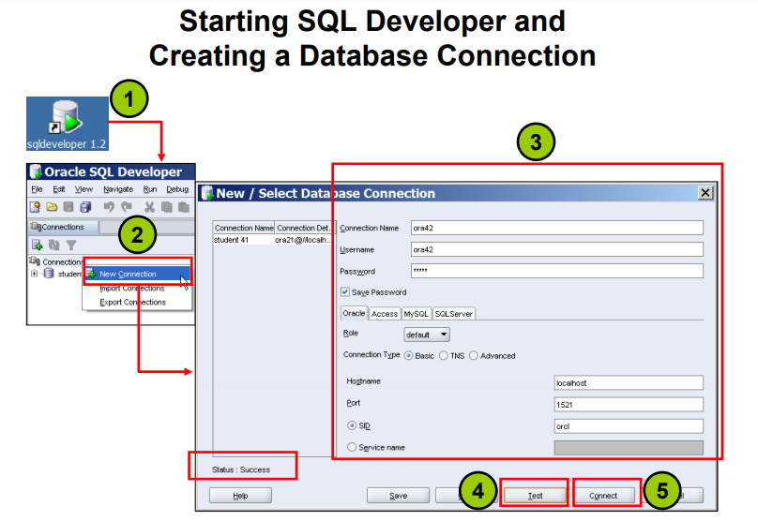

**Creating Schema Objects**

* You can create any schema object in SQL Developer
* using one of the following methods:
  + Executing a SQL statement in the SQL Worksheet
  + Using the context menu
* Edit the objects using an edit dialog box or one of the many context-sensitive menus.

• View the DDL for adjustments such as creating a new object or editing an existing schema object.

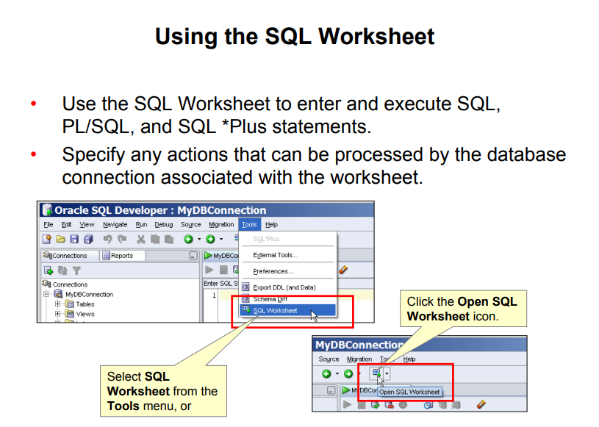

**Using the SQL Worksheet**

When you connect to a database, a SQL Worksheet window for that connection is automatically opened. You can use the SQL Worksheet to enter and execute SQL, PL/SQL, and SQL*Plus statements. The SQL Worksheet supports SQL*Plus statements to a certain extent. SQL*Plus statements that are not supported by the SQL Worksheet are ignored and not passed to the database.

You can specify any actions that can be processed by the database connection associated with the worksheet, such as:

* Creating a table
* Inserting data
* Creating and editing a trigger
* Selecting data from a table
* Saving the selected data to a file

You can display a SQL Worksheet by using any of the following:

* Select Tools > SQL Worksheet.
* Click the Open SQL Worksheet icon.

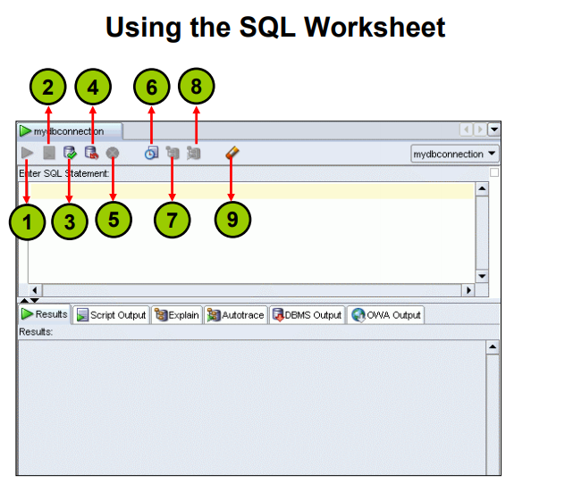

You may want to use the shortcut keys or icons to perform certain tasks such as executing a SQL statement, running a script, and viewing the history of SQL statements that you have executed.

You can use the SQL Worksheet toolbar that contains icons to perform the following tasks:

**1. Execute Statement**: Executes the statement at the cursor in the Enter SQL Statement box.

You can use bind variables in the SQL statements, but not substitution variables.

**2. Run Script**: Executes all statements in the Enter SQL Statement box using the Script

Runner. You can use substitution variables in the SQL statements, but not bind variables.

**3. Commit**: Writes any changes to the database and ends the transaction

**4. Rollback**: Discards any changes to the database, without writing them to the database, and ends the transaction

**5. Cancel**: Stops the execution of any statements currently being executed

6. SQL History: Displays a dialog box with information about SQL statements that you have executed

**7. Execute Explain Plan**: Generates the execution plan, which you can see by clicking the Explain tab

**8. Autotrace**: Generates trace information for the statement

**9. Clear:** Erases the statement or statements in the Enter SQL Statement box

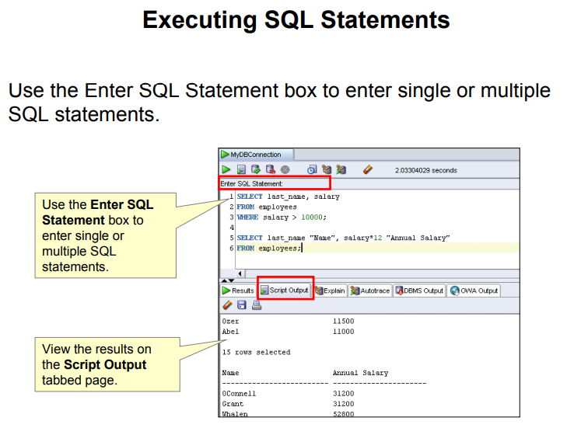

**Executing SQL Statements**

In the SQL Worksheet, you can use the Enter SQL Statement box to enter a single or multiple SQL statements. For a single statement, the semicolon at the end is optional.

When you enter the statement, the SQL keywords are automatically highlighted. To execute a SQL statement, ensure that your cursor is within the statement and click the Execute Statement icon. Alternatively, you can press the **F9** key.

To execute multiple SQL statements and see the results, click the Run Script icon.

Alternatively, you can press the **F5** key.

In the example in the slide, because there are multiple SQL statements, the first statement is terminated with a semicolon. The cursor is in the first statement and, therefore, when the statement is executed, results corresponding to the first statement are displayed in the Results box.

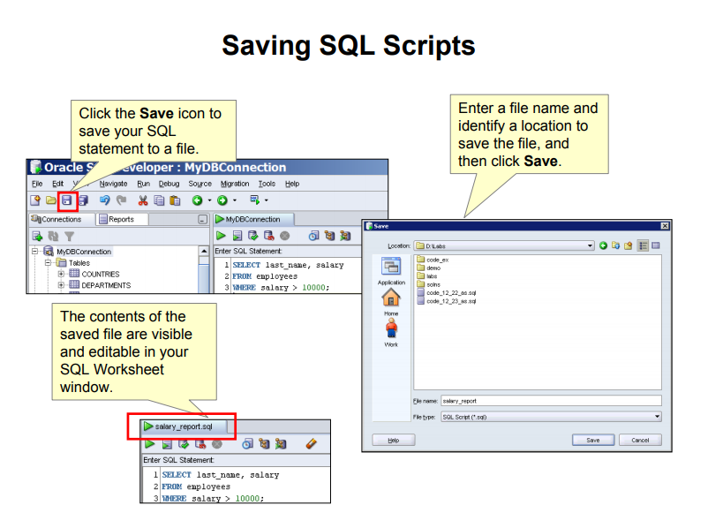

**Saving SQL Scripts**

You can save your SQL statements from the SQL Worksheet into a text file. To save the contents of the Enter SQL Statement box, follow these steps:

1. Click the Save icon or use the File > Save menu item.
2. In the Windows Save dialog box, enter a file name and the location where you want the file saved.
3. Click Save.

After you save the contents to a file, the Enter SQL Statement window displays a tabbed page of your file contents. You can have multiple files open at once. Each file displays as a tabbed page.

**Script Pathing**

You can select a default path to look for scripts and to save scripts. Under **Tools > Preferences > Database > Worksheet Parameters**, enter a value in the **Select default path to look for** **scripts** field.

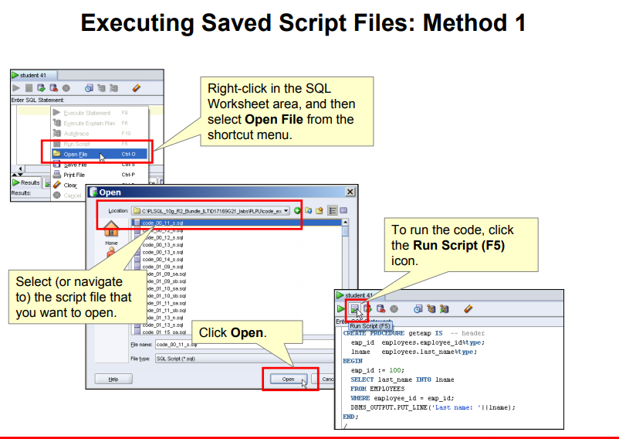

**Executing Saved Script Files: Method 1**

You can open and execute a script file in the SQL Worksheet area as follows:

1. Right-click in the SQL Worksheet area, and then select Open File from the pop-up menu.

The Open dialog box is displayed.

1. In the Open dialog box, select (or navigate to) the script file that you want to open.
2. Click Open. The code of the script file is displayed in the SQL Worksheet area.
3. To run the code, click Run Script (F5) on the SQL Worksheet toolbar.

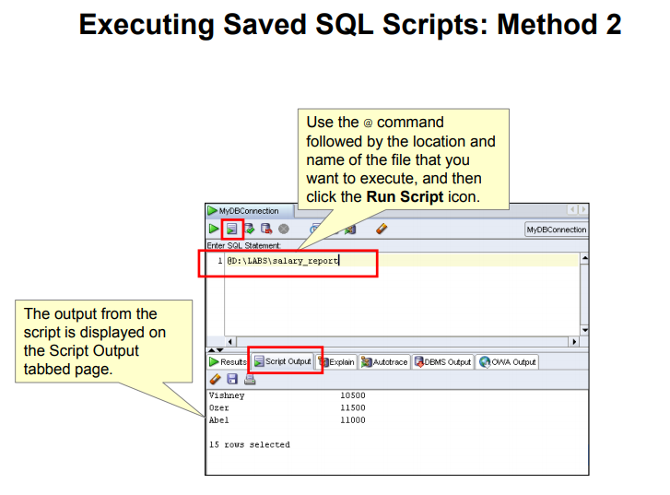

**Sali Connection Info**

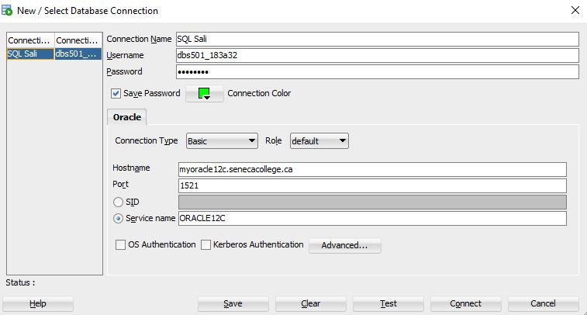

**Oracle SQL Developer Tables for Sali Account**

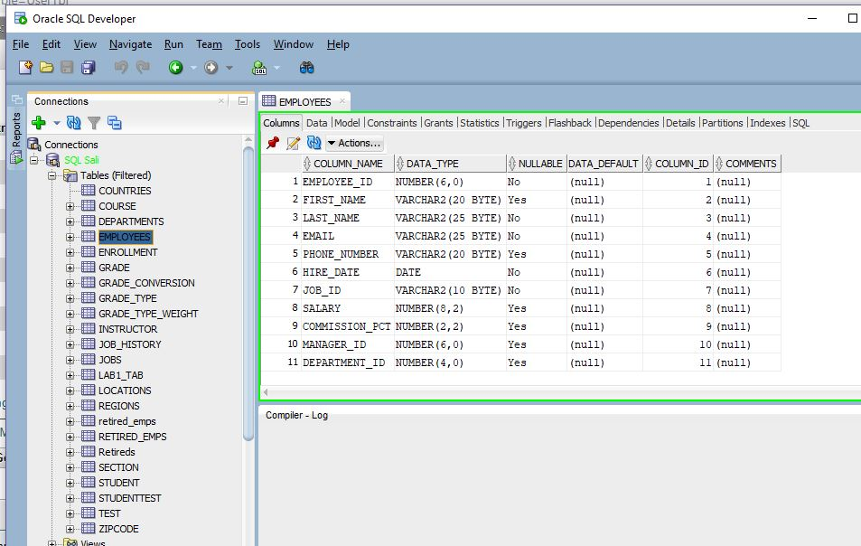

**Executing Saved Script Files: Method 2**

To run a saved SQL script, perform the following steps:

1. In the Enter SQL Statement window, use the @ command, followed by the location and name of the file that you want to run.
2. Click the Run Script icon.

The results from running the file are displayed on the Script Output tabbed page. You can also save the script output by clicking the Save icon on the Script Output tabbed page. The Windows

File Save dialog box appears and you can identify a name and location for your file.

**Practice**

This is the first of many practices in this course. The solutions (if you require them) can be found in Appendix A. Practices are intended to cover most of the topics that are presented in the corresponding lesson.

1. Start up SQL Developer using the user ID and password that are provided to you by the instructor such as oraxx where xx is the number assigned to your PC.

2. Create a database connection using the following information:

* 1. Connection Name: MyDBConnection.
  2. Username: oraxx where xx is the number assigned to your PC by the instructor.
  3. Password: oraxx where xx is the number assigned to your PC by the instructor.
  4. Hostname: Enter the host name for your PC.
  5. Port: 1521
  6. SID: ORCL

3. Test the new connection. If the Status is Success, connect to the database using this new connection.

1. Double-click the MyDBConnection icon on the Connections tabbed page.
2. Click the Test button in the New/Select Database Connection window. If the status is Success, click the Connect button.

4. Browse the structure of the EMPLOYEES table and display its data.

1. Expand the MyDBConnection connection by clicking the plus sign next to it.
2. Expand the Tables icon by clicking the plus sign next to it.
3. Display the structure of the EMPLOYEES table.

Sali >> DESCRIBE Employees

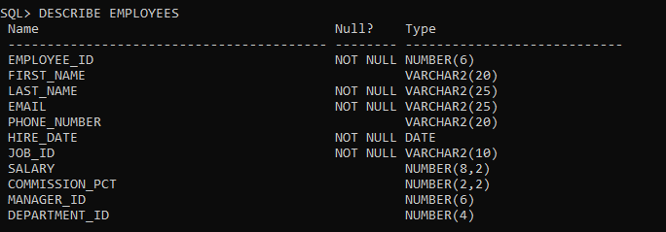

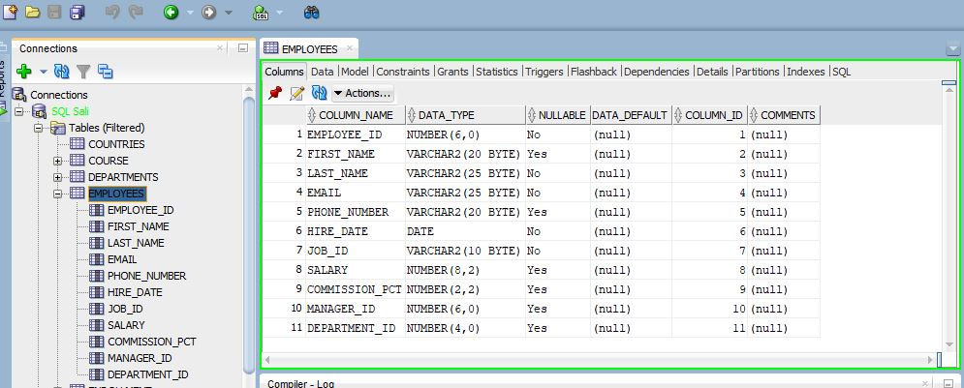

1. Browse the EMPLOYEES table and display its data.

SELECT * FROM Employees

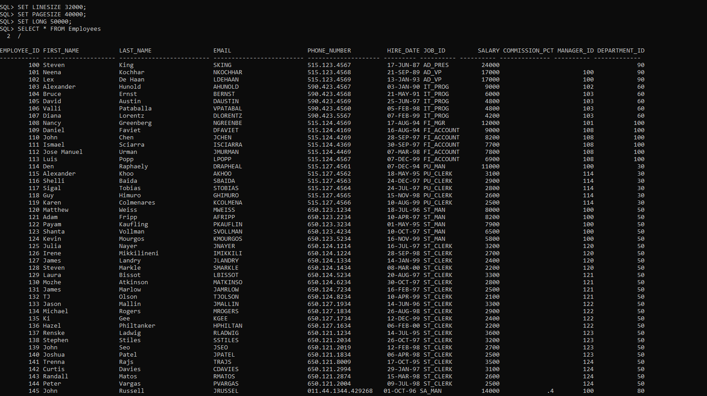

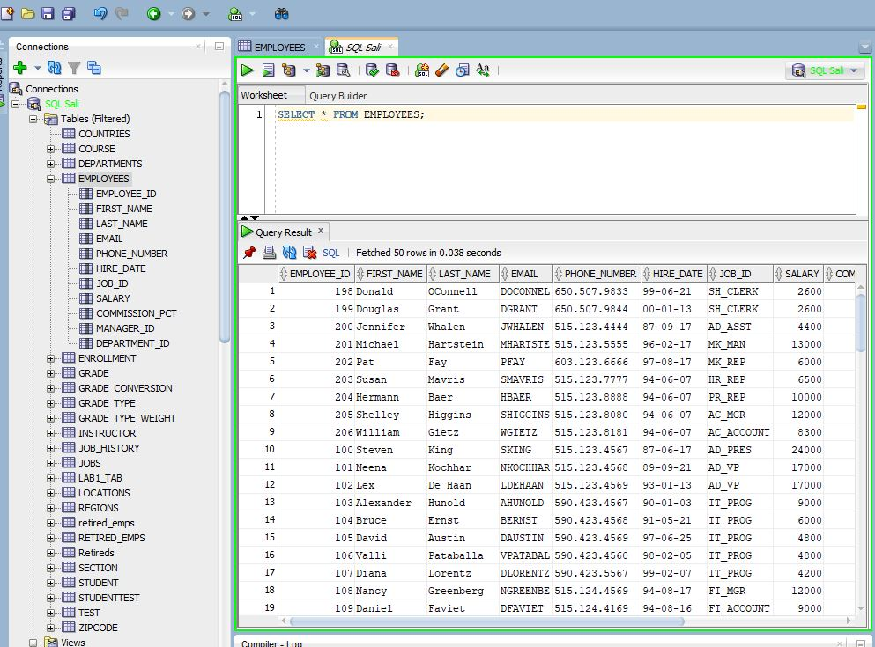

1. Use the SQL Worksheet to select the last names and salaries of all employees whose annual salary is greater than $10,000. Use both the Execute Statement (F9) and the Run Script icon (F5) icons to execute the SELECT statement. Review the results of both methods of executing the SELECT statements in the appropriate tabs.

Sali >>>>>

SELECT Employees.last_name, Employees.salary

FROM Employees

WHERE salary >10000

ORDER BY Employees.salary DESC

SAME AS

SELECT last_name, salary

FROM Employees

WHERE salary >10000

ORDER BY salary DESC

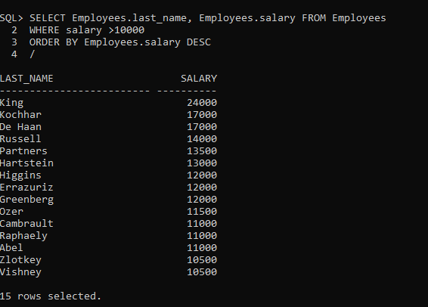

Note: Take a few minutes to familiarize yourself with the data, or consult Appendix B, which provides the description and data for all tables in the HR schema that you will use in this course.

7. In the SQL Developer menu, navigate to **Tools > Preferences**. The Preferences window is displayed.

8. Click the Worksheet Parameters option under the Database option. In the “Select default path to look for scripts” text box, specify the D:\labs\PLSF folder. This folder contains the solutions scripts, code examples scripts, and any labs or demos used in this course.

Oracle University and ORACLE CORPORATION use only THESE eKIT MATERIALS ARE FOR YOUR USE.

Sali >>>>>

SELECT first_name

FROM Employees

WHERE employee_id = 100;

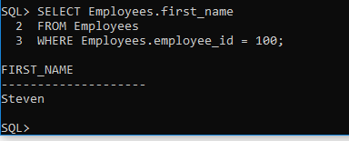

Sali >>>>>

SET SERVEROUTPUT ON;

DECLARE

v_name VARCHAR(20);

BEGIN

SELECT Employees.first_name INTO v_name

FROM Employees

WHERE Employees.employee_id = 100;

DBMS_OUTPUT.PUT_LINE('Employee name is ' || v_name);

END;

/

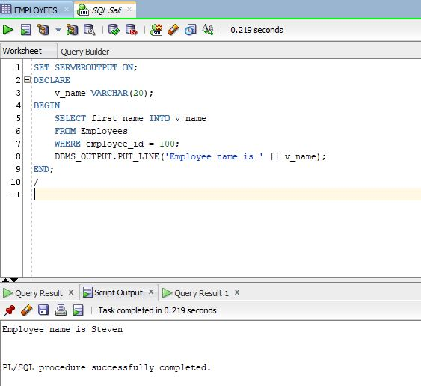

PL/SQL is not case sensitive.

V_name is equal to V_NaME ….

Sali >>

DECLARE

V_naMe VARCHAR(20);

BEGIN

SELECT Employees.first_name INTO v_name

FROM Employees

WHERE Employees.employee_id = 100;

DBMS_OUTPUT.PUT_LINE('Employee name is ' || V_NaME );

END;

/

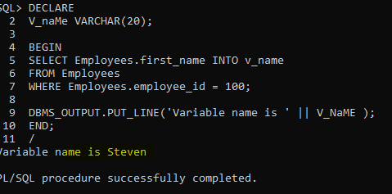

Writing the “ Employees.employee_id “ is not a must

DECLARE

V_naMe VARCHAR(20);

BEGIN

SELECT first_name INTO v_name

FROM Employees

WHERE employee_id = 100;

DBMS_OUTPUT.PUT_LINE('Variable name is ' || V_NaME );

END;

/

**About PL/SQL**

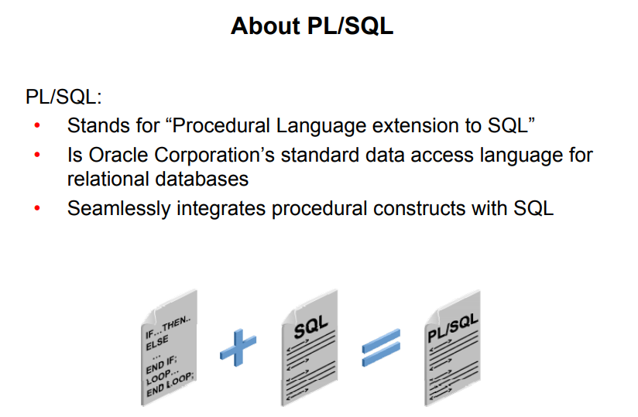

Structured Query Language (SQL) is the primary language used to access and modify data in relational databases. There are only a few SQL commands, so you can easily learn and use them.

Consider an example:

SELECT first_name, department_id, salary FROM employees;

The SQL statement shown above is simple and straightforward. However, if you want to alter any data that is retrieved in a conditional manner, you soon encounter the limitations of SQL.

Consider a slightly modified problem statement: For every employee retrieved, check the department ID and the salary. Depending on the department’s performance and also the employee’s salary, you may want to provide varying bonuses to the employees.

Looking at the problem, you know that you have to execute the preceding SQL statement, collect the data, and apply logic to the data. One solution is to write a SQL statement for each department to give bonuses to the employees in that department. Remember that you also have to check the salary component before deciding the bonus amount. This makes it a little complicated. You now feel that it would be much easier if you had conditional statements.

PL/SQL is designed to meet such requirements. It provides a programming extension to the already-existing SQL.

PL/SQL:

• Provides a block structure for executable units of code.

Maintenance of code is made easier with such a well-defined structure.

• Provides procedural constructs such as:

* + Variables, constants, and data types
  + Control structures such as conditional statements and loops
  + Reusable program units that are written once and executed many times – stored procedures, functions and packages

PL/SQL offers modern software engineering features such as data encapsulation, exception handling, information hiding, and object orientation. It brings state-of-the-art programming to the Oracle server and toolset. PL/SQL provides all the procedural constructs that are available in any third-generation language (3GL).

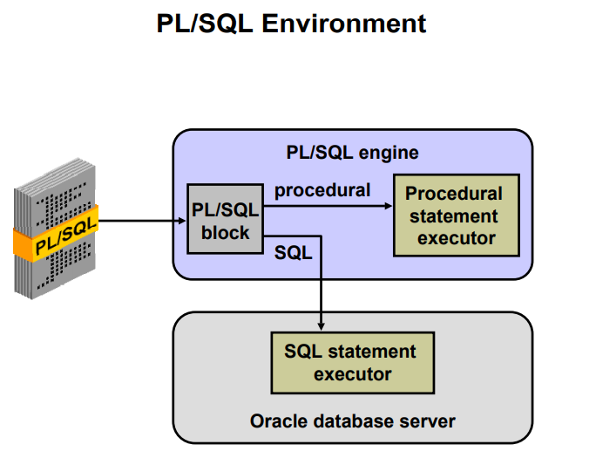

**PL/SQL Environment**

The slide shows the PL/SQL execution environment in the Oracle database server. A PL/SQL block contains procedural statements and SQL statements. When you submit the PL/SQL block to the server, the PL/SQL engine first parses the block. The PL/SQL engine identifies the procedural statements and the SQL statements. It passes the procedural statements to the procedural statement executor and the SQL statements to the SQL statement executor individually.

The diagram in the slide shows the PL/SQL engine within the database server. The Oracle application development tools can also contain a PL/SQL engine. The tool passes the blocks to its local PL/SQL engine. Therefore, all procedural statements are executed locally and only the SQL statements are executed in the database. The engine used depends on where the PL/SQL block is being invoked from.

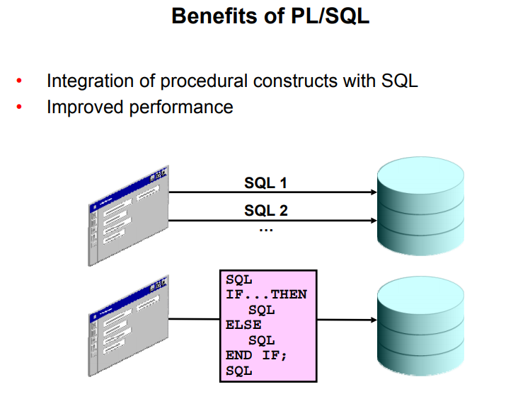

**Benefits of PL/SQL**

Integration of procedural constructs with SQL: The most important advantage of PL/SQL is the integration of procedural constructs with SQL. SQL is a nonprocedural language. When you issue a SQL command, your command tells the database server what to do. However, you cannot specify how to do it. PL/SQL integrates control statements and conditional statements with SQL, giving you better control of your SQL statements and their execution. Earlier in this lesson, you saw an example of the need for such integration.

Improved performance: Without PL/SQL, you would not be able to logically combine SQL statements as one unit. If you have designed an application containing forms, you may have many different forms with fields in each form. When a form submits the data, you may have to execute a number of SQL statements. SQL statements are sent to the database one at a time. This results in many network trips and one call to the database for each SQL statement, thereby increasing network traffic and reducing performance (especially in a client/server model).

With PL/SQL, you can combine all these SQL statements into a single program unit. The application can send the entire block to the database instead of sending the SQL statements one at a time. This significantly reduces the number of database calls. As the slide illustrates, if the application is SQL intensive, you can use PL/SQL blocks to group SQL statements before sending them to the Oracle database server for execution.

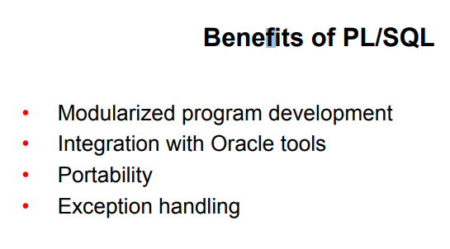

**Modularized program development**: A basic unit in all PL/SQL programs is the block. Blocks can be in a sequence or they can be nested in other blocks. Modularized program development has the following advantages:

* You can group logically related statements within blocks.
* You can nest blocks inside larger blocks to build powerful programs.
* You can break your application into smaller modules. If you are designing a complex application, PL/SQL allows you to break down the application into smaller, manageable, and logically related modules.

• You can easily maintain and debug the code.

In PL/SQL, modularization is implemented using procedures, functions, and packages, which are discussed in the lesson titled “Creating Stored Procedures and Functions.”

**Integration with tools:** The PL/SQL engine is integrated in Oracle tools such as Oracle Forms, Oracle Reports, and so on. When you use these tools, the locally available PL/SQL engine processes the procedural statements; only the SQL statements are passed to the database.

**Portability**: PL/SQL programs can run anywhere an Oracle server runs, irrespective of the operating system and the platform. You do not need to customize them to each new environment. You can write portable program packages and create libraries that can be reused in different environments.

Exception handling: PL/SQL enables you to handle exceptions efficiently. You can define separate blocks for dealing with exceptions. You learn more about exception handling in the lesson titled “Handling Exceptions.”

PL/SQL shares the same data type system as SQL (with some extensions) and uses the same expression syntax.

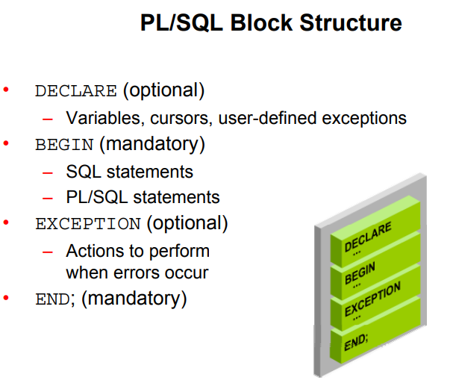

**PL/SQL Block Structure**

The slide shows a basic PL/SQL block. A PL/SQL block consists of three sections:

• **Declarative (optional):** The declarative section begins with the keyword DECLARE and ends when the executable section starts.

• **Executable (required):** The executable section begins with the keyword BEGIN and ends with END. This section essentially needs to have at least one statement. Observe that END is terminated with a semicolon. The executable section of a PL/SQL block can, in turn, include any number of PL/SQL blocks.

• **Exception handling (optional):** The exception section is nested within the executable section. This section begins with the keyword EXCEPTION.

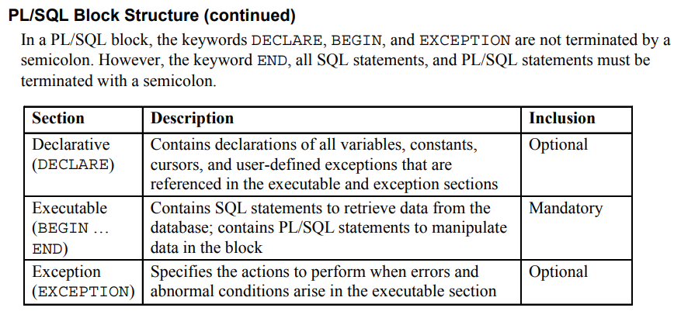

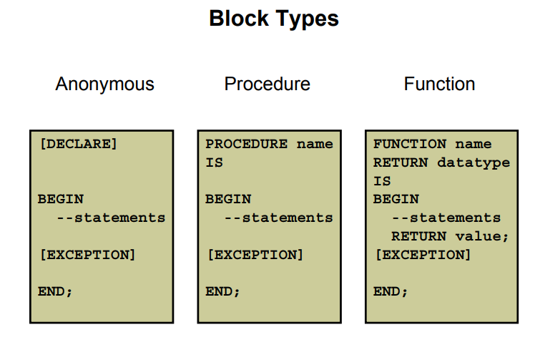

**Block Types**

A PL/SQL program comprises one or more blocks. These blocks can be entirely separate or nested within another block. There are three types of blocks that make up a PL/SQL program.

They are:

* Anonymous blocks
* Procedures
* Functions

**Anonymous blocks**: Anonymous blocks are unnamed blocks. They are declared inline at the point in an application where they are to be executed and are compiled each time the application is executed. These blocks are not stored in the database. They are passed to the PL/SQL engine for execution at run time. Triggers in Oracle Developer components consist of such blocks.

These anonymous blocks get executed at run time because they are inline. If you want to execute the same block again, you have to rewrite the block. You are unable to invoke or call the block that you wrote earlier because blocks are anonymous and do not exist after they are executed.

**Subprograms**: Subprograms are complementary to anonymous blocks. They are named

PL/SQL blocks that are stored in the database. Because they are named and stored, you can invoke them whenever you want (depending on your application). You can declare them either as procedures or as functions. You typically use a procedure to perform an action and a function to compute and return a value.

You can store subprograms at the server or application level. Using Oracle Developer components (Forms, Reports), you can declare procedures and functions as part of the application (a form or report) and call them from other procedures, functions, and triggers within the same application whenever necessary.

Note: A function is similar to a procedure, except that a function must return a value.

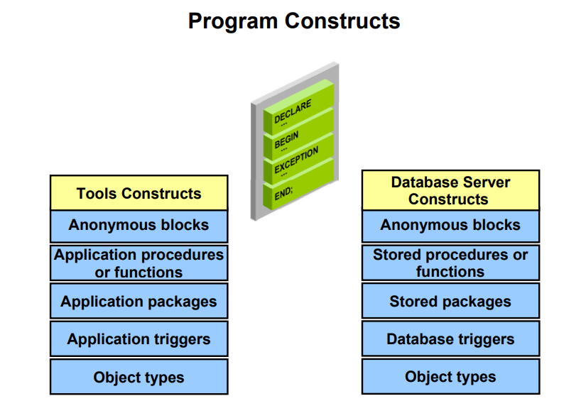

**Program Constructs**

The following table outlines a variety of PL/SQL program constructs that use the basic PL/SQL block. The program constructs are available based on the environment in which they are executed.

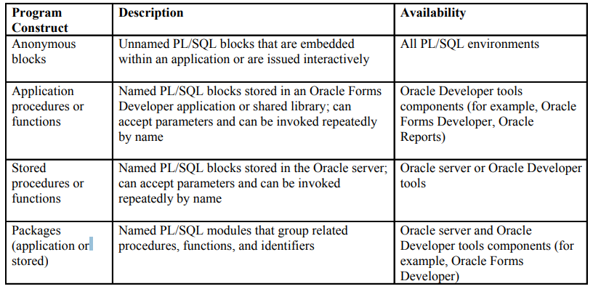

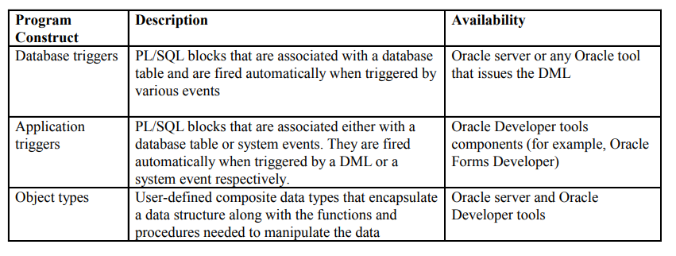

**Create an Anonymous Block**

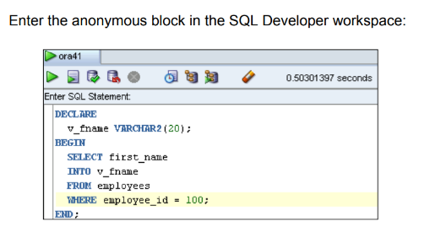

DECLARE

V_fname VARCHAR2(20);

BEGIN

SELECT first_name

INTO v_fname

FROM Employees

WHERE employee_id = 100;

END;

/

**Test the Output of a PL/SQL Block**

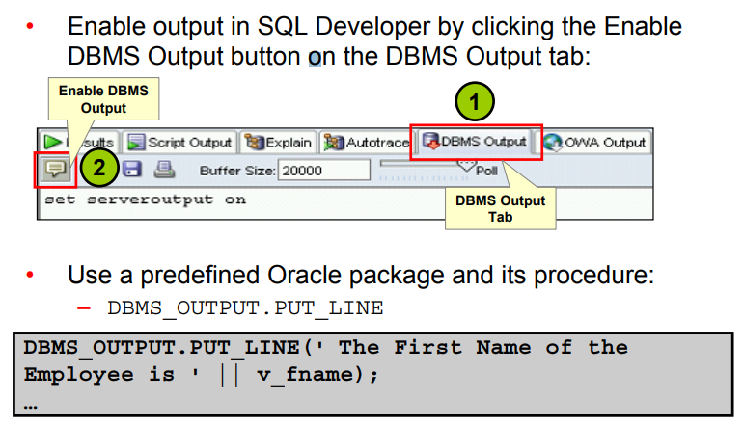

PL/SQL does not have built-in input or output functionality. Therefore, you need to use predefined Oracle packages for input and output. To generate output, you must:

• Enable output in SQL Developer by clicking the Enable Output button on the DBMS Output tab. This will, in turn, execute the SET SERVEROUTPUT ON command, which is displayed in the window. To enable output in SQL*Plus, you must explicitly issue the SET

SERVEROUTPUT ON command.

SET SERVEROUTPUT ON;

• Use the PUT_LINE procedure of the DBMS_OUTPUT package to display the output. Pass the value that has to be printed as argument to this procedure (as shown in the slide). The procedure then outputs the argument.

DBMS_OUTPUT.PUT_LINE(' ‘|| V_NaME );

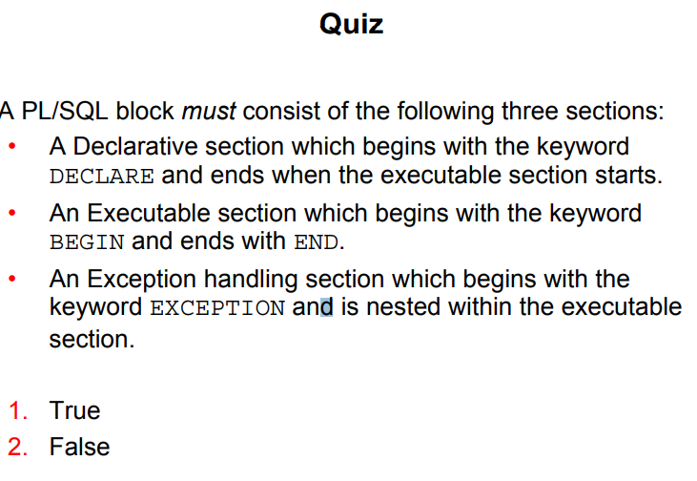

FALSE

A PL/SQL block consists of three sections:

• Declarative (optional): The optional declarative section begins with the keyword

DECLARE and ends when the executable section starts.

• Executable (required): The required executable section begins with the keyword BEGIN and ends with END. This section essentially needs to have at least one statement. Observe that END is terminated with a semicolon. The executable section of a PL/SQL block can, in turn, include any number of PL/SQL blocks.

• Exception handling (optional): The optional exception section is nested within the executable section. This section begins with the keyword EXCEPTION.

1. Which of the following PL/SQL blocks execute successfully?

a. BEGIN

END;

>>>> Error must have something in between

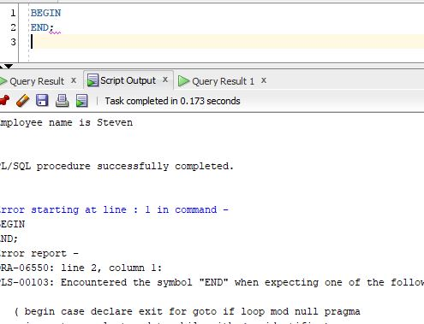

b. DECLARE

amount INTEGER(10);

END;

>>> Error – the “amount” declaration belongs to “DECLARE” section

c. DECLARE

BEGIN

END;

>>> Error - ORA-06550: line 3, column 1:

PLS-00103: Encountered the symbol "END" when expecting one of the following:

d. DECLARE

amount INTEGER(10);

BEGIN

DBMS_OUTPUT.PUT_LINE(amount);

END;

/

Sali >> >> d – still no output printed because there is no SET SERVEROUTPUT ON; statement

SET SERVEROUTPUT ON;

DECLARE

amount INTEGER(10);

BEGIN

DBMS_OUTPUT.PUT_LINE(amount);

END;/

>>> still no output because variable is not initialized to any number

2. Create and execute a simple anonymous block that outputs “Hello World.” Execute and

save this script as lab_01_02_soln.sql.

Sali >>>

SET SERVEROUTPUT ON;

DECLARE

BEGIN

DBMS_OUTPUT.PUT_LINE('Hello Sali :* :) :*' );

END;

/

Output: Hello Sali :* :) :*

BEGIN

DBMS_OUTPUT.PUT_LINE('Hello Sali :* :) :*' );

/

>>>>> GIVES ERROR – its looking for the END;

BEGIN

DBMS_OUTPUT.PUT_LINE('Hello Sali :* :) :*' );

END;

Output: Hello Sali :* :) :*

**Variables**

With PL/SQL, you can declare variables and then use them in SQL and procedural statements.

Variables are mainly used for storage of data and manipulation of stored values. Consider the PL/SQL statement shown in the slide. The statement retrieves the first_name and department_id from the table. If you have to manipulate the first_name or the department_id, then you have to store the retrieved value. Variables are used to temporarily

store the value. You can use the value stored in these variables for processing and manipulating the data. Variables can store any PL/SQL object, such as variables, types, cursors, and subprograms.

**Reusability** is another advantage of declaring variables. After the variables are declared, you can use them repeatedly in an application by referring to them multiple times in various statements.

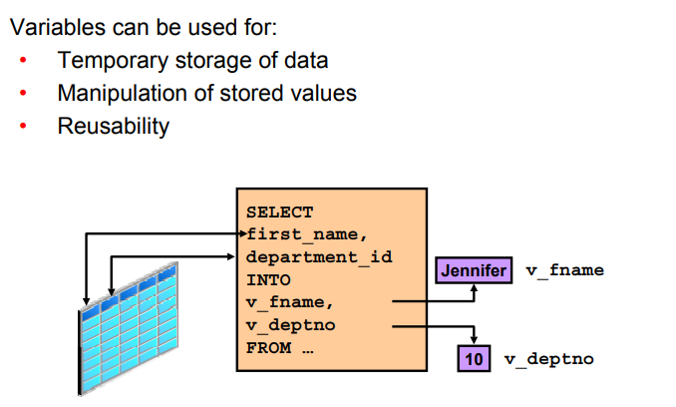

A variable name:

• Must start with a letter

• Can include letters or numbers - no number in the beginning

• Can include special characters (such as $, _, and # ) - no special characters in the beginning

• Must contain no more than 30 characters

• Must not include reserved words

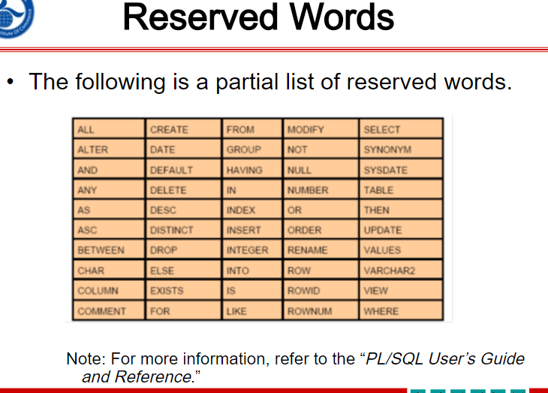

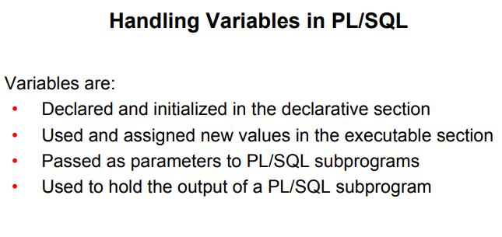

**Handling Variables in PL/SQL**

You can use variables in the following ways.

• Declare and initialize them in the declaration section: You can declare variables in the declarative part of any PL/SQL block, subprogram, or package. Declarations allocate storage space for a value, specify its data type, and name the storage location so that you can reference it. Declarations can also assign an initial value and impose the NOT NULL constraint on the variable. Forward references are not allowed. You must declare a variable before referencing it in other statements, including other declarative statements.

• Use them and assign new values to them in the executable section: In the executable section, the existing value of the variable can be replaced with the new value.

• Pass them as parameters to PL/SQL subprograms: Subprograms can take parameters.

You can pass variables as parameters to subprograms.

• Use them to hold the output of a PL/SQL subprogram: Variables can be used to hold the value that is returned by a function.

Declaring and Initializing PL/SQL Variables

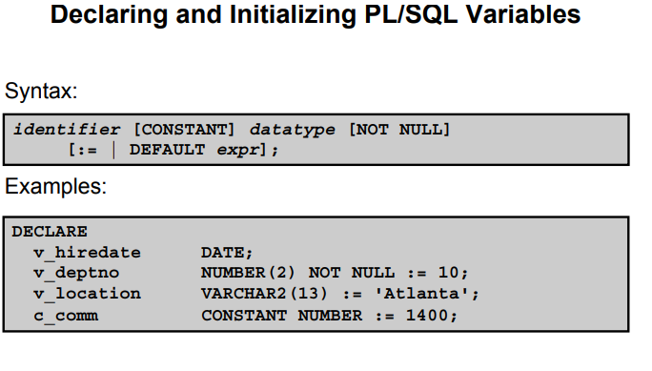

You must declare all PL/SQL identifiers in the declaration section before referencing them in the PL/SQL block. You have the option of assigning an initial value to a variable (as shown in the slide). You do not need to assign a value to a variable in order to declare it. If you refer to other variables in a declaration, be sure that they are already declared separately in a previous statement.

In the syntax:

**identifier** Is the name of the variable

**CONSTANT**  Constrains the variable so that its value cannot change Constants must be initialized.)

**data type**  Is a scalar, composite, reference, or LOB data type (This course covers only scalar, composite, and LOB data types.)

**NOT NULL** Constrains the variable so that it must contain a value (NOT NULL variables must be initialized.)

**expr** Is any PL/SQL expression that can be a literal expression, another variable, or an expression involving operators and functions

Note: In addition to variables, you can also declare cursors and exceptions in the declarative section. You learn about declaring cursors in the lesson titled “Using Explicit Cursors” and about exceptions in the lesson titled “Handling Exceptions.”

**Declaring and Initializing PL/SQL Variables**

DECLARE

v_myName VARCHAR2(20);

BEGIN

DBMS_OUTPUT.PUT_LINE('My name is: '|| v_myName);

v_myName := 'John';

DBMS_OUTPUT.PUT_LINE('My name is: '|| v_myName);

END;

/

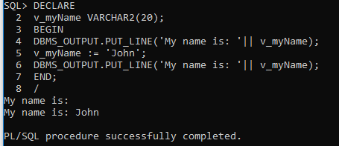

Sali >> v_myName did not have value in the first print but after initiation it has “john” inside it

DECLARE

v_myName VARCHAR2(20):= 'John';

BEGIN

v_myName := 'Steven';

DBMS_OUTPUT.PUT_LINE('My name is: '|| v_myName);

END;

/

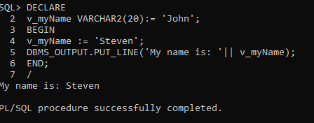

Sali >> v_myName had “John” inside it which got override by “Steven” inside BEGIN block

DECLARE

v_event VARCHAR2(15);

BEGIN

v_event := q'!Father's day!';

DBMS_OUTPUT.PUT_LINE('3rd Sunday in June is : '|| v_event );

v_event := q'[Mother's day]';

DBMS_OUTPUT.PUT_LINE('2nd Sunday in May is : '|| v_event );

END;

/

Sali >> 3rd Sunday in June is :

Father’s day!

2nd Sunday in May is :

Mother’s day

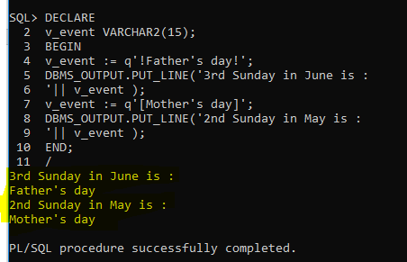

Types of Variables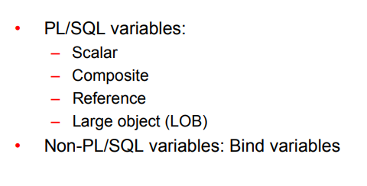

Every PL/SQL variables has a data type, which specifies a storage format, constraints, and a valid range of values. PL/SQL supports five data type categories—scalar, composite, reference, large object (LOB), and object—that you can use to declare variables, constants, and pointers.

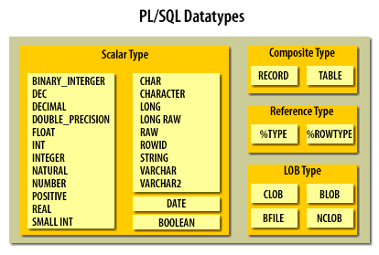

• **Scalar data types**: Scalar data types hold a single value. The value depends on the data type of the variable. For example, the v_myName variable in the example in the section “Declaring and Initializing PL/SQL Variables” (in this lesson) is of type VARCHAR2.

Therefore, v_myName can hold a string value. PL/SQL also supports Boolean variables.

These data types don’t include any internal components. It includes data types such as NUMBER, DATE, BOOLEAN, etc.

• **Composite data types**: Composite data types contain internal elements that are either scalar or composite. RECORD, collections and TABLE are examples of composite data types.

• **Reference data types**: Reference data types hold values, called pointers that point to a storage location.

• **LOB data types**: Large Objects data types hold values, called locators that specify the location of large objects (such as graphic images) that are stored outside the table.

This type of data type stores objects that are relatively large in size and stored separately from other data types such as text, graphic images, video clips, sound, etc.

Now, I have listed down some of the sub data types frequently used in PL/SQL

1. **Numeric**: Numeric values on which arithmetic operations are performed. It includes sub types such as number, decimal, real, float, etc.

2. **Character**: Character values on which character operations such as strings are performed. It includes sub types such as char, varchar, varchar2, nvarchar2, etc.

3. **Data and Time**: This data type is used to store fixed data type which displays and saves time and date values. The default data format saved into the database might be ‘DD-MM-YY’. However, you can change and alter the position of the terms accordingly.

4. **Boolean**: These include logical values on which logical operations are performed. The logical values are the Boolean values TRUE and FALSE and the value NULL. But, SQL has no data type equivalent to BOOLEAN. It cannot be used in SQL Statements, built in SQL functions such as To_char, PL/SQL function invoked from DQL commands.

5. **Number**: Syntax: Number(Precision, Scale). Fixed-point or floating-point number with absolute value in range 1E-130 to (but not including) 1.0E126. A NUMBER variable can also represent 0.

6. **Float**: ANSI and IBM specific floating-point type with maximum precision of 126 binary digits (approximately 38 decimal digits).

7. **Integer**: ANSI and IBM specific integer type with maximum precision of 38 decimal digits

8. **Real**: Floating-point type with maximum precision of 63 binary digits (approximately 18 decimal digits).

9. **Varchar2**: Variable-length character string with maximum size of 32,767 bytes.

10. **Rowid**: Physical row identifier, the address of a row in an ordinary table.

11. **Bfile**: Used to store large binary objects in operating system files outside the database System-dependent. Cannot exceed 4GB.

12. **Blob**: Used to store large binary objects in the database. Memory Capacity: 8 to 128 TB.

13. **Clob**: Used to store large blocks of character data in the database. Memory Capacity: 8 to 128 TB.

14. **Nclob**: Used to store large blocks of NCHAR data in the database. Memory Capacity: 8 to 128 TB.

Note: A variable in PL/SQL program code can be assigned a NULL value i.e., ‘’. However, it cannot be equated with any other variable or even itself.

Non-PL/SQL variables include host language variables declared in precompiler programs, screen fields in Forms applications, and host variables. You learn about host variables later in this lesson.

For more information about LOBs, see the PL/SQL User’s Guide and Reference.

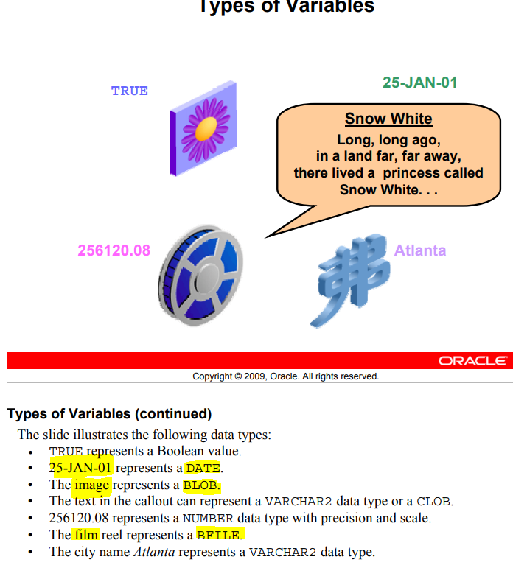

MUST Initialize variables designated as **NOT NULL** and **CONSTANT**.

• Initialize variables with the assignment operator (:=) or the

DEFAULT keyword:

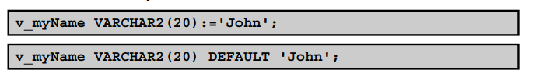

• Declare one identifier per line for better readability and code maintenance.

sal CONSTANT NUMBER := 50000.00;

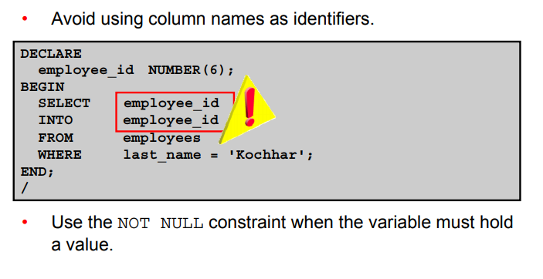

**Guidelines for Declaring PL/SQL Variables**

• Initialize the variable to an expression with the assignment operator (:=) or with the DEFAULT reserved word. If you do not assign an initial value, the new variable contains NULL by default until you assign a value. To assign or reassign a value to a variable, you write a PL/SQL assignment statement. It is good programming practice to initialize all

variables.

• Two objects can have the same name only if they are defined in different blocks(Scoping). Where they coexist, you can qualify them with labels (namespacing) and use them.

• Avoid using column names as identifiers. If PL/SQL variables occur in SQL statements and have the same name as a column, the Oracle server assumes that it is the column that is being referenced. Although the code example in the slide works, code that is written using the same name for a database table and a variable is not easy to read or maintain.

• Impose the NOT NULL constraint when the variable must contain a value. You cannot assign nulls to a variable defined as NOT NULL. The NOT NULL constraint must be followed by an initialization clause.

pincode VARCHAR2(15) NOT NULL := 'Oxford';

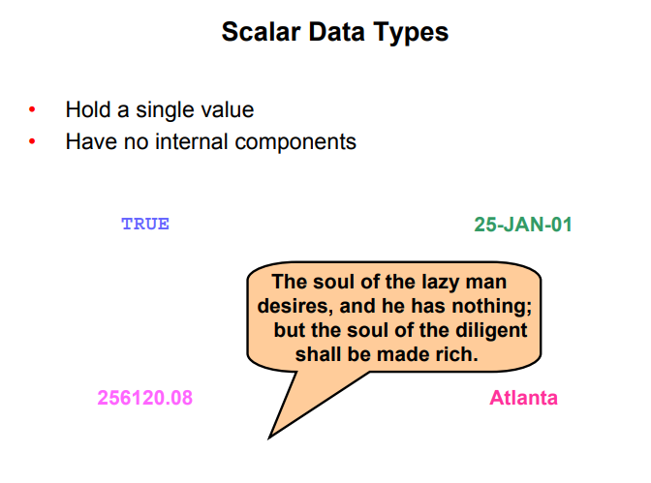

**Scalar Data Types**

PL/SQL provides a variety of predefined data types. For instance, you can choose from integer, floating point, character, Boolean, date, collection, and LOB types.

This lesson covers the basic types that are used frequently in PL/SQL programs.

A **scalar data** type holds a single value and has no internal components. Scalar data types can be classified into four categories: **number**, **character**, **date**, and **Boolean**. Character and number data types have subtypes that associate a base type to a constraint. For example, NTEGER and POSITIVE are subtypes of the NUMBER base type.

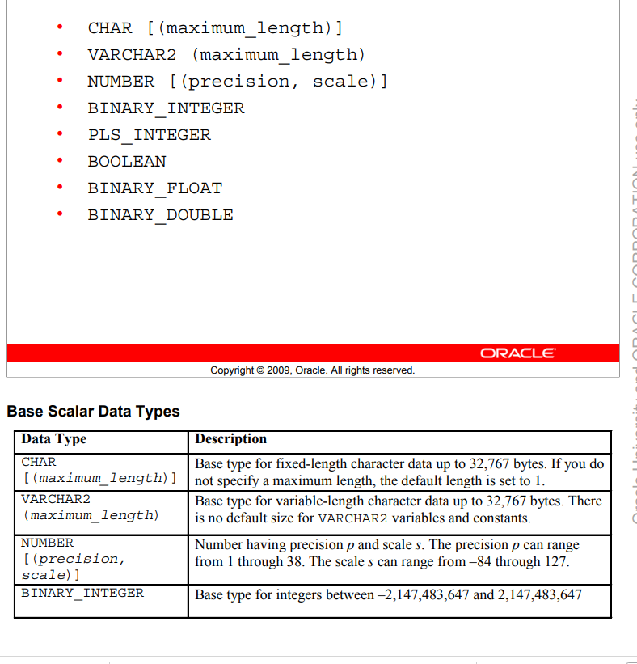

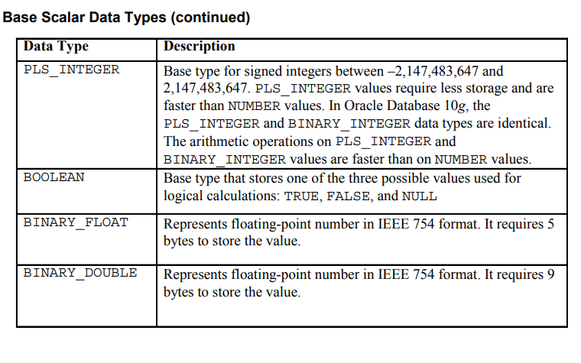

Base Scalar Data Types

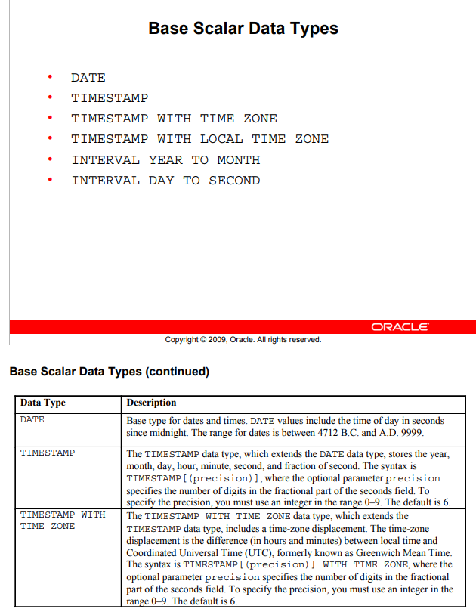

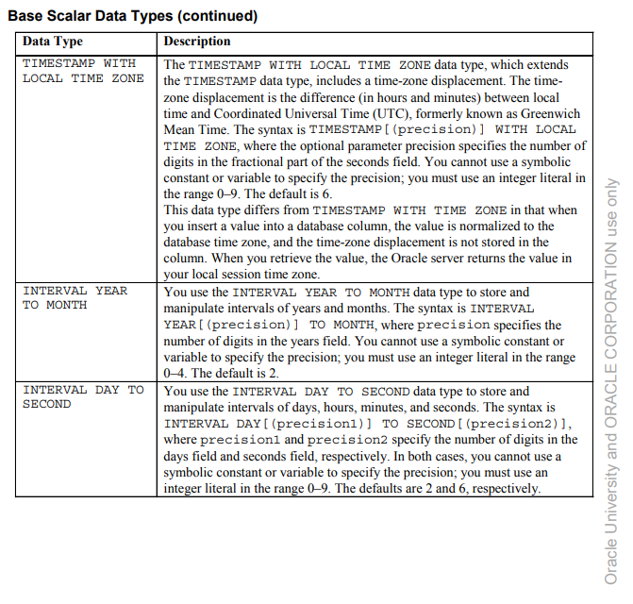

Declaring Scalar Variables

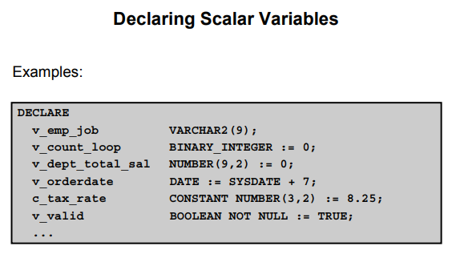

The examples of variable declaration shown in the slide are defined as follows.

• **v_emp_job**: Variable to store an employee job title

• **v_count_loop**: Variable to count the iterations of a loop; initialized to 0

• **v_dept_total_sal**: Variableto accumulatethe total salary for a department; initialized to 0

• **v_orderdate**: Variable to store the ship date of an order; initialized to one week from today

• **c_tax_rate**: Constant variable for the tax rate (which never changes throughout the PL/SQL block); set to 8.25

• **v_valid**: Flag to indicate whether a piece of data is valid or invalid; initialized to TRUE

**Anchor Data Type (%TYPE)**

The %TYPE attribute lets you declare a constant, variable, field, or parameter to be of the same data type a previously declared variable, field, record, nested table, or database column.

Variable_name Typed_attribute%Type;

DECLARE

v_job_id NUMBER(10);

BEGIN

SELECT job_id

INTO v_job_id

FROM Jobs

WHERE Job_title = 'President';

DBMS_OUTPUT.PUT_LINE(v_job_id);

END;

/

Output: Error because v_job_id is not NUMBER(10 ) type but VARCHAR2 even though usually table id is supposed to be NUMBER

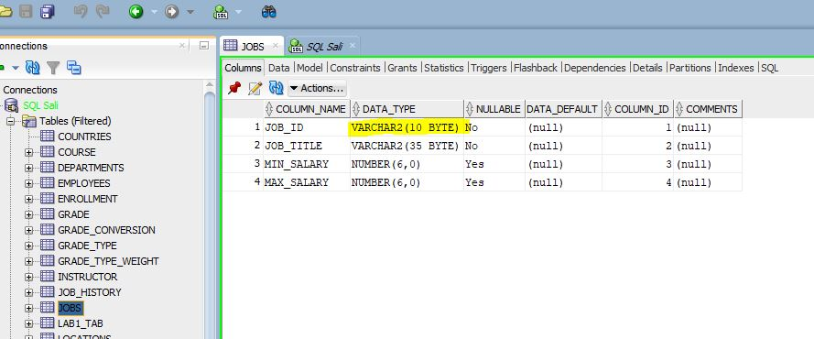

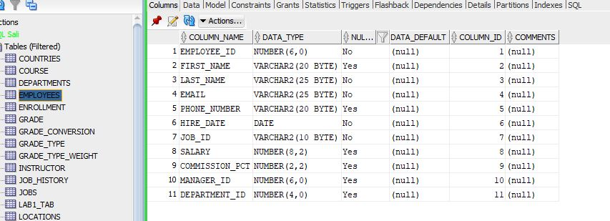

DECLARE

v_job_id Jobs.Job_id%Type;

BEGIN

SELECT job_id

INTO v_job_id

FROM Jobs

WHERE Job_title = 'President';

DBMS_OUTPUT.PUT_LINE(v_job_id);

END;

/

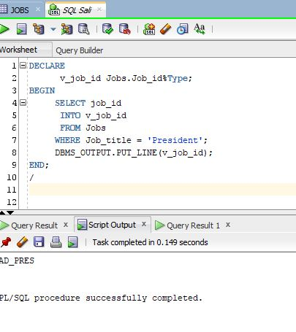

**Constants in PLSQL:**

Constants must be initialized at their declaration. They only get declared in declaration section of the plsql commands.

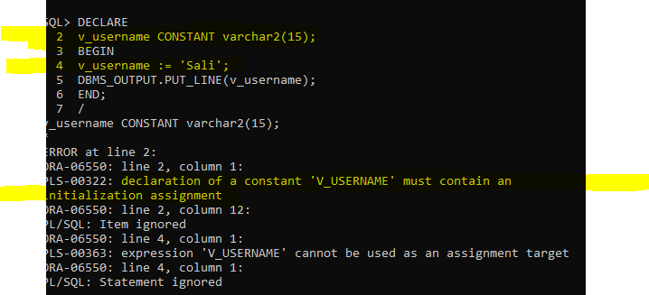

Error : constant must be initialized at creation

DECLARE

C_username CONSTANT varchar2(15) := 'Sali';

BEGIN

DBMS_OUTPUT.PUT_LINE(c_username);

END;

/

Output : Sali

**DEFAULT** and **NOT NULL** keywords:

DECLARE

c_pi CONSTANT NUMBER(7, 6) := 3.141592 NOT NULL DEFAULT;

BEGIN

DBMS_OUTPUT.PUT_LINE(c_pi);

END;/

Output: Error – wrong keyword orders

DECLARE

c_pi CONSTANT NUMBER(7, 6) NOT NULL DEFAULT 3.141592;

BEGIN

DBMS_OUTPUT.PUT_LINE(c_pi);

END;/

Output: 3.141592

**Bind Variables = Host Variables**

Unlike user variables which can be only declared in declaration section of the sql block, bind variables can be defined before declaration section and are being referenced inside the sql block by using ‘ :ariable_name ‘

VARIABLE v_bind1 VARCHAR2(40);

EXECUTE :V_bind1 := ‘Sali Safi’; // EX

VARIABLE v_bind1 VARCHAR2(40);

EXEC :v_bind1 := 'Sali Safi";

BEGIN

DBMS_OUTPUT.PUT_LINE(:v_bind1);

:V_BIND1 := 'Ava Abtahi is here';

DBMS_OUTPUT.PUT_LINE(:v_bind1);

END;

/

Output: Ava Abtahi is here

Does not print Sali safi at all

VARIABLE v_bind1 VARCHAR2(40);

EXEC :v_bind1 := 'Sali Safi";

BEGIN

DBMS_OUTPUT.PUT_LINE(:v_bind1);

DBMS_OUTPUT.PUT_LINE(:v_bind1);

END;

/

Ouput: nothing still does not print Sali Safi

Using ‘ PRINT ‘ or/or ‘ SET AUTOPRINT ON; ‘ instead of ‘ DBMS_OUTPUT….’ Can also print the content of bind variable.

PRINT :v_bind1;

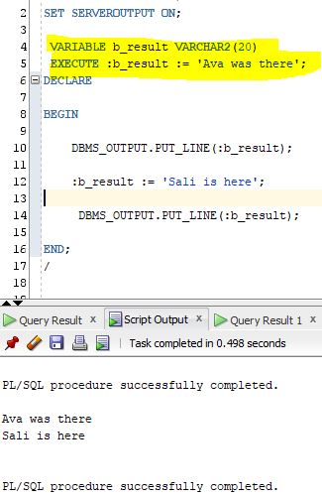

Bind variables are declared before PL/SQL code block and to assign value to them we can use EXECUTE command.

Not using EXECUTE keyword cause an error for assignment.

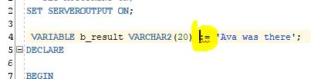

Using SET AUTOPRINT ON;

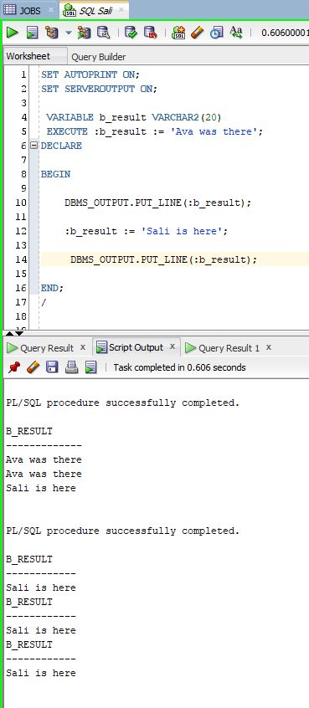

Using only PRINT

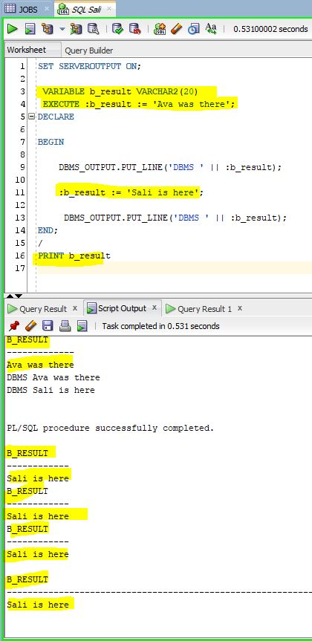

**Writing Control Structures**

**Control Statements**

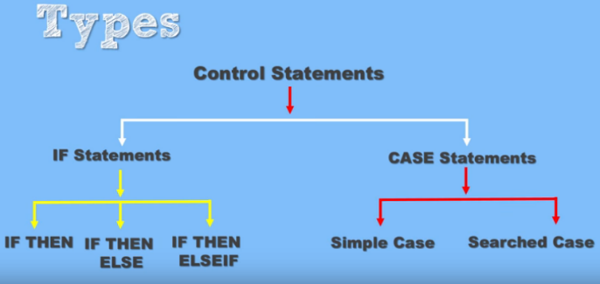

IF – ELSIF - ELSE

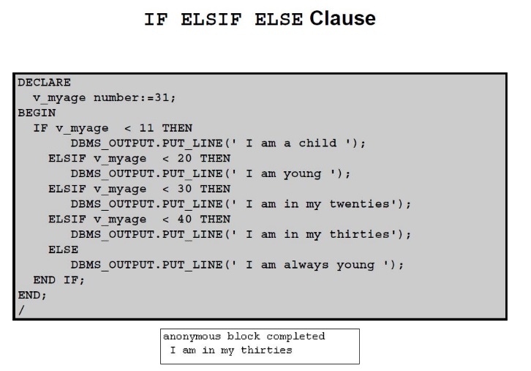

**Guidelines**

• You can perform actions selectively based on conditions that are being met.

• When writing code, remember the spelling of the keywords:

– ELSIF is one word. – NOT ELSE IF but ELSIF

– END IF is two words.

If the controlling Boolean condition is TRUE, the associated sequence of statements is

executed; if the controlling Boolean condition is FALSE or NULL, the associated sequence of statements is passed over. Any number of ELSIF clauses are permitted.

-- Conditional statements which change the flow of the program execution depending on the conditions

-- Only one of the conditions can be true

-- IF condition1 THEN statement1;

-- ELSIF condition2 THEN statement2;

-- ELSIF condition3 THEN statement3;

-- ....

-- ELSE statementN;

-- END IF;

----------------------

SET SERVEROUTPUT ON;

ACCEPT currrenttime PROMPT 'What time is it - use 24 hours format???'

DECLARE

v_currrenttime NUMBER(2) := &currrenttime;

BEGIN

IF v_currrenttime > 0 AND v_currrenttime < 12 THEN

DBMS_OUTPUT.PUT_LINE('Pleanty of time it is just ' || v_currrenttime || ' AM. It is a Beautiful day!!!');

ELSIF v_currrenttime > 12 AND v_currrenttime < 24 THEN

DBMS_OUTPUT.PUT_LINE('Really is it ' || v_currrenttime || ' PM. It was a Beautiful day!!!');

ELSE

DBMS_OUTPUT.PUT_LINE('Try to use 1 to 24 hours number format');

END IF;

END;

/

Entered : 7

Output: Pleanty of time it is just 7 AM. It is a Beautiful day!!!

Entered : 20

Output: Really is it 20 PM. It was a Beautiful day!!!

Entered : 54

Output: Try to use 1 to 24 hours number format

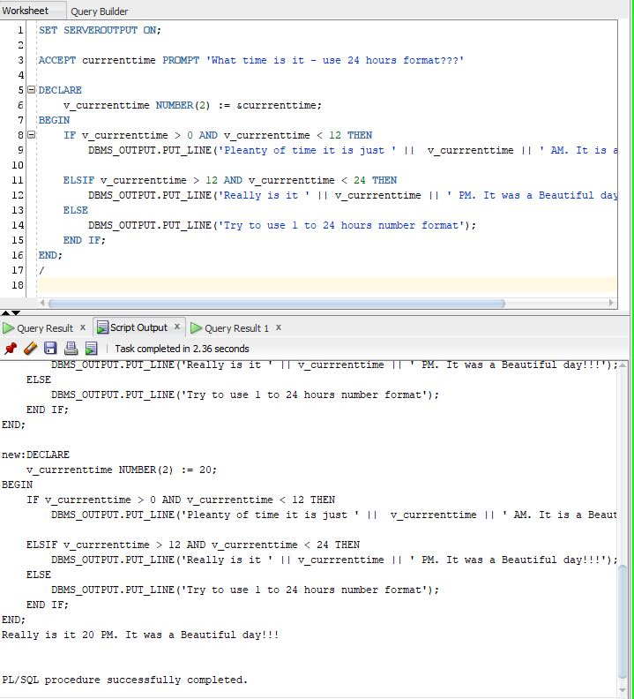

**CASE Expressions**

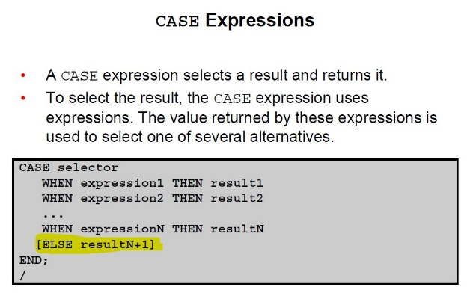

**CASE Expressions Example**

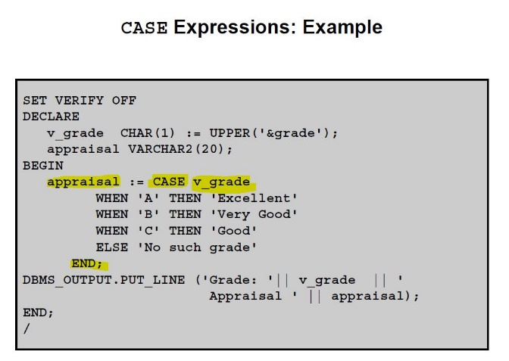

-- Case statements are very similar to IF-ELSIF-ELSE expressions

-- Case statements are 1. Simple case 2. Searched case

-- Syntax :

-- CASE search_expression

-- WHEN input_expression1 THEN result1

-- WHEN input_expression2 THEN result2

-- WHEN input_expression3 THEN result3

-- ELSE elst_result

SET SERVEROUTPUT ON;

ACCEPT currrenttime PROMPT 'What time is it - use 24 hours format???'

DECLARE

v_currrenttime NUMBER(2) := &currrenttime;

BEGIN

CASE

WHEN v_currrenttime > 0 AND v_currrenttime < 12 THEN

DBMS_OUTPUT.PUT_LINE('Pleanty of time it is just ' || v_currrenttime || ' AM. It is a Beautiful day!!!');

WHEN v_currrenttime > 12 AND v_currrenttime < 24 THEN

DBMS_OUTPUT.PUT_LINE('Really is it ' || v_currrenttime || ' PM. It was a Beautiful day!!!');

ELSE

DBMS_OUTPUT.PUT_LINE('Try to use 1 to 24 hours number format');

END CASE;

END;

/

Entered : 7

Output: Pleanty of time it is just 7 AM. It is a Beautiful day!!!

Entered : 20

Output: Really is it 20 PM. It was a Beautiful day!!!

Entered : 54

Output: Try to use 1 to 24 hours number format

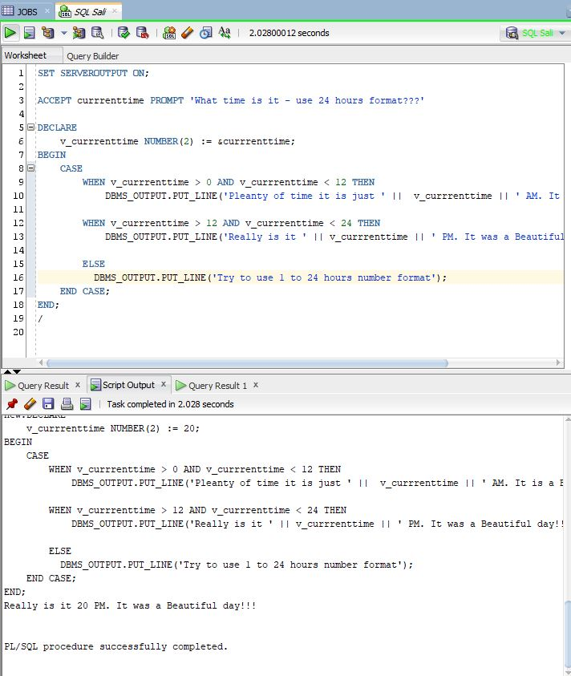

**How a CASE Expression Differs from a CASE Statement**

A CASE expression evaluates the condition and returns a value, whereas a CASE statement

evaluates the condition and performs an action. A CASE statement can be a complete PL/SQL

block.

• CASE statements end with END CASE;

• CASE expressions end with END;

**Handling Nulls**

When working with nulls, you can avoid some common

mistakes by keeping in mind the following rules:

• Simple comparisons involving nulls always yield NULL.

• Applying the logical operator NOT to a null yields NULL.

• If the condition yields NULL in conditional control statements, its associated sequence of statements is not

executed.

**Handling Nulls**

x := 5;

y := NULL;

...

IF x != y THEN -- yields NULL, not TRUE

-- **sequence_of_statements that are not executed**

END IF;

You may expect the sequence of statements to execute because x and y seem unequal. But nulls

are indeterminate. Whether or not x is equal to y is unknown. Therefore, the IF condition yields

NULL and the sequence of statements is bypassed.

a := NULL;

b := NULL;

...

IF a = b THEN -- yields NULL, not TRUE

-- **sequence_of_statements that are not executed**

END IF;

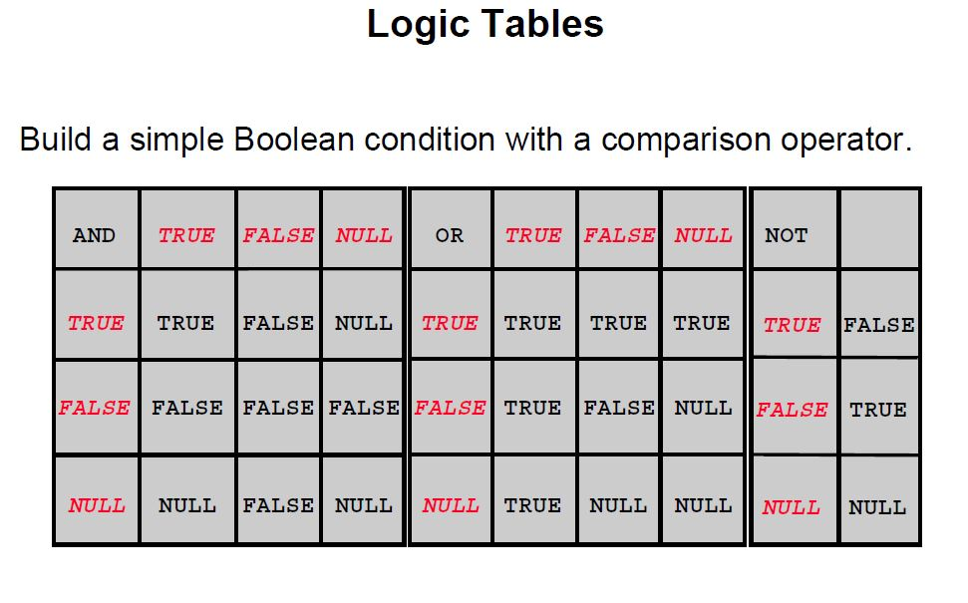

**Logic Tables**

You can build a simple Boolean condition by combining number, character, and date

expressions with comparison operators.

You can build a complex Boolean condition by combining simple Boolean conditions with the

logical operators AND, OR, and NOT. The logical operators are used to check the Boolean

variable values and return TRUE, FALSE, or NULL. In the logic tables shown in the slide:

• FALSE takes precedence in an AND condition, and TRUE takes precedence in an OR

condition

• AND returns TRUE only if both of its operands are TRUE

• OR returns FALSE only if both of its operands are FALSE

• NULL AND TRUE always evaluates to NULL because it is not known whether the second

operand evaluates to TRUE

**Note:** The negation of NULL (NOT NULL) results in a null value because null values are

indeterminate.

**Boolean Conditions**

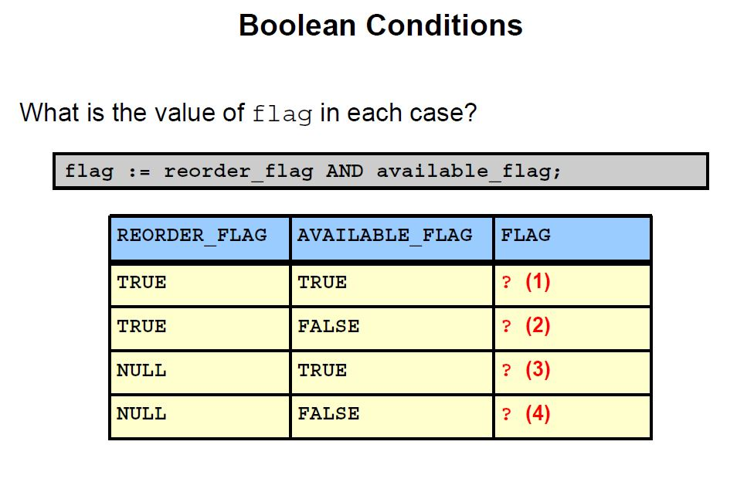

**Answers**

1. TRUE

2. FALSE

3. NULL

4. FALSE

**Iterative Control: LOOP Statements**

Loops repeat a statement (or sequence of statements)

multiple times.

• There are three loop types:

– Basic loop

– FOR loop

– WHILE loop

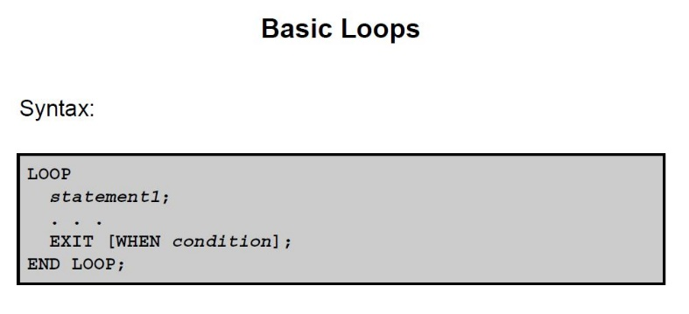

DECLARE

v_countryid locations.country_id%TYPE := 'CA';

v_loc_id locations.location_id%TYPE;

v_counter NUMBER(2) := 1;

v_new_city locations.city%TYPE := 'Montreal';

BEGIN

SELECT MAX(location_id)

INTO v_loc_id

FROM locations

WHERE country_id = v_countryid;

LOOP

INSERT INTO locations(location_id, city, country_id)

VALUES((v_loc_id + v_counter), v_new_city, v_countryid);

DBMS_OUTPUT.PUT_LINE(v_loc_id || ' at ' || v_new_city || ' is added');

v_counter := v_counter + 1;

EXIT WHEN v_counter > 3;

END LOOP;

END;

/

1906 at Montreal is added

1906 at Montreal is added

1906 at Montreal is added

----------------------------------------

SET SERVEROUTPUT ON;

ACCEPT num PROMPT 'Enter a number less than 20 to create time table from 1 till this number '

DECLARE

v_num NUMBER(2) := &num;

v_counter NUMBER(2) := 1;

v_result NUMBER(4) := 0;

BEGIN

LOOP

v_result := (v_num * v_counter) + v_result;

DBMS_OUTPUT.PUT_LINE('The result of ' || v_num || ' * ' || v_counter || ' = ' || v_result);

v_counter := v_counter + 1;

-- DBMS_OUTPUT.PUT_LINE(v_result);

IF v_counter > 20 THEN -- Need to write our own EXIT condition

EXIT;

END IF;

END LOOP;

END;

/

Entered : 9

Output:

The result of 9 * 1 = 9

The result of 9 * 2 = 27

The result of 9 * 3 = 54

The result of 9 * 4 = 90

The result of 9 * 5 = 135

The result of 9 * 6 = 189

The result of 9 * 7 = 252

The result of 9 * 8 = 324

The result of 9 * 9 = 405

The result of 9 * 10 = 495

The result of 9 * 11 = 594

The result of 9 * 12 = 702

The result of 9 * 13 = 819

The result of 9 * 14 = 945

The result of 9 * 15 = 1080

The result of 9 * 16 = 1224

The result of 9 * 17 = 1377

The result of 9 * 18 = 1539

The result of 9 * 19 = 1710

The result of 9 * 20 = 1890

**WHILE Loops**

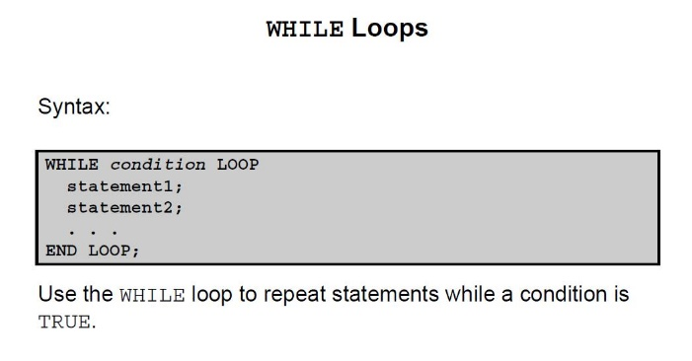

In the syntax:

*condition* Is a Boolean variable or expression (TRUE, FALSE, or NULL)

*statement* Can be one or more PL/SQL or SQL statements

If the variables involved in the conditions do not change during the body of the loop, the

condition remains TRUE and the loop does not terminate.

**Note:** If the condition yields NULL, the loop is bypassed and control passes to the next

statement.

SET SERVEROUTPUT ON;

DECLARE

v_countryid locations.country_id%TYPE := 'CA';

v_loc_id locations.location_id%TYPE;

v_new_city locations.city%TYPE := 'Montreal';

v_counter NUMBER := 1;

BEGIN

SELECT MAX(location_id)

INTO v_loc_id

FROM locations

WHERE country_id = v_countryid;

WHILE v_counter <= 3 LOOP

INSERT INTO locations(location_id, city, country_id)

VALUES((v_loc_id + v_counter), v_new_city, v_countryid);

DBMS_OUTPUT.PUT_LINE(v_loc_id || ' at ' || v_new_city || ' is added');

v_counter := v_counter + 1;

END LOOP;

END;

/

1915 at Montreal is added

1915 at Montreal is added

1915 at Montreal is added

------------------------------

SET SERVEROUTPUT ON;

ACCEPT num PROMPT 'Enter a number less than 20 to create time table from 1 till this number '

DECLARE

v_num NUMBER(2) := &num;

v_counter NUMBER(2) := 1;

v_result NUMBER(4) := 0;

BEGIN

WHILE v_counter < 20 LOOP

v_result := (v_num * v_counter) + v_result;

DBMS_OUTPUT.PUT_LINE('The result of ' || v_num || ' * ' || v_counter || ' = ' || v_result);

v_counter := v_counter + 1;

END LOOP;

DBMS_OUTPUT.PUT_LINE('The final result is ' || v_result);

END;

/

Entered : 9

Output:

The result of 9 * 1 = 9

The result of 9 * 2 = 27

The result of 9 * 3 = 54

The result of 9 * 4 = 90

The result of 9 * 5 = 135

The result of 9 * 6 = 189

The result of 9 * 7 = 252

The result of 9 * 8 = 324

The result of 9 * 9 = 405

The result of 9 * 10 = 495

The result of 9 * 11 = 594

The result of 9 * 12 = 702

The result of 9 * 13 = 819

The result of 9 * 14 = 945

The result of 9 * 15 = 1080

The result of 9 * 16 = 1224

The result of 9 * 17 = 1377

The result of 9 * 18 = 1539

The result of 9 * 19 = 1710

The final result is 1710

**FOR Loops**

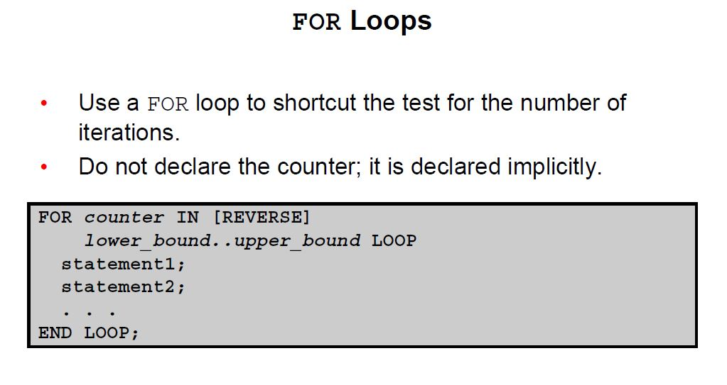

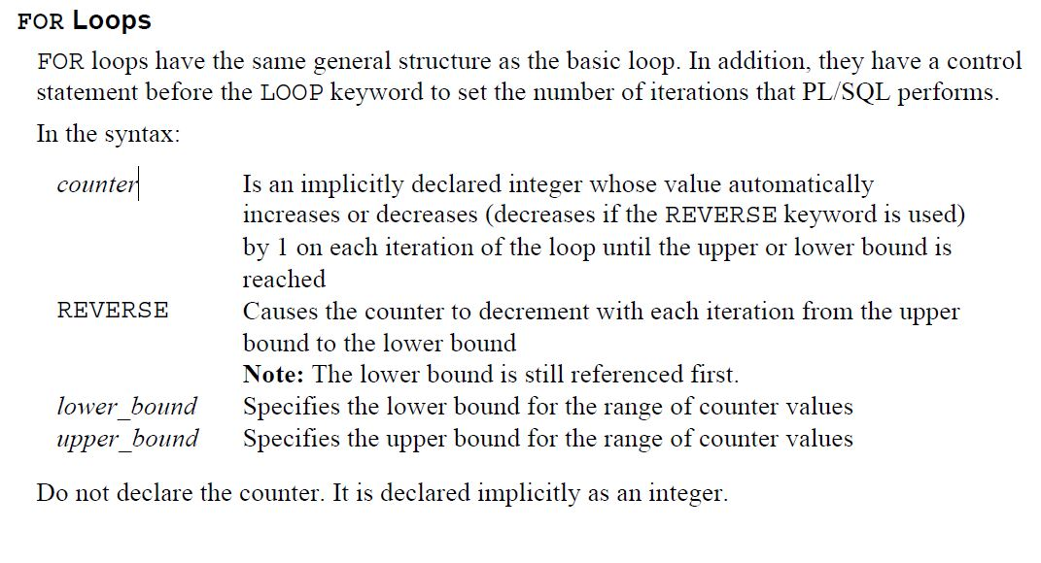

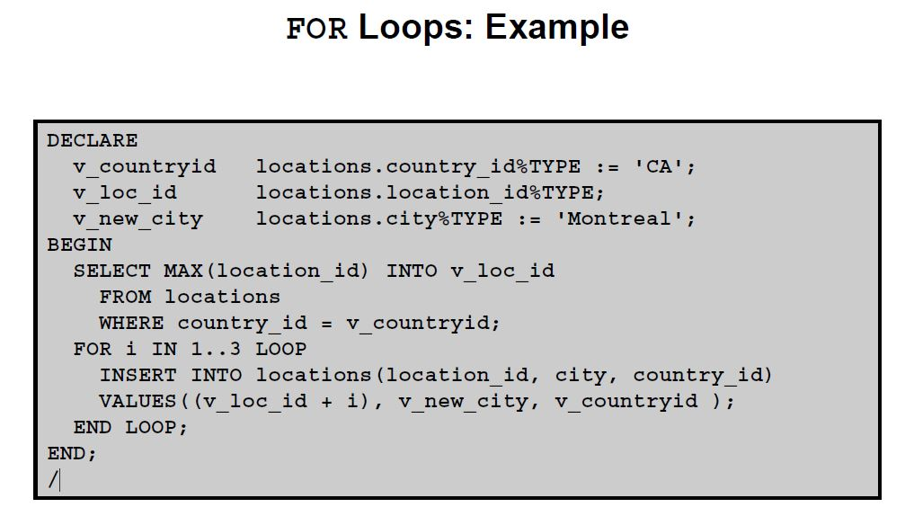

SET SERVEROUTPUT ON;

DECLARE

v_countryid locations.country_id%TYPE := 'CA';

v_loc_id locations.location_id%TYPE;

v_new_city locations.city%TYPE := 'Montreal';

BEGIN

SELECT MAX(location_id)

INTO v_loc_id

FROM locations

WHERE country_id = v_countryid;

FOR i IN 1..3 LOOP

INSERT INTO locations(location_id, city, country_id)

VALUES((v_loc_id + i), v_new_city, v_countryid );

DBMS_OUTPUT.PUT_LINE('The city is ' || v_new_city || ' with the location id ' || v_loc_id || ' and country ' || v_countryid);

END LOOP;

END;

/

The city is Montreal with the location id 1930 and country CA

The city is Montreal with the location id 1930 and country CA

The city is Montreal with the location id 1930 and country CA

SET SERVEROUTPUT ON;

ACCEPT num PROMPT 'Enter a number less than 20 to create time table from 1 till this number '

DECLARE

v_num NUMBER(2) := &num;

v_counter NUMBER(2) := 1;

v_result NUMBER(4) := 0;

BEGIN

FOR v_ind IN 0 .. 20 LOOP

v_result := (v_num * v_counter) + v_result;

DBMS_OUTPUT.PUT_LINE('The result of ' || v_num || ' * ' || v_counter || ' = ' || v_result);

END LOOP;

DBMS_OUTPUT.PUT_LINE('The final result is ' || v_result);

END;

/

Entered: 9

Output:

The result of 9 * 0 = 0

The result of 9 * 1 = 9

The result of 9 * 2 = 27

The result of 9 * 3 = 54

The result of 9 * 4 = 90

The result of 9 * 5 = 135

The result of 9 * 6 = 189

The result of 9 * 7 = 252

The result of 9 * 8 = 324

The result of 9 * 9 = 405

The result of 9 * 10 = 495

The result of 9 * 11 = 594

The result of 9 * 12 = 702

The result of 9 * 13 = 819

The result of 9 * 14 = 945

The result of 9 * 15 = 1080

The result of 9 * 16 = 1224

The result of 9 * 17 = 1377

The result of 9 * 18 = 1539

The result of 9 * 19 = 1710

The result of 9 * 20 = 1890

The final result is 1890

-----------------------------------------------------

-------- ****** REVERSE keyword

SET SERVEROUTPUT ON;

DECLARE

BEGIN

FOR i IN REVERSE 0 .. 10 LOOP

DBMS_OUTPUT.PUT_LINE('In a REVERSE for-loop, index is ' || i);

END LOOP;

END;

/

Output :

In a REVERSE for-loop, index is 10

In a REVERSE for-loop, index is 9

In a REVERSE for-loop, index is 8

In a REVERSE for-loop, index is 7

In a REVERSE for-loop, index is 6

In a REVERSE for-loop, index is 5

In a REVERSE for-loop, index is 4

In a REVERSE for-loop, index is 3

In a REVERSE for-loop, index is 2

In a REVERSE for-loop, index is 1

In a REVERSE for-loop, index is 0

**Guidelines for Loops**

• Use the basic loop when the statements inside the loop must execute at least once.

• Use the WHILE loop if the condition must be evaluated at the start of each iteration.

• Use a FOR loop if the number of iterations is known.

**Nested Loops and Labels**

• You can nest loops to multiple levels.

• Use labels to distinguish between blocks and loops.

• Exit the outer loop with the EXIT statement that references

the label.

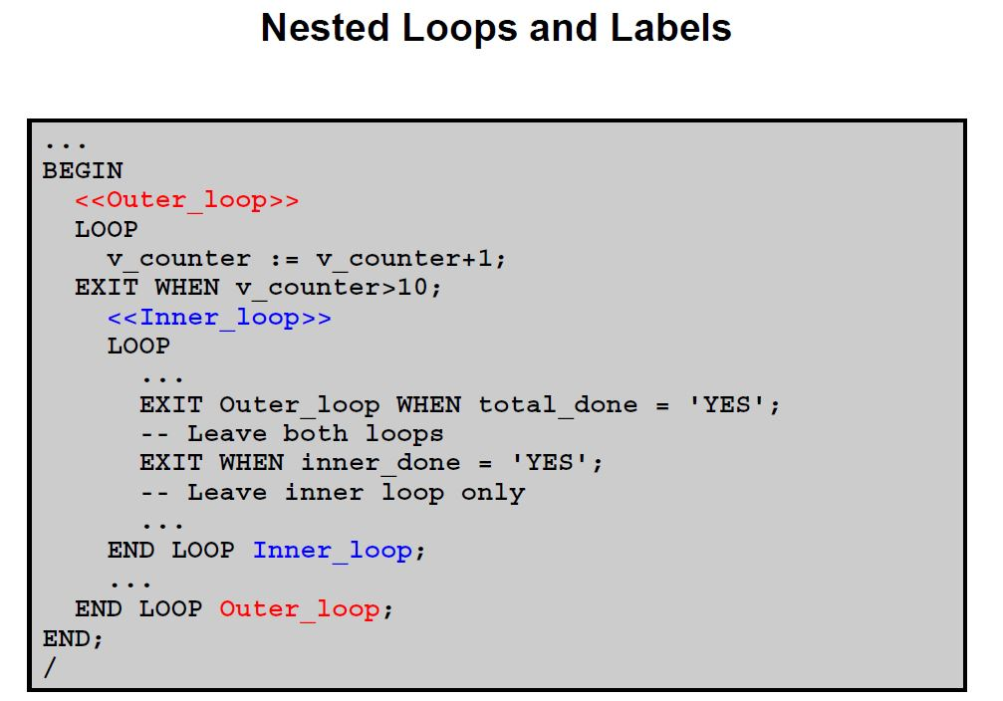

**Nested Loops and Labels**

In the example in the slide, there are two loops. The outer loop is identified by the label

<<Outer_Loop>> and the inner loop is identified by the label <<Inner_Loop>>.

The identifiers are placed before the word LOOP within label delimiters (<<*label*>>). The inner

loop is nested within the outer loop. The label names are included after the END LOOP

statements for clarity.

**Composite Data Types**

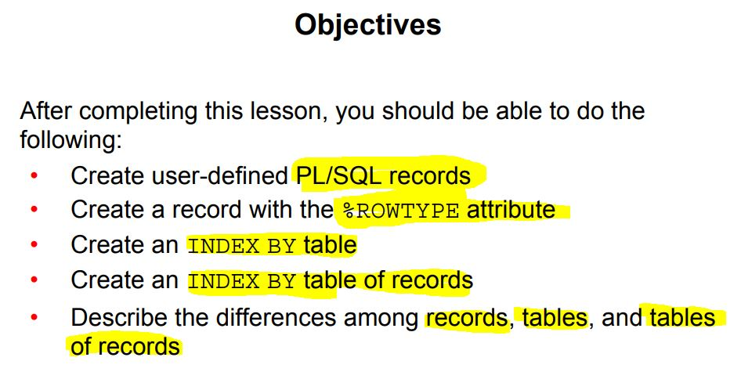

Composite Data Types

• Can hold multiple values (unlike scalar types)

• Are of two types:

– PL/SQL records

– PL/SQL collections

* + INDEX BY tables or associative arrays
  + Nested table
  + VARRAY

You have learned that variables of scalar data type can hold only one value, whereas a variable of composite data type can hold multiple values of scalar data type or composite data type.

There are two types of composite data types:

• PL/SQL records: Records are used to treat related but dissimilar data as a logical unit. A PL/SQL record can have variables of different types. For example, you can define a record to hold employee details. This involves storing an employee number as NUMBER, a first name and a last name as VARCHAR2, and so on. By creating a record to store employee details, you create a logical collective unit. This makes data access and manipulation easier.

• PL/SQL collections: Collections are used to treat data as a single unit. Collections are of three types:

- INDEX BY tables or associative arrays

- Nested table

- VARRAY

Why Use Composite Data Types?

You have all the related data as a single unit. You can easily access and modify the data. Data is easier to manage, relate, and transport if it is composite.

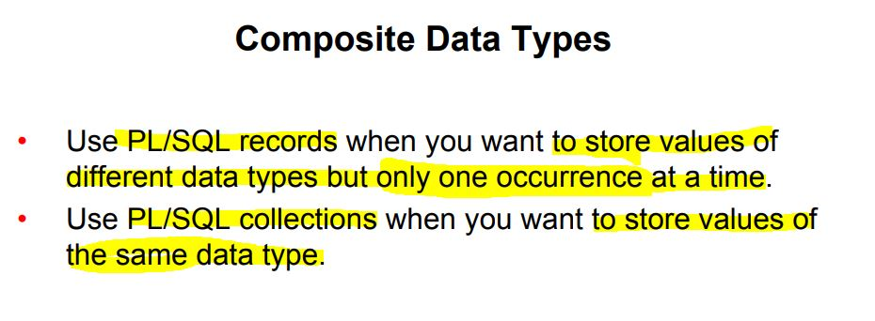

Use PL/SQL records when you want to store values of different data types that are logically related. If you create a record to hold employee details, indicate that all the values stored are related because they provide information about a particular employee.

Use PL/SQL collections when you want to store values of the same data type. Note that this data type can also be of the composite type (such as records). You can define a collection to hold the first names of all employees. You may have stored n names in the collection; however, name 1 is not related to name 2. The relation between these names is only that they are employee names.

These collections are like arrays in programming languages such as C, C++, and Java.

**PL/SQL Records**

• Must contain one or more components (called fields) of any scalar, **RECORD**, or **INDEX BY table** data type. Each record defined can have as many fields as necessary.

• Are like structures in most third-generation languages (including C and C++)

• Are user defined and can be a subset of a row in a table

• Treat a collection of fields as a logical unit

• Are convenient for fetching a row of data from a table for

processing

Records can be assigned initial values and can be defined as NOT NULL.

• Fields without initial values are initialized to NULL.

• The DEFAULT keyword can also be used when defining fields.

• You can define RECORD types and declare user-defined records in the declarative part of any block, subprogram, or package.

• You can declare and reference nested records. One record can be the component of another record.

**%ROWTYPE Attribute**

• Declare a variable according to a collection of columns in a database table or view.

• Prefix %ROWTYPE with the database table or view.

• Fields in the record take their names and data types from the columns of the table or view.

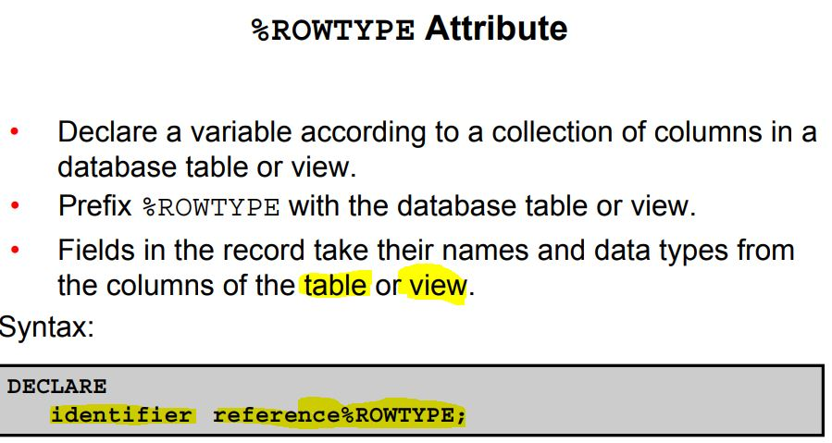

You have learned that %TYPE is used to declare a variable of a column type. The variable has the same data type and size as the table column. The benefit of %TYPE is that you do not have to change the variable if the column is altered. Also, if the variable is used in any calculations, you need not worry about its precision.

The %ROWTYPE attribute is used to declare a record that can hold an entire row of a table or view. The fields in the record take their names and data types from the columns of the table or view. The record can also store an entire row of data fetched from a cursor or cursor variable.

The slide shows the syntax for declaring a record. In the syntax:

In the following example, a record is declared using %ROWTYPE as a data type specifier:

DECLARE

emp_record employees%ROWTYPE;

The emp_record record has a structure consisting of the following fields, each representing a column in the employees table.

Note: This is not code but simply the structure of the composite variable.

(employee_id NUMBER(6),

first_name VARCHAR2(20),

last_name VARCHAR2(20),

email VARCHAR2(20),

phone_number VARCHAR2(20),

hire_date DATE,

salary NUMBER(8,2),

commission_pct NUMBER(2,2),

manager_id NUMBER(6),

department_id NUMBER(4))

To reference an individual field, use dot notation:

record_name.field_name

For example, you reference the commission_pct field in the emp_record record as follows:

emp_record.commission_pct

You can then assign a value to the record field:

emp_record.commission_pct:= .35;

**Assigning Values to Records**

You can assign a list of common values to a record by using the SELECT or FETCH statement. Make sure that the column names appear in the same order as the fields in your record. You can also assign one record to another if both have the same corresponding data types. A record of type employees%ROWTYPE and a user-defined record type having

analogous fields of the employees table will have the same data type. Therefore, if a userdefined record contains fields similar to the fields of a %ROWTYPE record, you can assign that user-defined record to the %ROWTYPE record.

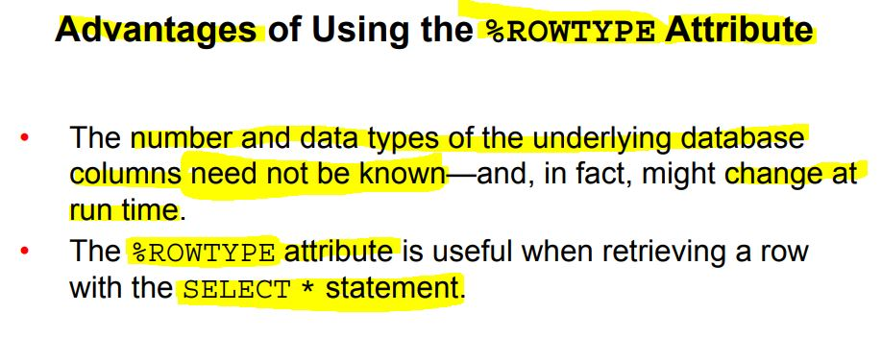

The %ROWTYPE attribute is particularly useful when you want to retrieve an entire row from a table. In the absence of this attribute, you would be forced to declare a variable for each of the columns retrieved by the SELECT statement.

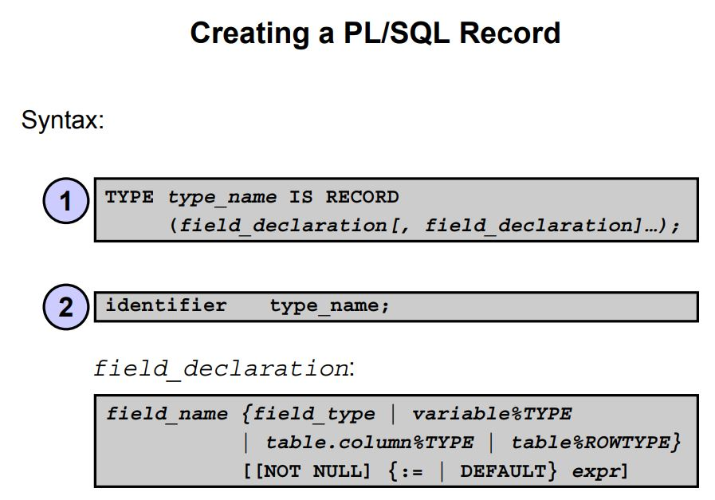

**Creating a PL/SQL Record**

PL/SQL records are user-defined composite types. To use them:

1. Define the record in the declarative section of a PL/SQL block. The syntax for defining the record is shown in the slide.

2. Declare (and optionally initialize) the internal components of this record type. In the syntax:

type_name Is the name of the RECORD type (This identifier is used to declare records.)

field_name Is the name of a field within the record

field_type Is the data type of the field (It represents any PL/SQL data type except REF CURSOR. You can use the %TYPE and %ROWTYPE attributes.)

expr Is the field_type or an initial value

The NOT NULL constraint prevents assigning nulls to those fields. Be sure to initialize the NOT NULL fields.

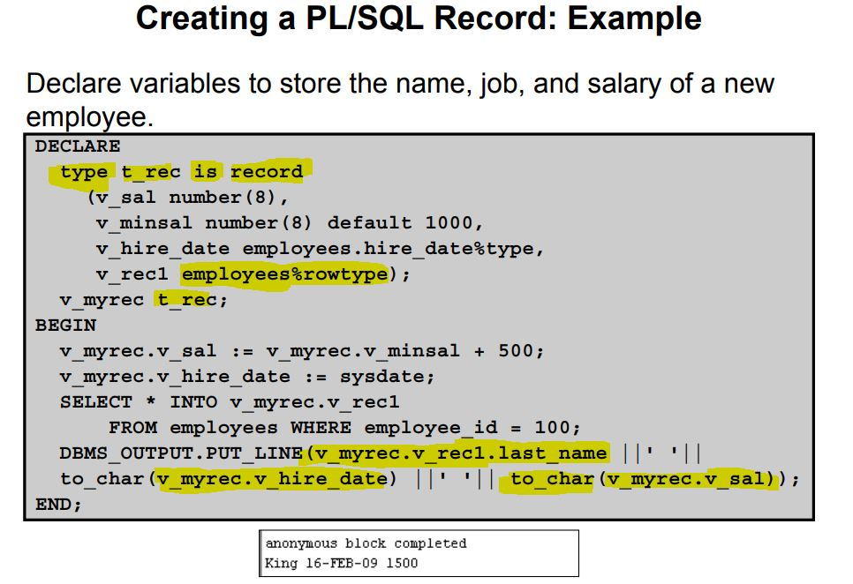

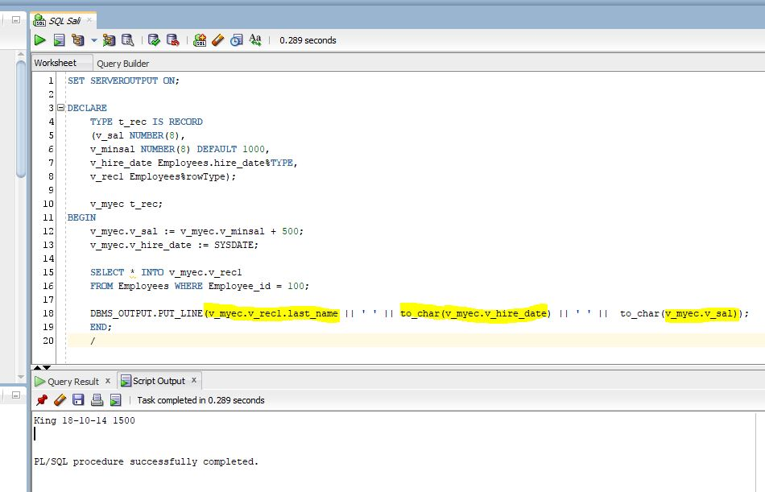

**Creating a PL/SQL Record**

Field declarations used in defining a record are like variable eclarations. Each field has a unique name and a specific data type. There are no predefined data types for PL/SQL records, as there are for scalar variables. Therefore, you must create the record type first and then declare an identifier using that type.

In the example in the slide, a record type (t_rec) is defined. In the next step, a record (v_myrec) of the t_rec type is declared.

Note: You can add the NOT NULL constraint to any field declaration to prevent assigning nulls to that field. Remember that the fields declared as NOT NULL must be initialized.

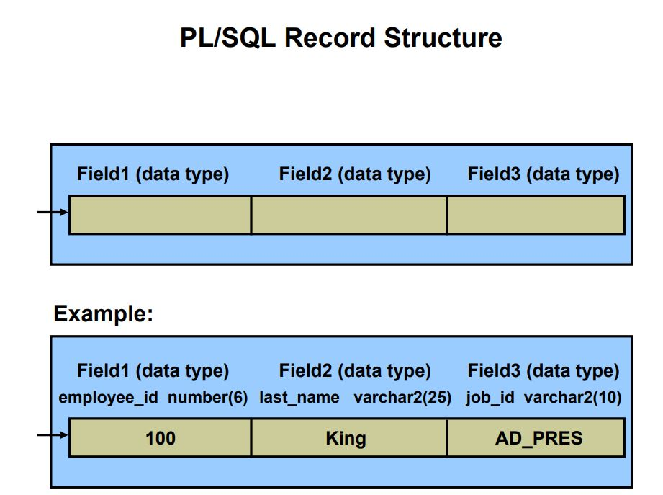

**PL/SQL Record Structure**

Fields in a record are accessed with the name of the record. To reference or initialize an individual field, use dot notation:

record_name.field_name

For example, you reference the job_id field in the emp_record record as follows:

emp_record.job_id

You can then assign a value to the record field:

emp_record.job_id := 'ST_CLERK';

In a block or subprogram, user-defined records are instantiated when you enter the block or subprogram. They cease to exist when you exit the block or subprogram.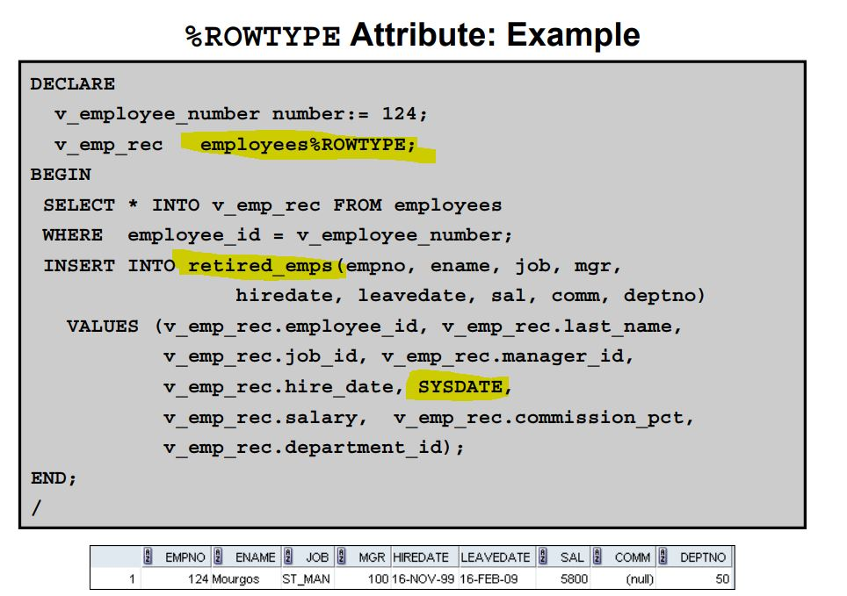

DECLARE

v_employee_number number:= 124;

v_emp_rec employees%ROWTYPE;

BEGIN

SELECT * INTO v_emp_rec FROM employees

WHERE employee_id = v_employee_number;

INSERT INTO retired_emps(empno, ename, job, mgr,

hiredate, leavedate, sal, comm, deptno)

VALUES (v_emp_rec.employee_id, v_emp_rec.last_name,

v_emp_rec.job_id, v_emp_rec.manager_id,

v_emp_rec.hire_date, SYSDATE,

v_emp_rec.salary, v_emp_rec.commission_pct,

v_emp_rec.department_id);

END;

/

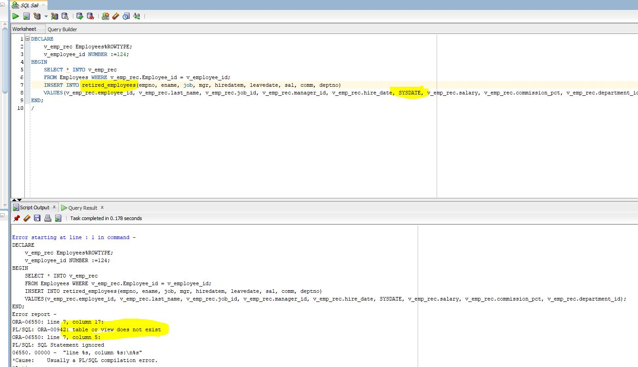

**Inserting a Record by Using %ROWTYPE**

Inserting a Record by Using %ROWTYPE Compare the INSERT statement in the previous slide with the INSERT statement in this slide.

The emp_rec record is of type retired_emps. The number of fields in the record must be equal to the number of field names in the INTO clause. You can use this record to insert values into a table. This makes the code more readable.

Examine the SELECT statement in the slide. You select hire_date twice and insert the hire_date value in the leavedate field of retired_emps. No employee retires on the hire date. The inserted record is shown in the slide.

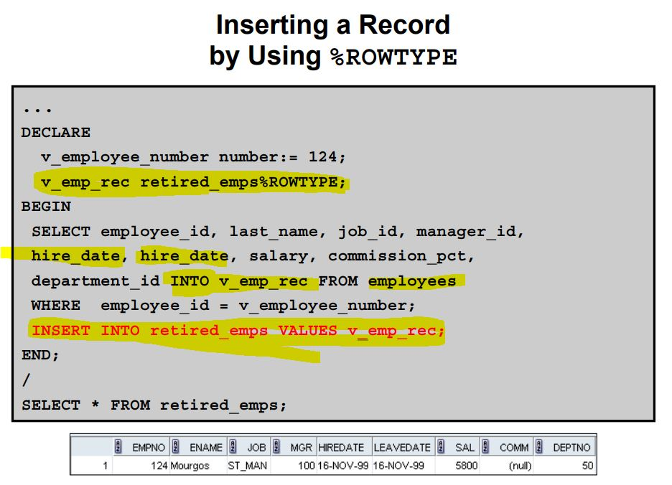

DECLARE

v_employee_number number:= 124;

v_emp_rec retired_emps%ROWTYPE;

BEGIN

SELECT employee_id, last_name, job_id, manager_id,

hire_date, hire_date, salary, commission_pct,

department_id INTO v_emp_rec FROM employees

WHERE employee_id = v_employee_number;

INSERT INTO retired_emps VALUES v_emp_rec;

END;

/

SELECT * FROM retired_emps;

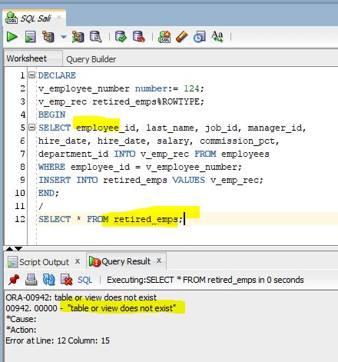

I created “Retired” table

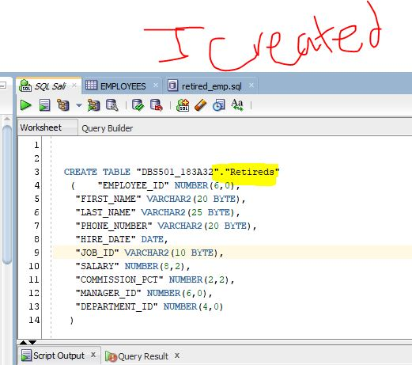

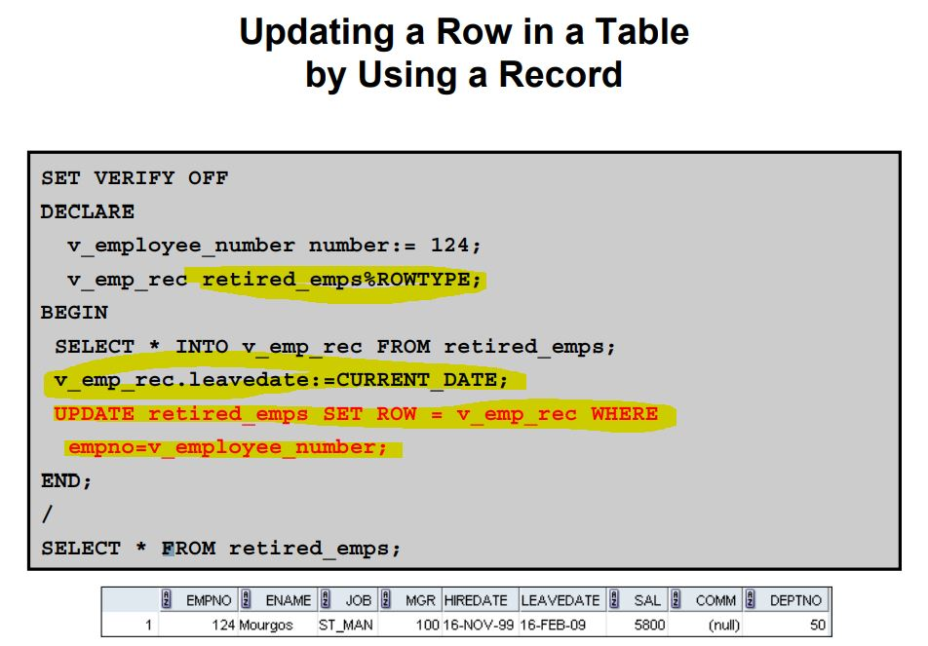

SET VERIFY OFF

DECLARE

v_employee_number number:= 124;

v_emp_rec retired_emps%ROWTYPE;

BEGIN

SELECT * INTO v_emp_rec FROM retired_emps;

v_emp_rec.leavedate:=CURRENT_DATE;

UPDATE retired_emps SET ROW = v_emp_rec WHERE

empno=v_employee_number;

END;

/

SELECT * FROM retired_emps;

Updating a Row in a Table by Using a Record

You have learned to insert a row by using a record. This slide shows you how to update a row by using a record. The ROW keyword is used to represent the entire row. The code shown in the slide updates the leavedate of the employee.

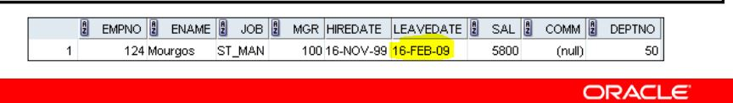

**INDEX BY Tables or Associative Arrays**

INDEX BY tables are composite types (collections) and are user defined. INDEX BY tables can store data using a primary key value as the index, where the key values are not necessarily sequential. INDEX BY tables are sets of key-value pairs.

INDEX BY tables have only two columns:

• A column of integer or string type that acts as the primary key. The key can be numeric, either BINARY_INTEGER or PLS_INTEGER. The BINARY_INTEGER and PLS_INTEGER keys require less storage than NUMBER. They are used to represent mathematical integers in a compact form and to implement arithmetic operations by using

machine arithmetic. Arithmetic operations on these data types are faster than NUMBER arithmetic. The key can also be of type VARCHAR2 or one of its subtypes. The examples in

this course use the PLS_INTEGER data type for the key column.

• A column of scalar or record data type to hold values. If the column is of scalar type, it can hold only one value. If the column is of record type, it can hold multiple values.

The INDEX BY tables are unconstrained in size. However, the key in the PLS_INTEGER column is restricted to the maximum value that a PLS_INTEGER can hold. Note that the keys can be both positive and negative. The keys in INDEX BY tables are not necessarily in sequence.

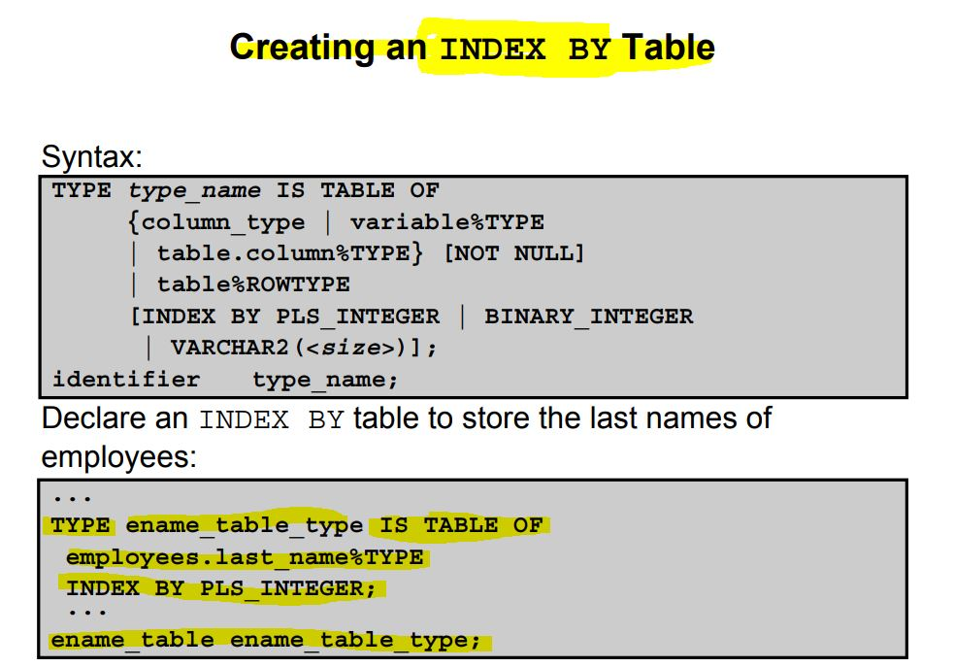

**Creating an INDEX BY Table**

There are two steps involved in creating an INDEX BY table.

1. Declare a TABLE data type.

2. Declare a variable of that data type.

In the syntax:

type_name Is the name of the TABLE type (It is a type specifier used in subsequent declarations of the PL/SQL table identifiers.)

column_type Is any scalar or composite data type such as VARCHAR2, DATE, NUMBER, or %TYPE (You can use the %TYPE attribute to provide the column data type.)

identifier Is the name of the identifier that represents an entire PL/SQL table

The NOT NULL constraint prevents nulls from being assigned to the PL/SQL table of that type.

Do not initialize the INDEX BY table.

INDEX BY tables can have the element of any scalar type.

INDEX BY tables are not automatically populated when you create them. You must programmatically populate the INDEX BY tables in your PL/SQL programs and then use them

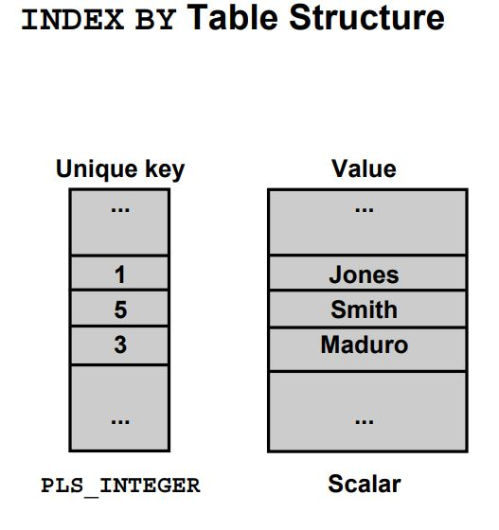

**INDEX BY Table Structure**

Like the size of a database table, the size of an INDEX BY table is unconstrained. That is, the number of rows in an INDEX BY table can increase dynamically so that your INDEX BY table grows as new rows are added.

INDEX BY tables can have one column and a unique identifier to that column, neither of which can be named. The column can belong to any scalar or record data type. The primary key is either a number or a string. You cannot initialize an INDEX BY table in its declaration. An

INDEX BY table is not populated at the time of declaration. It contains no keys or values.

An explicit executable statement is required to populate the INDEX BY table.

**Creating an INDEX BY Table**

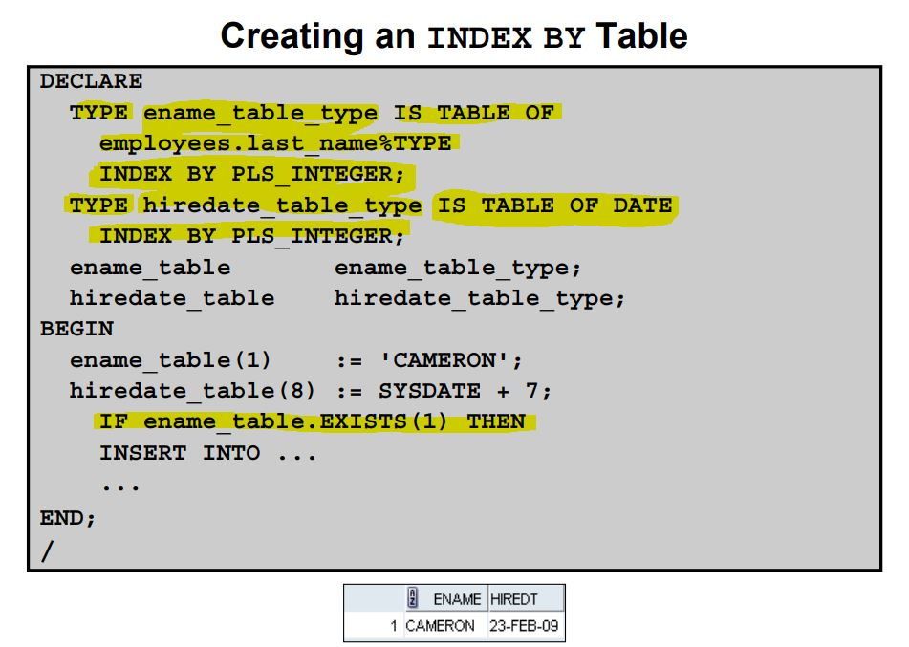

DECLARE

TYPE ename_table_type IS TABLE OF

employees.last_name%TYPE

INDEX BY PLS_INTEGER;

TYPE hiredate_table_type IS TABLE OF DATE

INDEX BY PLS_INTEGER;

ename_table ename_table_type;

hiredate_table hiredate_table_type;

BEGIN

ename_table(1) := 'CAMERON';

hiredate_table(8) := SYSDATE + 7;

IF ename_table.EXISTS(1) THEN

INSERT INTO ...

...

END;

/

The example in the slide creates two INDEX BY tables.

Use the key of the INDEX BY table to access an element in the table.

INDEX_BY_table_name(index)

Here, index belongs to type PLS_INTEGER.

The following example shows how to reference the third row in an INDEX BY table called

ename_table:

ename_table(3)

The magnitude range of a PLS_INTEGER is –2,147,483,647 through 2,147,483,647, so the

primary key value can be negative. Indexing does not need to start with 1.

Note: The exists(i)method returns TRUE if a row with index i is returned. Use the exists

method to prevent an error that is raised in reference to a nonexistent table element.

INDEX BY is not completed yet

# PL/SQL Cursor in Oracle Database

What is a Cursor in Oracle Database:

cursor is a pointer to a memory area called ‘context area’ which is a memory region inside the Process Global Area or PGA. Context area is assigned to hold the information about the processing of a SELECT statement or DML statement, such as INSERT, DELETE, UPDATE OR MERGE

* Rows returned by a query
* Number of rows processed by a query
* A pointer to the parsed query in the shared pool

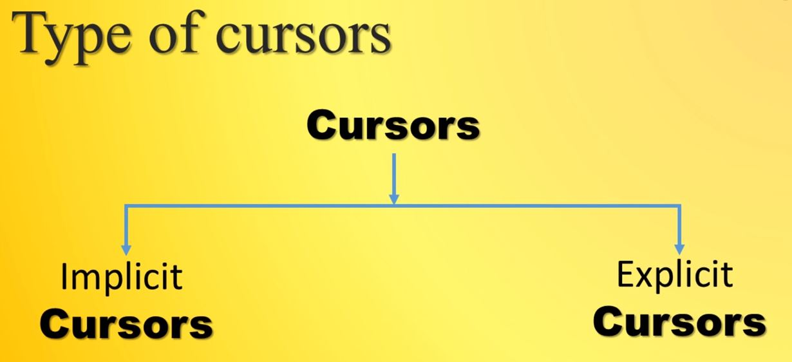

Implicit cursor

* Automatically created by Oracle server
* User cannot control the behavior of these cursors
* Oracle server creates an implicit cursor for any PL/SQL block which executes an SQL statement if explicit cursor does not exist for that SQL statement

Explicit cursor

* are user/programmer defined
* has full control on them
* handles any SQL query which might returns more than one row

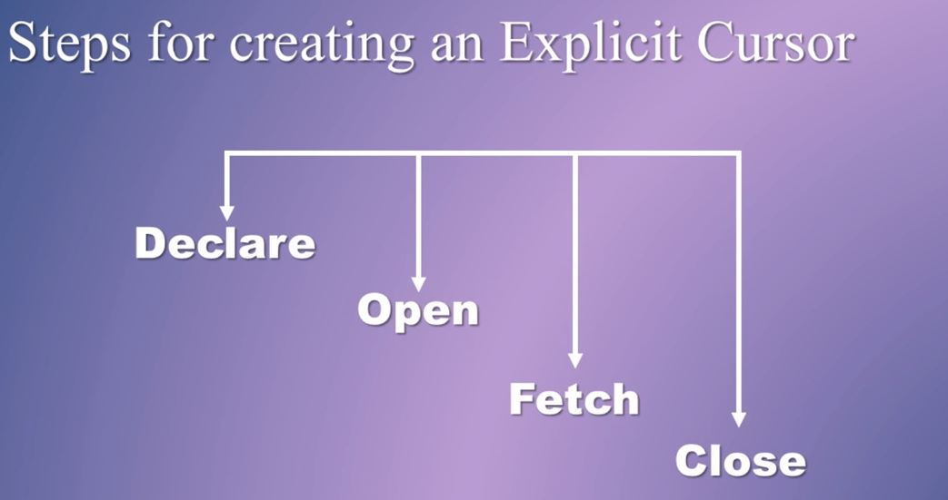

**PL\SQL Explicit Cursors**

Distinguish between implicit and explicit cursors

• Discuss the reasons for using explicit cursors

• Declare and control explicit cursors

• Use simple loops and cursor FOR loops to fetch data

• Declare and use cursors with parameters

• Lock rows with the FOR UPDATE clause

• Reference the current row with the WHERE CURRENT OF

clause

Implicit cursors that are automatically created by PL/SQL when you execute a SQL SELECT or DML statement.

**Cursors**

Every SQL statement executed by the Oracle server has an associated individual cursor:

• Implicit cursors: Declared and managed by PL/SQL for all DML and PL/SQL SELECT statements

• Explicit cursors: Declared and managed by the programmer

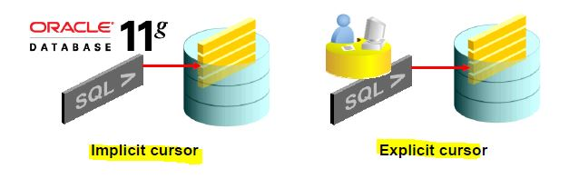

**Cursors**

The Oracle server uses work areas (called *private SQL areas*) to execute SQL statements and to store processing information. You can use explicit cursors to name a private SQL area and to access its stored information.

The Oracle server implicitly opens a cursor to process each SQL statement that is not associated with an explicitly declared cursor. Using PL/SQL, you can refer to the most recent implicit cursor as the SQL cursor.

**Explicit Cursor Operations**

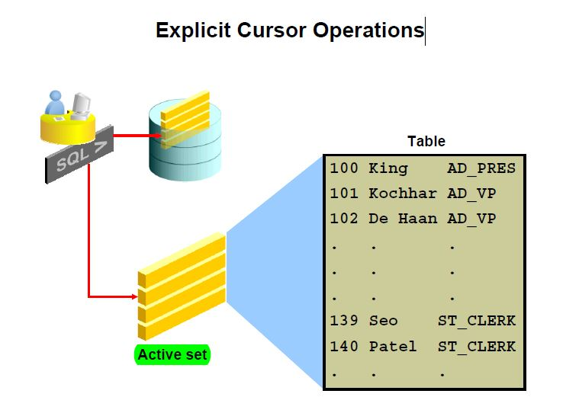

**Explicit Cursor Operations**

You declare explicit cursors in PL/SQL when you have a SELECT statement that returns

multiple rows. You can process each row returned by the SELECT statement.

The set of rows returned by a multiple-row query is called the *active set*. Its size is the number of rows that meet your search criteria. The diagram in the slide shows how an explicit cursor

“points” to the current row in the active set. This enables your program to process the rows one

at a time.

Explicit cursor functions:

• Can perform row-by-row processing beyond the first row returned by a query

• Keep track of the row that is currently being processed

• Enable the programmer to manually control explicit cursors in the PL/SQL block

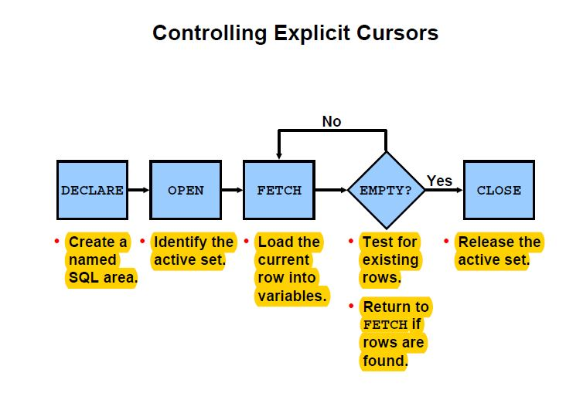

**Controlling Explicit Cursors**

Now that you have a conceptual understanding of cursors, review the steps to use them.

1. In the declarative section of a PL/SQL block, declare the cursor by naming it and defining the structure of the query to be associated with it.

2. Open the cursor.

The OPEN statement executes the query and binds any variables that are referenced. Rows identified by the query are called the *active set* and are now available for fetching.

3. Fetch data from the cursor.

In the flow diagram shown in the slide, after each fetch you test the cursor for any existing row. If there are no more rows to process, you must close the cursor.

4. Close the cursor.

The CLOSE statement releases the active set of rows. It is now possible to reopen the

cursor to establish a fresh active set.

**Controlling Explicit Cursors**

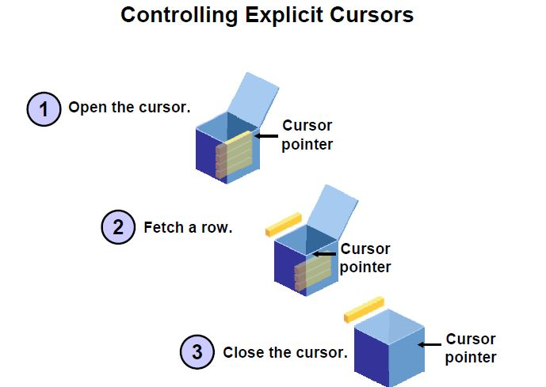

**Controlling Explicit Cursors (continued)**

A PL/SQL program opens a cursor, processes rows returned by a query, and then closes the cursor. The cursor marks the current position in the active set.

1. The OPEN statement executes the query associated with the cursor, identifies the active set, and positions the cursor at the first row.

2. The FETCH statement retrieves the current row and advances the cursor to the next

row until there are no more rows or a specified condition is met.

3. The CLOSE statement releases the cursor.

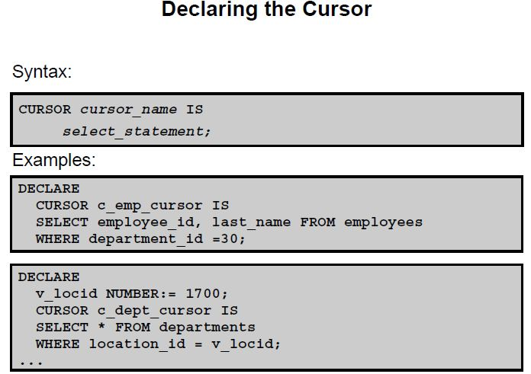

**Declaring the Cursor**

The syntax to declare a cursor is shown in the slide. In the syntax:

*cursor_name* Is a PL/SQL identifier

*select_statement* Is a SELECT statement without an INTO clause

The active set of a cursor is determined by the SELECT statement in the cursor declaration. It is mandatory to have an INTO clause for a SELECT statement in PL/SQL. However, note that the SELECT statement in the cursor declaration cannot have an INTO clause. That is because you are only defining a cursor in the declarative section and not retrieving any rows into the cursor.

**Note**

• Do not include the INTO clause in the cursor declaration because it appears later in the

FETCH statement.

• If processing rows in a specific sequence is required, use the ORDER BY clause in the

query.

• The cursor can be any valid SELECT statement, including joins, subqueries, and so on.

The c_emp_cursor cursor is declared to retrieve the employee_id and last_name columns for those employees working in the department with a department_id of 30.

The c_dept_cursor cursor is declared to retrieve all the details for the department with the location_id 1700. Note that a variable is used while declaring the cursor.

These variables are considered bind variables, which must be visible when you are declaring the cursor. These variables are examined only once at the time the cursor opens. You have learned that explicit cursors are used when you must retrieve and operate on multiple rows in PL/SQL. However, this example shows that you can use the explicit cursor even if your SELECT statement returns only one row.

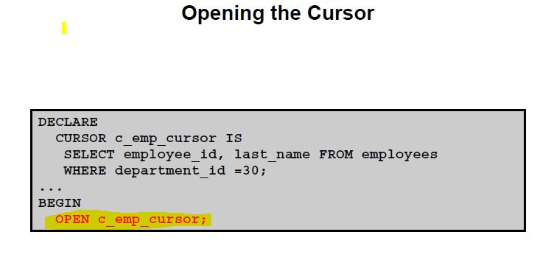

**Opening the Cursor**

The OPEN statement executes the query associated with the cursor, identifies the active set, and positions the cursor pointer at the first row. The OPEN statement is included in the executable section of the PL/SQL block.

OPEN is an executable statement that performs the following operations:

1. Dynamically allocates memory for a context area

2. Parses the SELECT statement

3. Binds the input variables (sets the values for the input variables by obtaining their memory addresses)

4. Identifies the active set (the set of rows that satisfy the search criteria). Rows in the active set are not retrieved into variables when the OPEN statement is executed. Rather, the FETCH statement retrieves the rows from the cursor to the variables.

5. Positions the pointer to the first row in the active set

**Note:** If a query returns no rows when the cursor is opened, PL/SQL does not raise an exception.

You can find out the number of rows returned with an explicit cursor by using the

<cursor_name>%ROWCOUNT attribute.

**Fetching Data from the Cursor**

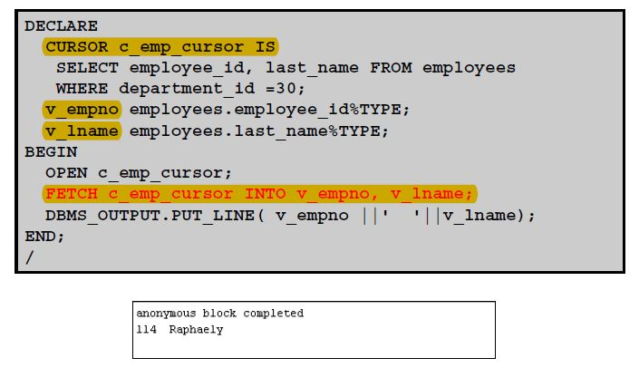

The FETCH statement retrieves the rows from the cursor one at a time. After each fetch, the cursor advances to the next row in the active set. You can use the %NOTFOUND attribute to determine whether the entire active set has been retrieved.

Consider the example shown in the slide. Two variables, empno and lname, are declared to hold the fetched values from the cursor. Examine the FETCH statement.

You have successfully fetched the values from the cursor to the variables. However, there are six employees in department 30, but only one row was fetched. To fetch all rows, you must use loops. In the next slide, you see how a loop is used to fetch all the rows.

The FETCH statement performs the following operations:

1. Reads the data for the current row into the output PL/SQL variables

2. Advances the pointer to the next row in the active set

You can include the same number of variables in the INTO clause of the FETCH statement as there are columns in the SELECT statement; be sure that the data types are compatible. Match each variable to correspond to the columns positionally. Alternatively, you can also define a record for the cursor and reference the record in the FETCH INTO clause. Finally, test to see whether the cursor contains rows. If a fetch acquires no values, there are no rows left to process in the active set and no error is recorded

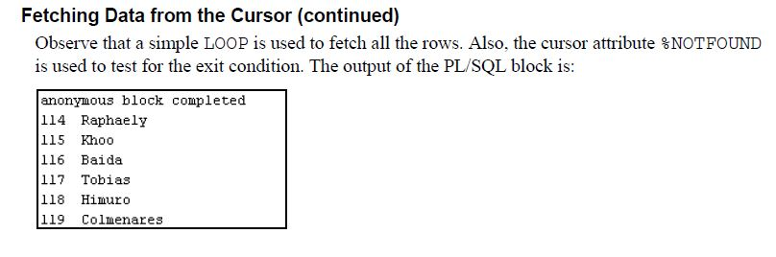

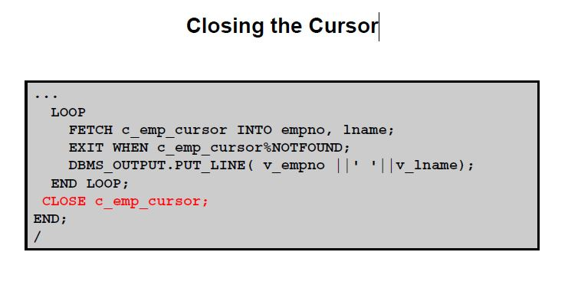

**Closing the Cursor**

The CLOSE statement disables the cursor, releases the context area, and “undefines” the active set. Close the cursor after completing the processing of the FETCH statement. You can reopen the cursor if required. A cursor can be reopened only if it is closed. If you attempt to fetch data from a cursor after it has been closed, then an INVALID_CURSOR exception will be raised.

**Note:** Although it is possible to terminate the PL/SQL block without closing cursors, you should make it a habit to close any cursor that you declare explicitly to free up resources.

There is a maximum limit on the number of open cursors per session, which is determined by the OPEN_CURSORS parameter in the database parameter file. (OPEN_CURSORS = 50 by default.)

**Cursors and Records**

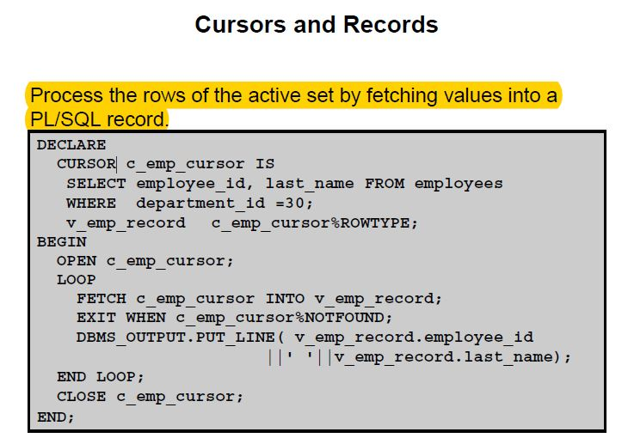

**Cursors and Records**

You have already seen that you can define records that have the structure of columns in a table.

You can also define a record based on the selected list of columns in an explicit cursor. This is convenient for processing the rows of the active set, because you can simply fetch into the record. Therefore, the values of the row are loaded directly into the corresponding fields of the record.

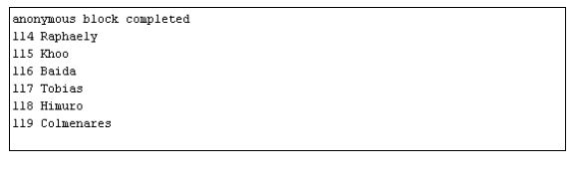

**Cursor FOR Loops**

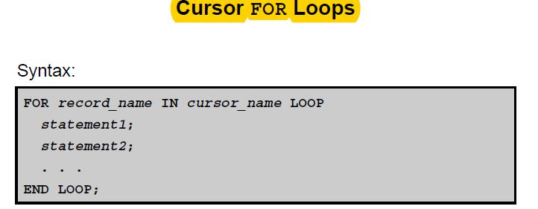

The cursor FOR loop is a shortcut to process explicit cursors.

• Implicit open, fetch, exit, and close occur.

• The record is implicitly declared.

You have learned to fetch data from cursors by using simple loops. You now learn to use a cursor FOR loop, which processes rows in an explicit cursor. It is a shortcut because the cursor is opened, a row is fetched once for each iteration in the loop, the loop exits when the last row is processed, and the cursor is closed automatically. The loop itself is terminated automatically at the end of the iteration where the last row is fetched.

In the syntax:

*record_name* Is the name of the implicitly declared record

*cursor_name* Is a PL/SQL identifier for the previously declared cursor

**Guidelines**

• Do not declare the record that controls the loop; it is declared implicitly.

• Test the cursor attributes during the loop, if required.

• Supply the parameters for a cursor, if required, in parentheses following the cursor name in the FOR statement.

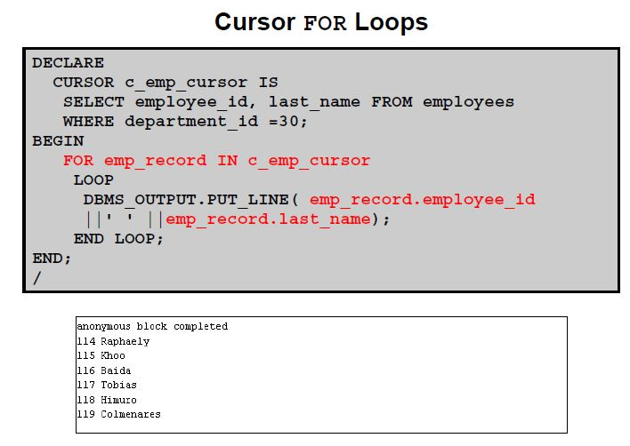

The example that was used to demonstrate the usage of a simple loop to fetch data from cursors is rewritten to use the cursor FOR loop.

The emp_record is the record that is implicitly declared. You can access the fetched data with this implicit record (as shown in the slide). Observe that no variables are declared to hold the fetched data using the INTO clause. The code does not have OPEN and CLOSE statements to open and close the cursor, respectively.

**Explicit Cursor Attributes**

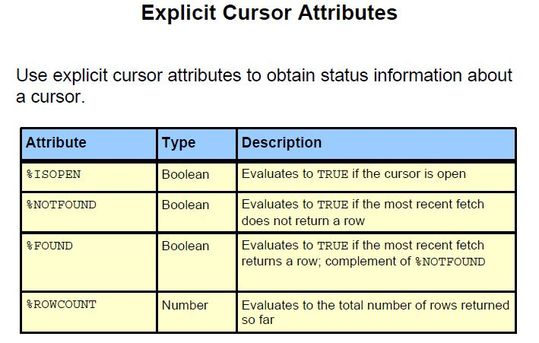

**Explicit Cursor Attributes**

As with implicit cursors, there are four attributes for obtaining status information about a cursor.

When appended to the cursor variable name, these attributes return useful information about the execution of a cursor manipulation statement.

**Note:** You cannot reference cursor attributes directly in a SQL statement.

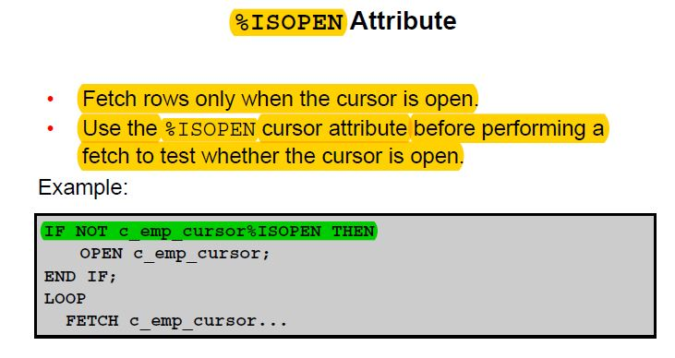

You can fetch rows only when the cursor is open. Use the %ISOPEN cursor attribute to

determine whether the cursor is open.

• Fetch rows in a loop. Use cursor attributes to determine when to exit the loop.

• Use the %ROWCOUNT cursor attribute to do the following:

- Process an exact number of rows

- Fetch the rows in a loop and determine when to exit the loop

**Note:** %ISOPEN returns the status of the cursor: TRUE if open and FALSE if not.

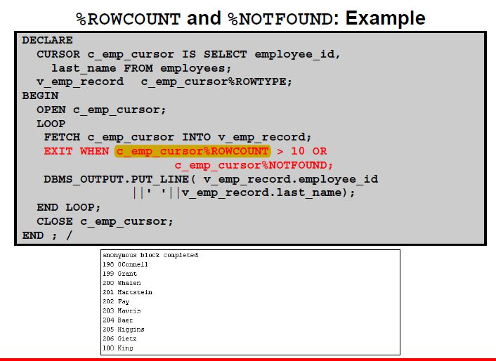

**Cursor FOR Loops Using Subqueries**

There is no need to declare the cursor.

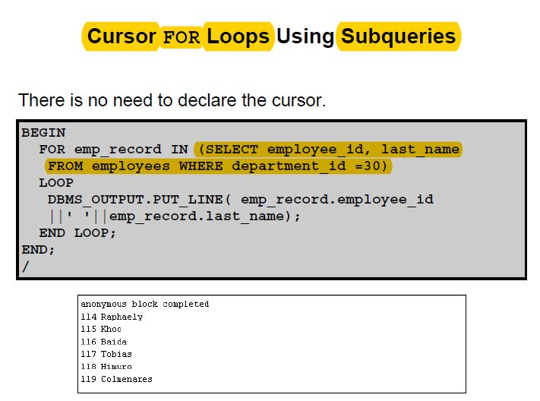

Note that there is no declarative section in this PL/SQL block. The difference between the cursor FOR loops using subqueries and the cursor FOR loop lies in the cursor declaration. If you are writing cursor FOR loops using subqueries, you need not declare the cursor in the declarative section. You must provide the SELECT statement that determines the active set in the loop itself.

The example that was used to illustrate a cursor FOR loop is rewritten to illustrate a cursor FOR loop using subqueries.

**Note:** You cannot reference explicit cursor attributes if you use a subquery in a cursor FOR loop because you cannot give the cursor an explicit name.

**Cursors with Parameters**

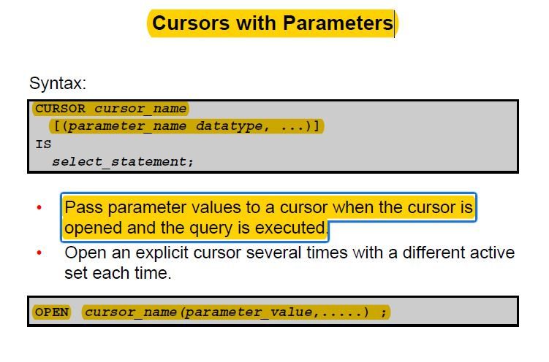

You can pass parameters to a cursor. This means that you can open and close an explicit cursor several times in a block, returning a different active set on each occasion. For each execution, the previous cursor is closed and reopened with a new set of parameters.

Each formal parameter in the cursor declaration must have a corresponding actual parameter in the OPEN statement. Parameter data types are the same as those for scalar variables, but you do not give them sizes. The parameter names are for references in the query expression of the cursor.

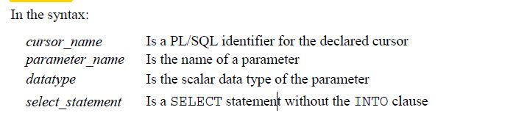

The parameter notation does not offer greater functionality; it simply allows you to specify input values easily and clearly. This is particularly useful when the same cursor is referenced repeatedly.

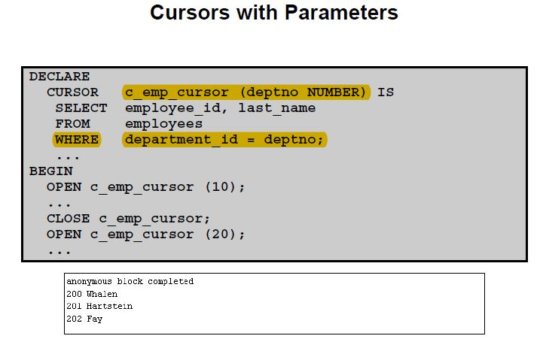

Parameter data types are the same as those for scalar variables, but you do not give them sizes.

The parameter names are for reference in the cursor’s query. In the following example, a cursor is declared and is defined with one parameter:

DECLARE

CURSOR c_emp_cursor(deptno NUMBER) IS SELECT ...

The following statements open the cursor and return different active sets:

OPEN c_emp_cursor(10);

OPEN c_emp_cursor(20);

You can pass parameters to the cursor that is used in a cursor FOR loop:

DECLARE

CURSOR c_emp_cursor(p_deptno NUMBER, p_job VARCHAR2)IS

SELECT ...

BEGIN

FOR emp_record IN c_emp_cursor(10, **'**Sales**'**) LOOP ...

**FOR UPDATE Clause**

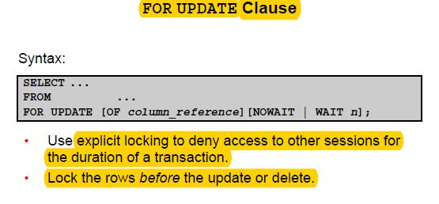

If there are multiple sessions for a single database, there is the possibility that the rows of a table were updated after you opened your cursor. You see the updated data only when

you reopen the cursor. Therefore, it is better to have locks on the rows before you update or delete rows. You can lock the rows with the FOR UPDATE clause in the cursor query.

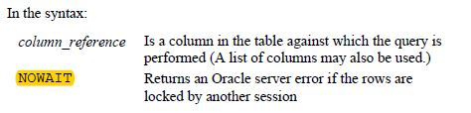

The FOR UPDATE clause is the last clause in a SELECT statement, even after ORDER BY (if it exists). When querying multiple tables, you can use the FOR UPDATE clause to confine row locking to particular tables. FOR UPDATE OF col_name(s) locks rows only in tables that contain col_name(s).

The SELECT ... FOR UPDATE statement identifies the rows that are to be updated or deleted, and then locks each row in the result set. This is useful when you want to base an update on the existing values in a row. In that case, you must make sure that the row is not changed by another session before the update.

The optional NOWAIT keyword tells the Oracle server not to wait if requested rows have been locked by another user. Control is immediately returned to your program so that it can do other work before trying again to acquire the lock. If you omit the NOWAIT keyword, the Oracle server waits until the rows are available.

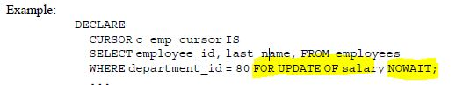

If the Oracle server cannot acquire the locks on the rows it needs in a SELECT FOR UPDATE operation, it waits indefinitely. Use NOWAIT to handle such situations. If the rows are locked by another session and you have specified NOWAIT, opening the cursor results in an error. You can try to open the cursor later. You can use WAIT instead of NOWAIT, specify the number of seconds to wait, and determine whether the rows are unlocked. If the rows are still locked after *n* seconds, an error is returned.

It is not mandatory for the FOR UPDATE OF clause to refer to a column, but it is

recommended for better readability and maintenance.

**WHERE CURRENT OF Clause**

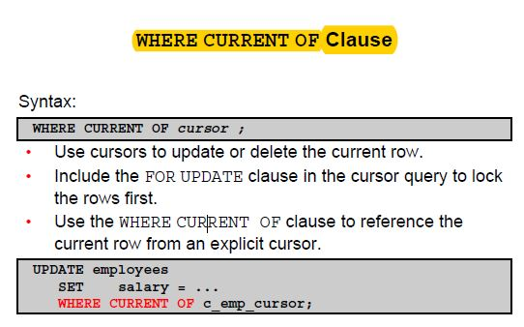

The WHERE CURRENT OF clause is used in conjunction with the FOR UPDATE clause to refer

to the current row in an explicit cursor. The WHERE CURRENT OF clause is used in the UPDATE or DELETE statement, whereas the FOR UPDATE clause is specified in the cursor declaration.

You can use the combination for updating and deleting the current row from the corresponding database table. This enables you to apply updates and deletes to the row currently being addressed, without the need to explicitly reference the row ID. You must include the FOR UPDATE clause in the cursor query so that the rows are locked on OPEN.

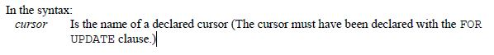

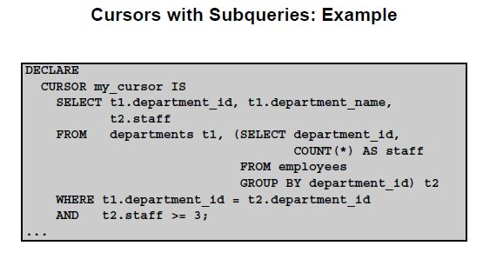

**Cursors with Subqueries**

A subquery is a query (usually enclosed by parentheses) that appears within another SQL

statement. When evaluated, the subquery provides a value or set of values to the outer query.

Subqueries are often used in the WHERE clause of a SELECT statement. They can also be used in the FROM clause, creating a temporary data source for that query.

In the example in the slide, the subquery creates a data source consisting of department numbers and the number of employees in each department (known by the alias STAFF). A table alias, t2, refers to this temporary data source in the FROM clause. When this cursor is opened, the active set contains the department number, department name, and total number of employees working for those departments that have three or more employees.

**Practices**

**Chapter 2 Practice**

**bind variables** : a placeholder in a SQL statement that must be replaced with a valid value or value address for the statement to execute successfully. By using bind variables, you can write a SQL statement that accepts inputs or parameters at run time.

Also host variables

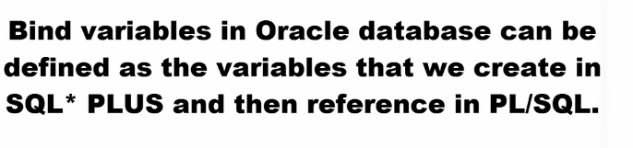

To declare bind variables:

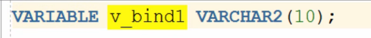

To initialize bind variable

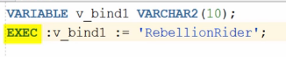

No PLSQL block

**Scalar variables :** A scalar variable, or scalar field, is a variable that holds one value at a time. It is a single component that assumes a range of number or string values. A scalar value is associated with every point in a space.

1) This is the example how can you use both bind variables that you declare BEFORE the block and regular scalar ones that you declare within the block.

You can print bind variables outside the block with the PRINT command.

*VARIABLE basic_percent NUMBER*

*VARIABLE calc NUMBER*

*SET SERVEROUTPUT ON*

*DECLARE*

*today DATE := SYSDATE;*

*tomorrow today%TYPE;*

*BEGIN*

*:basic_percent := 45;*

*:calc := :basic_percent/3;*

*tomorrow := today +1;*

*DBMS_OUTPUT.PUT_LINE(' Hello World ');*

*DBMS_OUTPUT.PUT_LINE('TODAY IS : '|| today);*

*DBMS_OUTPUT.PUT_LINE('TOMORROW IS : ' || tomorrow);*

*END;*

*/*

*PRINT basic_percent*

*PRINT calc*

**Hello World   
TODAY IS : 14-SEP-09   
TOMORROW IS : 15-SEP-09   
PL/SQL procedure successfully completed.**

|  |
| --- |
| **BASIC_PERCENT** |
| 45 |

Top of Form

Bottom of Form

|  |
| --- |
| **CALC** |
| 15 |

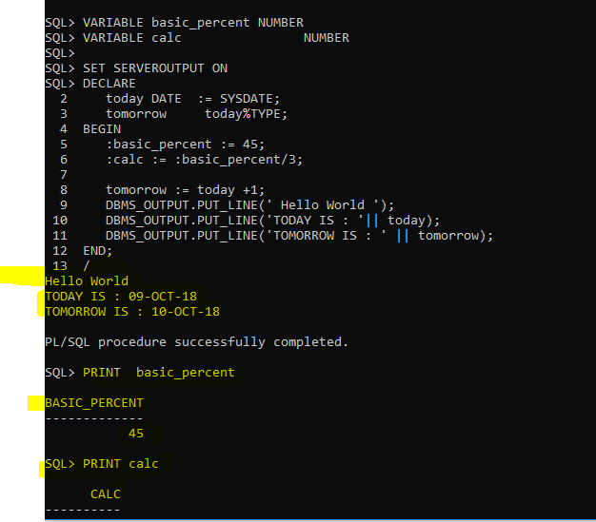

2) Let’s display the exact date and time of this moment and then the same in 18 hours. The scale for time components should be set to miliseconds.

*SET SERVEROUTPUT ON*

*DECLARE*

*v_datetime TIMESTAMP(3) := SYSTIMESTAMP;*

*v_tomorrow v_datetime%TYPE;*

*BEGIN*

*v_tomorrow := v_datetime + 18/24;*

*DBMS_OUTPUT.PUT_LINE('Right now is exactly ' || v_datetime || ' day and time');*

*DBMS_OUTPUT.PUT_LINE('In 18 hours will be exactly ' || v_tomorrow || ' day and time');*

*END;*

*/*

**Right now is exactly 14-SEP-09 09.28.24.939 PM day and time   
In 18 hours will be exactly 15-SEP-09 03.28.24.000 PM day and time   
PL/SQL procedure successfully completed.**

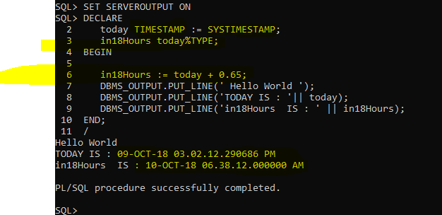

SET SERVEROUTPUT ON

DECLARE

today TIMESTAMP(3) := SYSTIMESTAMP;

in18Hours today%TYPE;

BEGIN

in18Hours := today + 0.65;

DBMS_OUTPUT.PUT_LINE(' Hello World ');

DBMS_OUTPUT.PUT_LINE('TODAY IS : '|| today);

DBMS_OUTPUT.PUT_LINE('in18Hours IS : ' || in18Hours);

END;

/

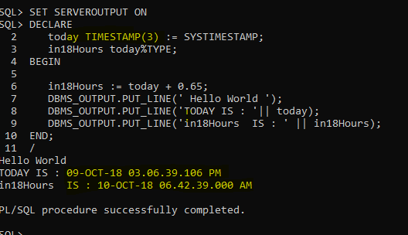

3) Lets’ find out when will be your approximate graduation month, assuming you need exactly 1 year and 3 months more. Exclude fractions of seconds from the output

and use this Date Format for today 🡺 **Sep 14, 2009**

*SET SERVEROUTPUT ON*

*DECLARE*

*v_grad TIMESTAMP(0) ;*

*BEGIN*

***v_grad := TO_TIMESTAMP('Sep 14,2009','Mon dd, yyyy') + INTERVAL '1-3' YEAR TO MONTH;***

*DBMS_OUTPUT.PUT_LINE('My graduation month is ' || v_grad) ;*

*END;*

*/*

**My graduation month is 14-DEC-10 12.00.00 AM FORMAT IS NOT THE SAME AS REQUESTED  
PL/SQL procedure successfully completed**.

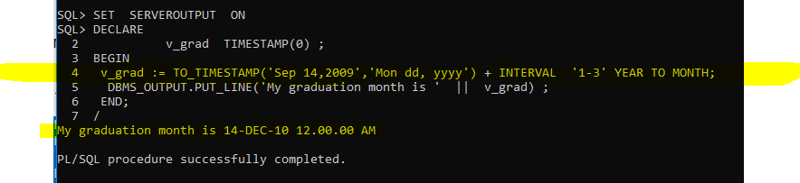

4) This example is using regular variable, %TYPE variable and **substitute** variable for the column value that will be entered at the run-time.

Lets’ figure out the full name for employee with the Id 145.

*SET SERVEROUTPUT ON*

*SET VERIFY OFF* -- this will turn off display of OLD and NEW values

*DECLARE*

*v_fname VARCHAR2(20) ;*

*v_lname employees.last_name%TYPE ;*

*v_empid employees.employee_id%TYPE := &employee;*

*BEGIN*

*SELECT first_name, last_name INTO v_fname, v_lname*

*FROM employees*

*WHERE employee_id = v_empid;*

*DBMS_OUTPUT.PUT_LINE(q'{Employee's name is }' || v_lname ||*

*', ' || v_fname);*

*END;*

Top of Form

|  |  |  |
| --- | --- | --- |
| Enter value for employee: |  |  |



**Employee's name is Russell, John   
PL/SQL procedure successfully completed.**

**Just the select statement**

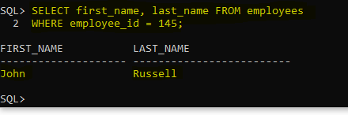

**Chapter 3 Practice**

1) Walkthrough the following PL/SQL code and try to guess what 3 values will be printed for “outervar”?

SET SERVEROUTPUT ON

<<outer>>

DECLARE

outervar NUMBER := 100;

BEGIN

DECLARE

inervar NUMBER := 700;

outervar NUMBER := 500;

BEGIN

outer.outervar := inervar *2;

DBMS_OUTPUT.PUT_LINE('Local Outer variable is: ' || outervar);

DBMS_OUTPUT.PUT_LINE('Main Outer variable is: ' || outer.outervar);

END;

DBMS_OUTPUT.PUT_LINE('Main Outer variable is: ' || outervar);

END;

/

>>> Local Outer variable ( outervar ) is: 500

>>> Main Outer variable ( outer.outervar ) is: 1400

>>> Main Outer variable ( outervar ) is : 14000

2) Write the PL/SQL code that will prompt you to enter today’s date and then will print today’s Day Name and tomorrow’s as well. Here is the output.

Top of Form

|  |  |  |
| --- | --- | --- |
| Enter value for day: |  |  |

**Today is : Friday   
Tomorrow will be : Saturday   
PL/SQL procedure successfully completed**.

*SET SERVEROUTPUT ON*

*SET VERIFY OFF*

*DECLARE*

*v_day DATE :=* ***'&day'****; -- with ‘ ‘ to bring the input as string and not only an integer*

*BEGIN*

*DBMS_OUTPUT.PUT_LINE('Today is : ' || TO_CHAR(v_day,'Day'));*

*v_day := v_day + 1;*

*DBMS_OUTPUT.PUT_LINE('Tomorrow will be : ' || TO_CHAR(v_day,'Day'));*

*END;*

**/**

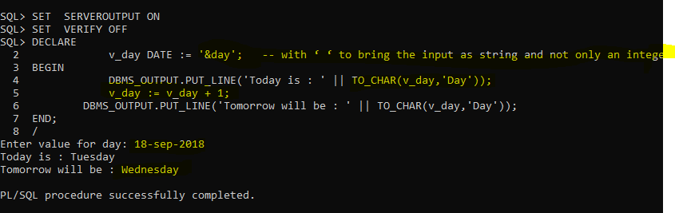

3) You need to walkthrough this code and figure out what would be the values for all 3 variables at Post A and Post B respectively?

*DECLARE*

*var1 NUMBER(3) := 100;*

*var2 VARCHAR2(100) := 'SQL is Great' ;*

*BEGIN*

*DECLARE*

*var1 NUMBER(3) := 5;*

*var2 VARCHAR2(100) := 'SQL is Fun' ;*

*local VARCHAR2(100) := 'Oracle rules' ;*

*BEGIN*

***var1 := var1 + 15;***

***local := 'I am sure that ' || local;***

*__________________________________ Post A*

*END;*

***var1 := var1 + 5;***

***var2 := var2 || ' if you come to class';***

***local := 'Who said that ' || local****;*

*__________________________________ Post B*

*END;*

*/*

**You may comment out some lines here in order to be sure what these values are!**

*WE GET ERROR bcz the ‘ local ‘ is not defined in the outer scope but we are trying to print it.*

***var1 := var1 + 15; -- 20***

***local := 'I am sure that ' || local; -- I am sure that Oracle rules***

*__________________________________ Post A*

*END;*

***var1 := var1 + 5; -- 105***

***var2 := var2 || ' if you come to class'; -- SQL is Great if you come to class if you come to class***

***local := 'Who said that ' || local; --Who said that***

*SET SERVEROUTPUT ON;*

*DECLARE*

*var1 NUMBER(3) := 100;*

*var2 VARCHAR2(100) := 'SQL is Great' ;*

*BEGIN*

*DECLARE*

*var1 NUMBER(3) := 5;*

*var2 VARCHAR2(100) := 'SQL is Fun' ;*

*local VARCHAR2(100) := 'Oracle rules' ;*

*BEGIN*

*var1:= var1 + 15;*

*local := 'I am sure that ' || local;*

*DBMS_OUTPUT.PUT_LINE('VAR1 at A is: ' || var1);*

*DBMS_OUTPUT.PUT_LINE('VAR2 at A is: ' || var2);*

*DBMS_OUTPUT.PUT_LINE('LOCAL at A is: ' || local);*

*END;*

*var1 := var1 + 5;*

*var2 := var2 || ' if you come to class';*

*-- local := 'Who said that ' || local;*

*DBMS_OUTPUT.PUT_LINE('VAR1 at B is: ' || var1);*

*DBMS_OUTPUT.PUT_LINE('VAR2 at B is: ' || var2);*

*-- DBMS_OUTPUT.PUT_LINE('LOCAL at B is: ' || local);*

*END;*

**/**

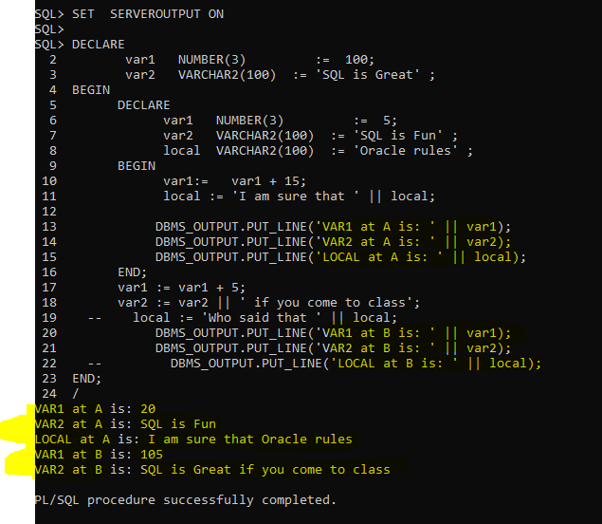

*4)* Prompt user to enter a valid city name of a department. Then display the message about the Id and Name for that department. Here is one possible output.

Top of Form

|  |  |  |
| --- | --- | --- |
| You may enter the city name : |  |  |

In the chosen city your department id is 20 and your department name is Marketing   
PL/SQL procedure successfully completed.

**Lines 19 and 22 are commented out so that you do NOT get the error, because “local” is NOT visible in the outer block.**

*SET SERVEROUTPUT ON;*

*SET VERIFY OFF;*

*ACCEPT v_city PROMPT 'You may enter the city name : '*

*DECLARE*

*dept# departments.department_id%TYPE ;*

*dname departments.department_name%TYPE;*

*loc# departments.location_id %TYPE;*

*BEGIN*

*SELECT location_id INTO loc#*

*FROM locations*

*WHERE UPPER(city) = '&v_city';*

*SELECT department_id, department_name*

*INTO dept#, dname*

*FROM departments*

*WHERE location_id = loc# ;*

*DBMS_OUTPUT.PUT_LINE('In the chosen city your department id is ' || dept# || ' and your department name is ' || dname);*

*END;*

*/*

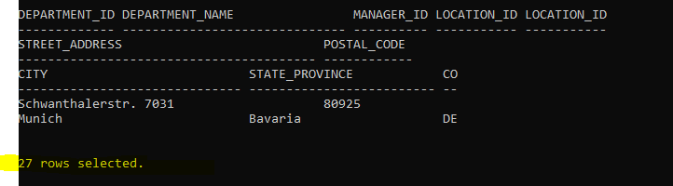

**Chapter 4 Practice**

1) Write the code that will prompt you for the employee’s Id and then will calculate the Annual Income based on the value of “commission_pct” column. If that value does exist it should be doubled (like some kind of reward for Good Sales year). Both numbers should be displayed.

Provide two examples where first employee is receiving the commission, while the other one is not. Here is the output.

Top of Form

|  |  |  |
| --- | --- | --- |
| Enter value for empid: |  |  |

**Employee Hutton has an annual income of 158400   
PL/SQL procedure successfully completed.**

|  |
| --- |
| **COM_PCT** |
| .5 |

Top of Form

|  |  |  |
| --- | --- | --- |
| Enter value for empid: |  |  |

**Employee Higgins has an annual income of 144000   
PL/SQL procedure successfully completed.**

|  |
| --- |
| **COM_PCT** |
| 0 |

2) You will write PL/SQL code that will insert a NEW employee with the following data:

Employee_id: Value is greater by 10 than the highest Id so far

First_name: Tim

Last_name: Ho

Email: It will be in the form of ‘whatever is the User’s name’ with the domain ‘yahoo.ca’

Hire_date: The latest hire date for the chosen department

Job_d: FI_ACCOUNT

Salary: The Average pay for the chosen department

Department_id: You will be prompted for this Id and provide one of the existing values

Then you will verify the look of this new row (just for the columns that are not blank) and then you will undo your insert. Here is the output.

Top of Form

|  |  |  |
| --- | --- | --- |
| Enter value for deptid: |  |  |

Bottom of Form

PL/SQL procedure successfully completed.

|  |  |  |  |  |  |  |  |
| --- | --- | --- | --- | --- | --- | --- | --- |
| **EMPLOYEE_ID** | **FIRST_NAME** | **LAST_NAME** | **EMAIL** | | **HIRE_DATE** | **SALARY** | **DEPARTMENT_ID** |
| 216 | Tim | Ho | DBS501_093A40@yahoo.ca | 07-FEB-99 | | 5760 | 60 |

Rollback complete.

3) You need to modify departments with NO manager so that one of the VP’s becomes their manager. Criteria is also that chosen VP had to be hired in the eighties.

Display firstly last name of that manager and then # of departments that have been modified. And finally undo you change. Here is the output.

**Name of VP is Kochhar   
# of departments that got Kochhar as a manager is 16   
PL/SQL procedure successfully completed.  
  
Rollback complete.**

**ANSWERS**

**1)**

*SET SERVEROUTPUT ON;*

*SET VERIFY OFF;*

*VARIABLE com_pct NUMBER;*

*DECLARE*

*lname employees.last_name%TYPE;*

*income employees.salary%TYPE;*

*empno employees.employee_id%TYPE := &empid;*

*BEGIN*

*SELECT commission_pct INTO :com_pct*

*FROM employees*

*WHERE employee_id = empno;*

*IF :com_pct IS NOT NULL THEN*

*:com_pct := :com_pct*2;*

*ELSE*

*:com_pct := 0;*

*END IF;*

*SELECT last_name, salary*12*(1+ :com_pct)*

*INTO lname, income*

*FROM employees*

*WHERE employee_id = empno;*

*DBMS_OUTPUT.PUT_LINE('Employee ' || lname || ' has an annual income of ' || TO_CHAR(income));*

*END;*

*/*

*PRINT com_pct*

**2)**

*DECLARE*

*mail_name VARCHAR2(40);*

*h_date employees.hire_date%TYPE;*

*avg_sal employees.salary%TYPE;*

*v_dept employees.department_id%TYPE := &deptid;*

*v_emp employees.employee_id%TYPE;*

*BEGIN*

*SELECT USER INTO mail_name*

*FROM DUAL;*

*SELECT MAX(hire_date), AVG(salary)*

*INTO h_date, avg_sal*

*FROM employees*

*WHERE department_id = v_dept;*

*SELECT MAX(employee_id) INTO v_emp*

*FROM employees;*

*v_emp := v_emp + 10;*

*mail_name := mail_name || '@yahoo.ca' ;*

*INSERT INTO employees VALUES (v_emp,'Tim','Ho',mail_name,NULL,h_date,'FI_ACCOUNT',avg_sal,NULL,NULL,v_dept);*

*END;*

*/*

*SELECT employee_id, first_name, last_name, email,hire_date, salary, department_id*

*FROM employees*

*WHERE employee_id = (SELECT MAX(employee_id)*

*FROM employees);*

*ROLLBACK;*

*/*

**3)**

*SET SERVEROUTPUT ON;*

*DECLARE*

*empid employees.employee_id%TYPE;*

*lname employees.last_name%TYPE;*

*BEGIN*

*SELECT employee_id, last_name*

*INTO empid, lname*

*FROM employees*

*WHERE job_id LIKE '%VP'*

*AND hire_date < '01-JAN-90';*

*DBMS_OUTPUT.PUT_LINE('Name of VP is ' || lname);*

*UPDATE departments*

*SET manager_id = empid*

*WHERE manager_id IS NULL;*

*DBMS_OUTPUT.PUT_LINE('# of departments that got ' || lname || ' as a manager is ' || SQL%ROWCOUNT) ;*

*END;*

*/*

*ROLLBACK*